UCF Senior Design II

Next Generation Portable Solar Charger

Department of Electrical Engineering and Computer Science
University of Central Florida
Dr. Lei Wei

Group 17

John (Conner) Dickman Electrical Engineering
Tyler Maignan Electrical Engineering
Luis Nicacio Electrical Engineering
Leslie Recendiz Computer Engineering

Table of Contents

1. Executive Summary 1
2. Project Description 3
2.1 Motivation 3
2.2 Goal 4
2.3 Related Work 4
2.4 Engineering Specification 5
2.4.1 Objective 6
2.4.2 Components 6
2.4.3 Battery Considerations 7
2.4.4 Overall Design 8
2.4.5 Stadium Construction 8
2.4.6 Arduino Connections 9
2.4.7 House of Quality 10
2.5 Block Diagram 12
2.6 Estimated Budget and Financing 13
2.7 Initial Milestones 13
3. Research and Part Selection 15
3.1 Technology Research 15
3.1.1 Photovoltaic Modules 15
3.1.2 Solar Panel Manufacturing Methods 18
3.1.3 Solar Panel Testing & Certification Standards 19
3.1.4 Battery 20
3.1.5 LCD Display 22
3.1.6 Microcontroller 23
3.1.7 Wireless Charger 25
3.1.8 Voltage Boosting 27
3.1.9 3D-Printer Technology 28
3.2 Market Product Comparisons 30
3.2.1 White Kaiman Solar Panel Mobile Charging System 30
3.2.2 FosPower NOAA Emergency Weather Radio Portable Power Bank with Solar Charging 32
3.2.3 Solar Charger Power Bank 20000mAh, Solar Charger with Dual USB 5V Outputs & LED Flashlights 33
3.2.4 Solar Power Bank 26800mAh, Damipow Portable Wireless Charger Foldable Solar Panel Charger 4 Outputs 5V/3A USB Type C, Flashlight Waterproof External Battery Pack Compatible with iPhone & Android 34
3.2.5 Market Product Comparison Summary 35

3.3 Part Selection 37
3.3.1 Solar Panel 37
3.3.2 Battery 40
3.3.3 Programming Language 43
3.3.4 Battery Charger 46
3.3.5 Wireless Charger 47
3.3.6 Voltage Booster 49
3.3.7 Charging Cable 51
3.3.8 Arduino Uno R3 51
3.3.9 1602 LCD 54
3.3.10 3D-Printer 55
3.3.11 3D-Printer Filament 58
3.3.12 JST Jumper Cable 59
3.3.13 DC Jack Adapter Cable 60
4. Design Constraints and Standards 61
4.1 Design Constraints 61
4.1.1 Economic Constraints 61
4.1.2 Time Constraints 62
4.1.3 Manufacturing Constraints 62
4.1.4 Sustainability Constraints 63
4.1.5 Environmental Constraints 63
4.1.6 Ethical, Health, and Safety Constraints 64
4.1.7 Software Constraints 64
4.1.8 Testing Constraints 65
4.1.9 Portability Constraints 65
4.1.10 Battery Constraints 66
4.2 Design Standards 66
4.2.1 Cost of Development 66
4.2.2 Programming Language - C Standard 67
4.2.3 Battery Standards 68
4.2.4 Solar Panel Standards 70
4.2.5 Design Impact of Solar Panel Standards 71
4.2.5 PCB Standards 72
4.2.6 Software Testing Standards 72
4.2.7 Wireless Charging Standards 74
4.2.8 Design Impact of Wireless Charging Standards 75
5. Project Design 76
5.1 Overall Design 76

5.1.1 Overall Design Details 76
5.1.2 Power Distribution 77
5.1.3 Breadboard Split 78
5.1.4 Charger Housing 79
5.2 Individual/Multi-Component Testing 82
5.2.1 Breadboard Testing 82
5.2.2 Arduino Testing 83
5.2.3 Solar Panel to Battery 85
5.2.4 Battery to Arduino 85
5.2.5 Arduino to LCD Display and Battery 86
5.3 Overall Schematic 88
5.3.1 Block Diagram 88
5.3.2 Schematic 89
5.4 Software 90
5.4.1 Methodologies 91
5.4.2 Development with Arduino 91
5.4.3 Microcontroller Software 93
5.5 Flowchart 94
5.5.1 Software Flowchart 94
5.6 Interface 95
5.6.1 Overall Interface 95
5.6.2 Stadium Design/Interface 96
5.6.3 AutoCAD Modeling 96
6. Integration, PCB Design, and System Testing 98
6.1 Overall Integration 98
6.1.1 Integration Preparation 98
6.1.2 Charger Integration 98
6.1.3 Arduino Integration 100
6.2 PCB Design 102
6.2.1 PCB Expectations 102
6.2.2 PCB Timeline 102
6.2.3 PCB Summary 104
6.2.4 PCB Research Step Preparation 104
6.3 System Testing 104
6.3.1 Solar Panel Testing 105
6.3.2 Microcontroller 105
6.3.2 Battery Health 105
6.3.3 Presentation Measurables 106

7. Administration 108
7.1 Budget and Financing 108
7.1.1 Budget 108
7.1.2 Expenses 108
7.2 Milestone Discussion 109
7.2.1 Milestones 109
7.3 Role Assignment 113
7.3.1 Project Experience - Conner (John) 114
7.3.2 Project Experience - Tyler 115
7.3.3 Project Experience - Luis 116
7.3.4 Project Experience - Leslie 117
8. Conclusion 119
Appendix 120
A1. References 121

List of Figures

Figure 1: Existing portable solar charger 4
Figure 2: 3D Printer 8
Figure 3: Arduino Voltage Measurement 9
Figure 4: House of Quality 11
Figure 5: Top level project design 12
Figure 6: Solar cell 15
Figure 7. Solar panels 17
Figure 8: Methods 18
Figure 9: Battery Design 20
Figure 10: LCD pins 22
Figure 11: Arduino Models 24
Figure 12:Wireless Charger 25
Figure 13 Adafruit PowerBoost 1000 Basic Voltage Booster 27
Figure 14: TI-TPS61175 Voltage Booster 27
Figure 15: Home 3D printer 28
Figure 16: Industrial 3D printer 29
Figure 17: 3D Model Generator 30
Figure 18: White Kaiman Solar Panel Mobile Charging System 31
Figure 19: FosPower NOAA Emergency Weather Radio Portable Power Bank with Solar Charging 32
Figure 20: Solar Charger Power Bank 20000mAh, Solar Charger with Dual USB 5V Outputs & LED Flashlights 33
Figure 21: Solar Power Bank, Wireless Charger, Portable 34
Figure 22: Solar Panel Image 37
Figure 23: Solar Panel Technical Drawing 40
Figure 24: Battery Design 41
Figure 25: Battery Pack Adafruit 42
Figure 26: C, C++ and Python example 45
Figure 27: Battery Charger Module (BCM) 46
Figure 48: BCM Underside 47
Figure 29: Wireless charger 48
Figure 30: Voltage Booster Adafruit 50
Figure 31: USB Cable 51
Figure 32. Arduino Uno R3 52
Figure 33. Arduino Architecture 53
FIgure 34: Arduino Architecture 54
Figure 35: Printer Cable 56
Figure 36: 3D Printer 56
Figure 37. Printer Schematic 58
Figure 38: Filament 58
Figure 39. Adafruit Cable 59
Figure 40. Jack Adapter 60
Figure 41. Comparison 65

Figure 42. Bill of materials 66
Figure 43. Block diagram 76
Figure 44. Battery Charger 77
Figure 45. Voltage booster 78
Figure 46. XYZmaker suite 79
Figure 47. Modeling Application. 79
Figure 48. Design Figure 81
Figure 49. Preview 81
Figure 50. XYZ Program 82
Figure 51. 3D model 78
Figure 52. Breadboard 79
Figure 53. Arduino uno microcontroller 84
Figure 54. Arduino Uno R3 (ATMEGA328) schematic 84
Figure 55. Wiring Diagram 86
Figure 56. Code Snippet 87
Figure 57. Block Diagram 88
Figure 58. schematic
Figure 59. Agile methodology 91
Figure 60. Flowchart 92
Figure 61. IDE 92
Figure 62 Flowchart 95
FIgure 63. AutoCad window 96
Figure 64. Box of Parts 98
FIgure 65. Breadboard 99
FIgure 66. Wireless charger chosen 99
FIgure 67. Arduino Integration 100
FIgure 68. Arduino Connections 101
FIgure 69. Eagle window 102
Figure 70. PCB screen 103
Figure 71. New PCB schematic 105
Figure 72. Board file of PCB 106
Figure 71. Solar panel testing 107
Figure 72. Devices we will test 107
Figure 73. Mockup drawing 115
Figure 74. Original Schematic 116
Figure 75. LED Screen 117

List of Tables

Table 1. Components Description 7
Table 2. Budget Table Setup 13
Table 3. Certification Standards 19
Table 4. Rechargeable Battery Comparison 21
Table 5. Manufacturers 28
Table 6. Product comparison 36
Table 7. Solar cell comparison 39
Table 8. Battery Specifications 41
Table 9. Battery Specifications comparison 43
Table 10 . Coding Languages 44

Table 11. Battery Charger Details 47
Table 12. Technical Details 49
Table 13. Voltage booster 51
Table 14. Arduino comparison 52
Table 15. LCD specifications 55
Table 16. 3D printer dimensions 57
Table 17. JST connector specs 60
Table 18. Battery standards description 69
Table 19. Solar panel description 71
Table 20. PCB standard descriptions 72
Table 21. Software testing standards 74
Table 22. Printer Specs 81
Table 23. 3D printer specs 104
Table 24. Measurables 108
Table 25. Parts and quantity 110
Table 26. Updated milestones 113
Table 27. Roles 115

1. Executive Summary

Phone calls, text messages, emails, and web browsing are all possible through one singular device, our smartphones. People around the world use these devices every hour of every day. However, due to limitations in battery technology, it has become a challenge to keep our smartphones powered on the entire day. There are thousands of research associations and large companies working toward developing the next breakthrough in battery storage technology without compromising the performance. Until that next great leap in technology is achieved, we will work toward improving the ways in which we charge our existing batteries.
We can extend the battery life of our smartphones by developing easier and more convenient charging solutions. The apparent simple solution to this battery life issue is to have an external battery pack that can be plugged in and on the go. To achieve our goal of a more convenient charger, we thought of putting together a portable charger. Portable chargers have become more popular but a lot of them can be bulky, not efficient enough or too expensive. We started by determining our source of power, sunlight, which is an extremely abundant source of energy, especially in the state of Florida.
Choosing solar energy allows us to have a constant, and Earth conscious, source of power for our charger. Solar power has long caught the interest of scientists and researchers as the ideal alternative to fossil energy. Given the abundance of sunlight available to us from our sun, it is logical to want to utilize this energy that has been present since the beginning of time and use it to power our engines and homes.We need a renewable source of energy which can function round the clock without any disruption. Therefore, we need to ensure that the consumer of this charger has stored power to use when the weather is not cooperating - this is especially important considering the amount of rain in Florida or in case of environmental disasters. Normal power banks can charge your smartphones and tablets just well, but they do need to be plugged into an outlet to recharge. Solar-powered chargers outperform the competitors in this area. They may be charged by the sun, which is a renewable source of energy that can be found almost anywhere. Solar energy is free, clean, and safe for the environment.
Including a battery into this charger will be extremely beneficial to the user because they can charge their phone inside, which is an added bonus for portability. Essentially, our charger will feature multiple solar panels, a battery, voltage regulators (to protect the battery from discharge/overcharge), and a wireless charger (for added convenience). In addition to these main components, we will include an Arduino, a LCD display, and accompanying hardware to allow the charger to display the current power output and battery capacity. The most important part of this system is ensuring the solar energy we collect is stored safely and properly within the battery. Safety always comes first, and ensuring our battery remains full throughout the day comes second. We will do this by developing a voltage regulator system that limits the amount of charge the battery takes in (to prevent overcharging) and another system that limits the amount of charge leaving through the charger (to prevent discharging).
While convenient and efficient charging is our main goal, we are still striving to make our charger different. We will design our charger around one of UCFs key infrastructures: the Bounce House. Using the football field as our wireless charger, and the seating as our solar panels, we will produce a solar charger that looks like no other. We are doing this to promote solar energy as an exciting and fun way to support the well-being of the planet. Solar chargers enable you to charge your electronics even in the most remote locations. Although direct sunshine is preferable, ambient lighting can be used as well. These solar chargers also have a wireless charging connector that allows them to be recharged when there is no light. Most significantly, these solar chargers will store energy for use on overcast days or at night.

2. Project Description

This section explains the project’s application by describing the criteria and providing a broad concept for the design so that everyone in the team meets the required goals. The section includes the product's motivation and influences, aims and objectives that the team wants to attain upon completion, and a full list and description of the parts and materials from which the product will be constructed.

2.1 Motivation

The main idea that drove us to this project is that it is one technique of charging that makes use of renewable energy in order to avoid the loss of power and charge. It decreases pollution while also being very user-friendly. In addition, the solar or photovoltaic system is a highly efficient energy source that has had a significant impact on society and industry. There are people that are consistently on the move, going to work, to school, to grocery shopping, they are always commuting. There are also those who have a really big heart for the environment and want to do more on their part for becoming more eco-friendly and being more energy-efficient. With seeing so much on the news about climate change and the effects that it is having in different parts of the world, it is our job as the future generation to come up with better solutions than the present-day solutions to find ways to get energy in a clean and efficient way. As we live in a state that has sunshine all year round, it is obvious to say that researching, investing and implementing solar energy across Florida should be a mission, rather than a goal for Floridians. Investing in renewable energy is crucial and is continuing to become much more prominent in the engineering field. As many engineers in the engineering field want to do more for their environment, we also wanted to do more for Mother Nature while also applying the best of our knowledge in a project that could be used in everyday life activities while being more conscious about the environment.

The group has the idea of making this specific device portable so that users can take it anywhere outdoors or any event where they would need their smartphones powered on. Solar energy is a form of a renewable source becoming popular as climate change continues to be a bigger issue in today’s world and could bring bigger issues in tomorrow’s world. As solar energy continues to become more and more widely available, it not only helps the consumer with saving more money in their pockets, but also pushes the consumer to invest in more renewable resources like solar energy that can help be more environmentally friendly while also preserving the natural environment. As many companies in different industries continue to implement clean energy sources, solar energy continues to be the most popular source to be tested and used in today’s products across the market as the sun provides unlimited amounts of energy during the day. We are moved by the idea of solar energy and implementing the best of our knowledge and the hard work through our college career into a project that can demonstrate our teamwork skills as individuals and as a team of engineers.

2.2 Goal

Our overall goal is to build a device that charges a phone and a battery at the same time via solar panels. We determined that this project would need to follow the example of any electrical system based on our research on similar models and our knowledge from previous courses. There must be a source, a function, and an output. We will use solar panels that have been optimized for solar tracking as our source. Additionally, we have other milestone goals we would like to achieve along the way. After we create a system where the solar panels charge the battery, we will switch our focus to charging a mobile device. Our milestone goal here is to use wireless charging to charge the phone. For this, we plan to incorporate a Qi charger to our model. Our next goal is to measure the output power using an Arduino unit, and then display the output on an LCD; this will help the user know how much charge the unit is receiving from the sun. Another goal is to include a separate charger for the battery, one that plugs into a wall outlet for when there is a rainy day or if the panels are not receiving enough sun. Our final goal is to build this charger to look like the University of Central Florida football stadium.

2.3 Related Work

Many companies across different industries are implementing technology toward net-zero carbon emissions or 100% renewable energy. Solar energy continues on the rise as its applications to technology continue to be implemented in today’s market across many different industries. From Tesla’s Solar Roof, which has many small efficient solar panels represented as a roof, to Anker’s Portable Solar Charger, which includes four foldable solar panels that can charge two devices at the same time. As solar energy continues to be a popular option on the rise as a source of electricity for a household. Smartphones are an example of a device that consumes more energy on a daily basis for the average person. As a result, more efficient chargers should be designed in order to consume more clean energy, especially from resources such as solar energy.
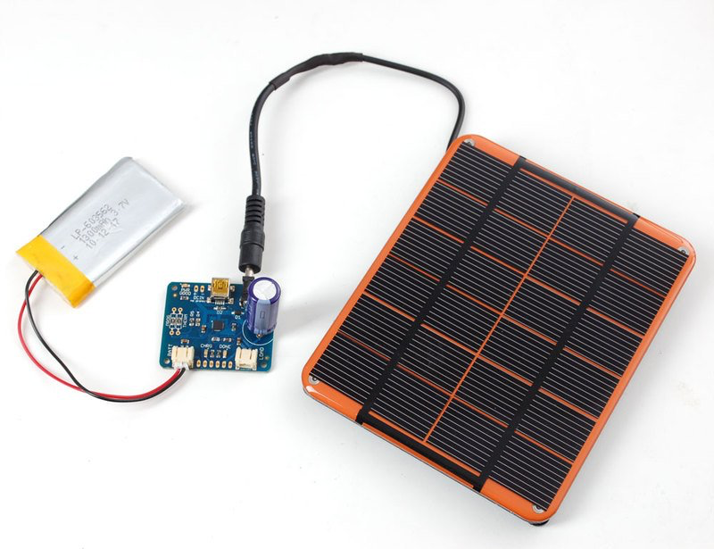
Figure 1. Existing portable solar charger
Technology changes from day to day and even though there are similar projects out there, we plan to have a fun design and a different approach to integrate it. Our project plans to provide a charger used with the Qi standard that can be an affordable option for the average person to use while they would like to charge their device outdoors while knowing that solar energy is charging their device. One of the first things that we decided was on the design of this charger, based on research on similar models we determined, we need to follow the example of an electrical system. It must have a source, a function, and an output. For our source, we will be using solar panels optimized with solar tracking. For our solar panels, we plan to connect them either series to produce a desired output voltage and/or parallel to produce a desired current capability. We have found similar projects where solar panels are used to charge a battery or that connect to an Arduino.

One of the problems we find when people work with Arduinos is that it can consume a lot of battery, but we plan to put the Arduino to sleep when not in use or we can also use an on/off switch. Based on our research we also realized we will need some kind of regulator to avoid overcharging it.

Figure 1 shows an existing portable charger that incorporates solar panels, however, the design isn’t too attractive. We can also see it uses a Lithium battery and a polymer charger. Also, most of the projects that we researched mentioned having a voltage regulator that we will definitely incorporate in our design. The design in Figure 1 could be portable, but there isn’t a case to protect cables or the battery. Therefore, we want to go with something more creative and attractive that even students could take to the UCF’s tailgates.

The UCF Charging Station was another product to be investigated. The energy generated by this charging station is utilized to charge electric vehicles that are connected to its batteries. The UCF Charging Station differs from other solar-powered buildings in that it does not convert the energy absorbed into AC voltage; instead, it stores it as DC in a battery. This is very similar to what we ought to research and create so it is a good point to look at and gather some information about photovoltaic modules. The station requires extremely minimal maintenance due to its basic construction and lack of complexity, which is a key prerequisite for any PV panel installation.

Some of the projects we found use a AA battery which would barely output any power, so we plan to modify this and use a bigger battery to make it more efficient and plan to make our project a wireless charging station. Another feature we plan to implement is adding an LCD to display the power output.

2.4 Engineering Specification

- The system shall be no longer than 1.5 feet
- The system shall be no taller than 15 inches
- The system will contain a Qi wireless charger
- The system shall not weigh more than 1500 grams
- The system will contain an on and off switch
- The system will contain a solar panel, arduino circuit board, and a battery
- The system will contain an LCD display showing voltage production
- The system will contain a battery to power the system in case the solar cell does not produce enough charge
- The system will be able to be converted into a wall charger
- The dimensions of the solar panels will be 7.7 x 4.9 x 0.08 inches
- The solar panels’ ratings will be 9V/3W
- The total cost of the system shall not exceed $600
- The solar charge regulator will have a protection circuit that limits the current being drawn in while the battery is fully charged
- The charger will be capable of charging a 3000mAh phone in 12 hours
- The USB that will be implemented must be able to output a 5V / 200mA output in order to successfully charge a cell phone
- The operation voltage range of the microcontroller will be 7-12V
- The operational voltage range of the solar charge regulator will be the same as the microcontroller
- The LCD display must not exceed 5 x 4 x 3 inches (Length/Width/Height)
- The system’s electrical components shall be weatherproof
- The secondary battery shall be a lithium ion battery
- The secondary battery shall be rated 12V
- The secondary battery shall be no bigger than 4 x 5 inches
- The secondary battery shall weigh no more than 100 grams
- The secondary battery will have a rating of 9V
- The arduino software will read the amount of voltage being produced by the solar panel and display it on the LCD board
- The Qi wireless charger PCBA’s dimensions will be 3.2 x 3.2 cm
- The Qi wireless charger will be 5 cm in diameter
- A button will be included to read the battery’s percentage, displayed on the LCD screen
- An LED will light up whenever there is a cell phone connected to the charger
- LCD needs to be big enough to display the battery life / battery output
- The 3D printed foundation will be made of PLA (Polylactic Acid)
- The field inside of the stadium foundation will be made of artificial turf
- AutoCAD will be the software that will be used for the design of the system
- The solar panels will be attached to the foundation using hot glue
- All required electronics that do not need to be outdoors (cables, microcontroller) must be totally housed.

2.4.1 Objective

In order to produce enough power to charge a phone, the solar cell must have a sufficient light source to activate the photoelectric effect. Sunlight hits the photovoltaic panel, and the photons energy breaks electrons free from the silicon semiconductors. This creates an electric field, providing DC electricity to the Arduino, which theoretically will regulate the amount of current going through the battery and charger. We may have to build the regulator ourselves. Furthermore, we’ll encode the Arduino board to read the battery percentage and display it on the LCD.

2.4.2 Components

The table below shows each component we will need in addition to their individual specifications such as dimensions, support capabilities, etc.
Components | Specification
Dimension of the charger | > 6.33 x 3.07 x 0.29
Overall dimension | TBD
Battery | Lead-acid battery
Solar panel | Solar panel should charge battery, arduino and qi charger
Devices supported | Mobile phone, iOS / Android and airpods
Charging connectivity | Wireless Qi charger
Power Output | > 5 - 7.5W, depending on device
LCD Display | Display power output
Arduino Kit | Circuit Elements and Design
3D Printed Stadium Model | Acts as a foundation for the solar panels to rest on
Charging capacity | Capable of charging a 3000mAh phone
USB Cable
Full Phone Charge Time | 6 hours
Table 1. Components Description

2.4.3 Battery Considerations

The project will require energy from the sun to the solar panels and convert it to alternating current voltage, which can power most mobile phones. The project should include a system for monitoring voltage levels and protect the system from being overused or overcharged. A lead - acid battery should sufficiently meet the charging requirements that are necessary to power a 5-7.5W wireless Qi charger. The charge regulator should meet the specifications necessary to maximize charging efficiency. We must also incorporate discharge protection to the battery, since keeping the battery from draining from the solar panel will be an important precondition.

Furthermore, since solar panels are a relatively inconsistent form of power generation due to cloud cover, temperature, and light source (sun) position, this will create the need for a charge regulator circuit that will connect between the battery and the solar panel. Another regulator we’ll need is a voltage regulator so that we can limit the amount of current being passed to the battery to avoid damage. Moreover, the regulator will make sure that a constant charge to the battery is maintained while the solar panel is exposed to sunlight, and power will be supplied to the Arduino microcontroller. Power to the microcontroller may require a step-down component, and the microcontroller will regulate the LCD display.

2.4.4 Overall Design

This charger is designed to look like the UCF Bounce House. The stadium is shaped like an oval; the longer sides will each feature a solar panel to charge the battery. One of the shorter sides will feature an LCD display that will show the current output power as well as the battery percentage. The other shorter side will have the on/off switch for the device. The wireless charger will be placed underneath the center of the football field. Underneath the bleachers and the field, we will store the battery, arduino, voltage regulators, wires, and other additional hardware that makes our charger work. The structure of the stadium will be 3D printed from PLA plastic filament. The football field will be made from artificial turf.

2.4.5 Stadium Construction

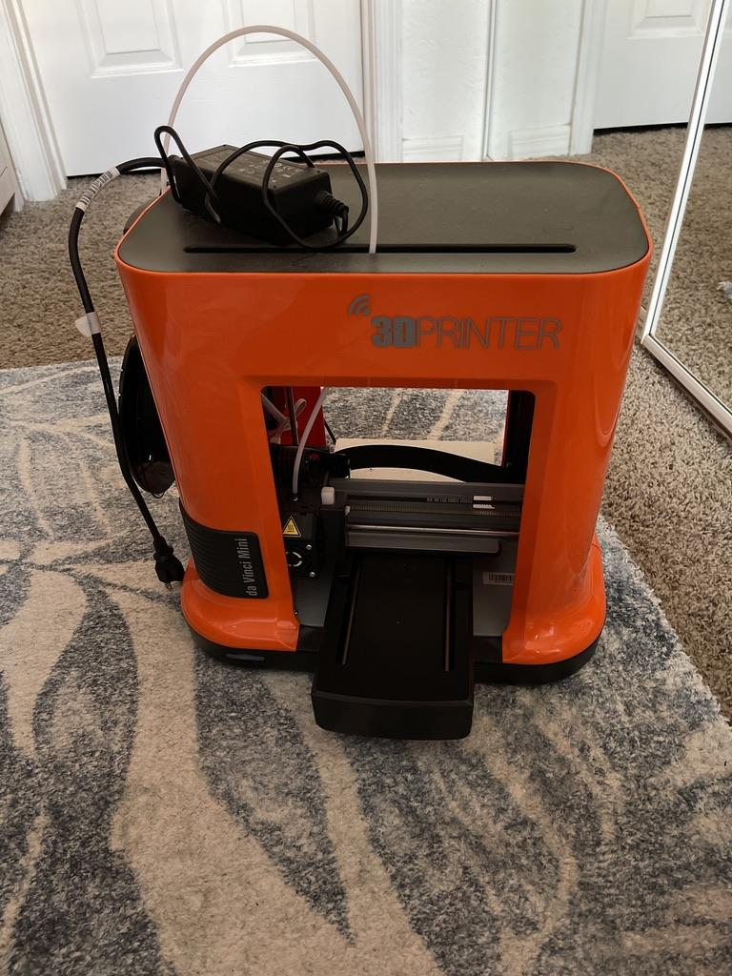
We decided to use a 3D printer to build our model stadium to ensure our solar charger had the most accurate appearance. There are many benefits to 3D printing including light weight, cost effective, durable, and detailed. The 3D printer we chose uses a PLA (Polylactic Acid) filament which is a lightweight and durable thermoplastic; additionally, PLA filament is made from renewable resources such as corn starch, tapioca roots, or sugar cane, which furthers our commitment to truly green energy. These resources ensure that PLA filament is extremely cheap due to how easily attainable they are; this allows our team to bring the cost down of our project, and make it available to more people. 3D printing also allows for an extreme level of detail. Thanks to modeling software available on our laptops and/or desktop machines, we have the ability to create a very accurate and precise model of the Bounce House.
Figure 2: 3D Printer
The printer we have chosen to use is an old printer from a team member’s high school years - it is called the da Vinci Mini. This printer was made by XYZPrinting, which is a part of a global manufacturing group based in Taiwan. Their main goal is to produce affordable and easy-to-use 3D printers. This exact model is not an industrial printer, and was designed for lower level designs. With this in mind, we still will have an accurate design, but we do not expect perfection; if we had a larger budget and more time, we would consider a more industrial-based printer. The stadium will have to be printed in multiple pieces due to a limited print size for our 3D printer.

The stadium will be designed using a software solution by XYZPrinting. They offer multiple tools for viewing and printing, as well as for editing. However, if we are not satisfied with the level of detail, we will move to more complex programs such as AutoCAD.

2.4.6 Arduino Connections

This section will be completely finalized after testing has begun. At this moment, our main goal is to ensure all of our components are at the same voltage (9V). We chose 9V because it is in the middle of the Arduino range of operation (7V - 12V). Ensuring all of our components have the same voltage will allow us to accurately measure, record, and display the voltage being output to our wireless phone charger.

Essentially, our design will feature multiple solar panels, if necessary, in series connected to a battery charger. This will start the parallel connections: battery, usb charger (phone charger), arduino. The arduino will be connected to a potentiometer via a jumper cable. Additionally, jumper wires will then be connected to the 5V and GND connections on the Arduino. This is the hardware setup required to measure the incoming voltage into the Arduino (the rest will be done via code implemented through the Arduino IDE). Since all of these components are in parallel, the measured voltage at the Arduino will also be the measured voltage at the battery and at the phone charger. This will allow us to display to the user (on the LCD panel) what the current voltage output is. This is important in determining how much sunlight the panels are receiving as well as how fast our phone will charge.

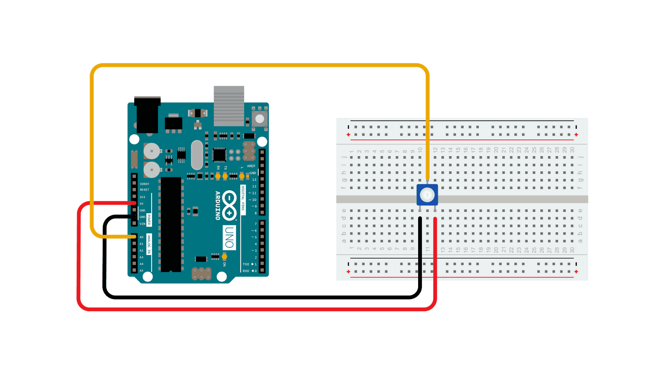
Figure 3: Arduino Voltage Measurement

The figure 3, shows some of our connections from the Arduino to the breadboard, but we will also implement other components to it. We will need a voltage booster connected to the arduino since our solar panel won’t be able to output all the necessary power to charge our desired phone and charge all the components.

2.4.7 House of Quality

The tradeoff matrix is depicted in Figure 4 as a House of Quality diagram. This matrix shows the tradeoff between various aspects of the design specifications and requirements. Some of the marketing requirements that we added are a set of needs and desires from the consumer’s point of view and we added functional requirements as well. Understanding these two developmental aspects can aid in determining what can and will be done to bring the notion to life.

This includes sections like price, which consumers want to be as low as possible and users want reliability to be one of the most important aspects. The market requirements are the conditions that the project must meet in order to attract investors. Basically, the attributes we anticipate the project to meet and demonstrate that it meets these standards in order to satisfy the funders.

Another criteria was battery life, which users prefer it to last as long as possible. When the user uses the device to charge their phone, they expect it to charge in a fair length of time. Inadequate output power causes delayed charging or, in rare cases, no charging at all. To optimize output power, a high efficiency design with low losses must be applied. Because high efficiency components are more expensive, satisfying this client criteria would have a negative impact on the cost. The weight of the device would be affected negatively since additional power sources would be required. Increasing the number of power sources would increase the continuous operational time, or having a voltage booster.

Also, as a team, we want the cost of production to be as low as possible while keeping efficiency and quality as a priority. However, the product must be market competitive. This has a negative correlation with technical needs. Reduced market costs would need lower production costs, meaning that lower-quality components would have to be employed in the design.

Reliability is one of the client requirements. The product should be able to work for a large proportion of the time. This is especially essential given that this is a solar product with a history of unreliability. As seen in the graph, achieving great dependability is highly related to the product's output power. Maintaining a constant output power above the defined range ensures that the product operates when the consumer wants it to. This is directly related to efficiency. To achieve the desired power output, the electrical components must be highly efficient in order to reduce losses.

The product would be largely reliant on its orientation in relation to the sun and cloudy circumstances. The design's efficiency would plummet dramatically. Because the technology is newer, high efficiency parts are more expensive. If the technology is older, the components will be bigger and bulkier. Bulkier components in the design will raise the weight and reduce the product's attractiveness and portability.

Weight is another customer criteria. Reduced weight would demand the procurement of smaller components. Buying smaller components will improve efficiency because the unit will still need to generate the least amount of power. Using efficient components ensures that the greatest feasible output power is produced with the least amount of loss. Better technology would be required to satisfy these criteria, therefore, raising production costs. We discuss more requirements in the house of quality below.

At the bottom of our house of quality, we added some targets for engineering requirements. We thought it was important to show some actual numbers of what we want to accomplish during the final section and the demo of our project. Some of those requirements include the dimension that we need it to be small so that it can be considered a portable solar charger, but we also want it to be big enough to be able to fit a phone in the center and charge it.

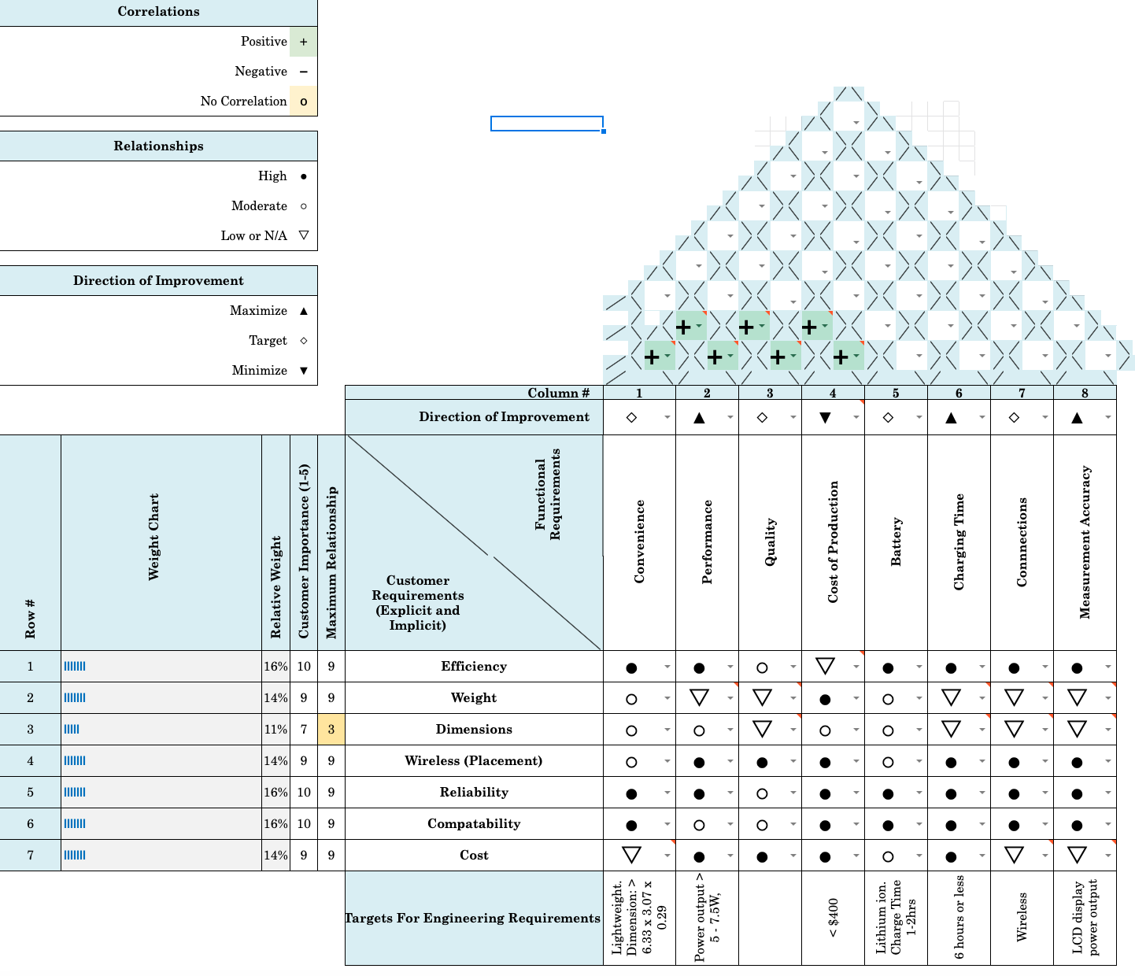
Figure 4. House of Quality

2.5 Block Diagram

The block diagram in Figure 5 serves as an overview of how we will connect our electronics and our design process. We start by describing the relationship between the energy input, the sun, and the battery. We will get the energy from the sun through the solar cells and the voltage regulator, and then it will be sent to the arduino.
The research and design teams will be guided by a rough description of the hardware and software systems in determining the design flow. A hierarchy of processes may be efficiently displayed and verified as the product is built using block diagrams. A block diagram illustrates the application's hardware system and subsystems using image and shape processors. This picture may be seen below. We also listed some of the actions we will take to complete the project such as designing in AutoCad, creating schematics, and testing connections in a breadboard.

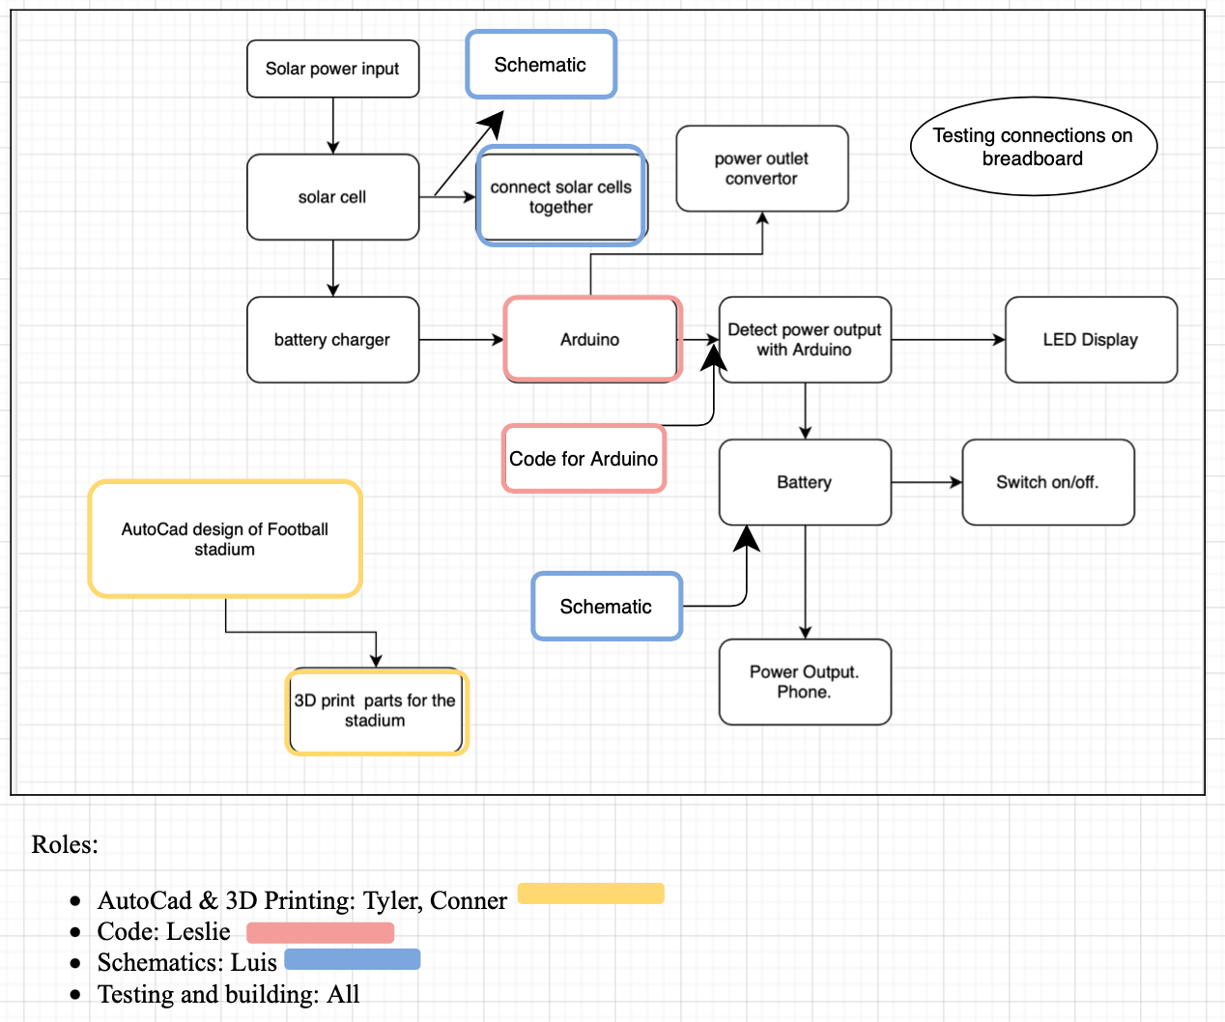
Figure 5. Top level project design

2.6 Estimated Budget and Financing

Below is the estimated budget and financing for the project. Our goal is to limit the overall cost of production, we are hoping to not exceed $600 and be as cost effective as possible. We are hoping to have some solar panels donated to reduce costs and we will work with some components that we already own. These prices are estimates and may change in the future once we start putting things together. We might also need to test some of these components and buy extra materials for testing purposes. We don’t have a sponsor for the project so all of the costs will be covered by the members of the team.

Each Team Member: $150
Total Budget: ~ $600

Components | Price
Solar Panels | $60
Circuit Elements | $20
USB Plug | $5
Qi Charger | $26.95
Arduino | Owned
LCD | Owned
Voltage Regulator | $1
Breadboard | Included in arduino starter kit
Battery | Lithium Ion Polymer Battery - 3.7V 10050mAh
3D Printer | Owned
3D printer filament | $20 - $100

Table 2. Budget Table Setup

2.7 Initial Milestones

The following milestones and due dates will be spread out from the beginning of Senior Design 1 semester to the end of Senior Design 2. This will ensure that our project is completed on time and our goal is met. We set these milestones in accordance with the team member’s schedules and responsibilities. The majority of the milestones in the first part of the project are based on research and familiarization with the project and system’s components. The dates on each will vary and some might need more time and dedication from the team.

- Senior Design 1:
  - Project Idea Discussion
  - Project Selection and meetings setup
  - Role Assignment
  - Design Document setup and access for all members
    - Project Report: Divide and Conquer Part 1
      - First Draft - 10 pages
      - Initial Idea Description and Motivation
      - Research on similar projects
      - Initial Specifications
      - Document Review w/Dr.Wei
    - Divide and Conquer Part 2:
      - Complete initial 10 pages
      - Discuss project specifications
      - Design House of Quality
      - Set table of contents
      - Discuss further design specifications
      - Set up a list of materials and their costs
      - Research, Documentation and Design
          - Solar panel
          - Power supply
          - Regulators
          - Order materials and parts
          - Design/sketch solar charger
          - Create the schematic diagrams
    - Test project materials and start putting it together
  - Senior Design 2:
    - Testing prototype
    - Redesign if necessary
    - Finalize prototype/documentation/presentation

3. Research and Part Selection

In this section, since we already have an idea of the requirements specification and milestones set, we look further into research and locate the technology that will most effectively meet the requirements for our project. We define different possible technologies that can meet our goal. Each key part of the design will be analyzed, and an extensive study will be required to select the best items for each system.

3.1 Technology Research

Innovation is important for many aspects of modern technology. Extending on previously established designs is the foundation of all modern engineering. In order to choose what parts and technology is needed to represent our project in the best way possible, we must understand how each element works. This research is meant to provide us knowledge and insights that will lead to improvement in the design process and will help with reducing costs.

3.1.1 Photovoltaic Modules

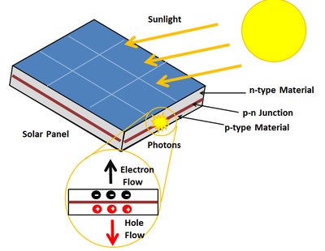
A photovoltaic system's solar array, which is typically made up of photovoltaic cells, modules and arrays, which produce more solar electricity and is used in domestic applications. Photovoltaic modules produce DC electricity and the amount of current flowing depends on how specifically how much of the sun’s light hits the module. The research and theory of photovoltaic power generation and the process of acquiring solar power are extremely complicated, requiring much more comprehension of the non-linear connection between voltage and current. It is defined as an electrical device that converts light energy into electrical energy. The 'photovoltaic effect' refers to the conversion of sunlight into usable electrical energy. Using thousands of these modules can harness enough energy to power many homes and businesses.
Figure 6. Solar cell

When light enters a PV cell, it can be reflected, absorbed, or simply pass through. The light that is absorbed generates electricity. As shown in figure 6, the Sun emits microscopic particles known as photons. When such photons collide with the surface of a semiconductor material, primarily a photovoltaic semiconductor, they transfer their energy to the outermost shell, causing them to detach from the atom. The free electrons are then directed by the solar cell, which generates an electric current by doping the semiconductor material. These electrons flow from the cells through the wire. The amount of current produced by a photovoltaic panel is proportional to the amount of light absorbed by the panel.

Furthermore, most solar panels are made of silicon, which is up to 35% reflective of the sun. In order to reduce the amount of light being lost due to reflection, an antireflective coating made of titanium dioxide or silicon oxide is used. Photovoltaic panels use two semiconductor silicon layers to produce power from the sun. A brain layer separates these two silicon layers, yet they are wired together. One layer faces the sun, while the other faces the opposite direction. When sunlight falls on photovoltaic panels, electrons are energized, causing them to separate from their atoms. The electrons on the silicon layer facing the sun are separated by photons from the sunlight and flow via the connecting wire to the separated second silicon layer.

Because a single solar module generates only a limited amount of power, most installations include multiple modules. In our case, we will most likely be using two panels. Photovoltaic systems commonly include an array of solar modules, a solar inverter, a battery, a solar tracker, and interconnection wiring. When placed directly under sunlight, the photovoltaic panels in solar energy battery banks can charge the system's internal battery. It may take some time to fill up the power bank or battery that we choose to use depending on its capacity and current level of charge. For instance, the time it takes to fully charge a smartphone is the same as the time it takes to fully charge a 1500mAh power bank [2]. This charging time can be doubled, tripled, or quadrupled for larger batteries. Photovoltaic cells can be popular among different projects. There are major benefits to using photovoltaic cells to power electronics. Solar cells require little to no maintenance after installation. Photovoltaic cells are excellent for the environment since they do not damage the environment, their surroundings or use fossil fuels in any way. Solar modules can be used in satellites, calculators, toys and batteries. The average life for a photovoltaic module is around 25 years.

There are different types of modules, some of the most common are made out of monocrystalline silicon, polycrystalline silicon and thin film.

- Thin Film: These film modules are not as efficient as the others, however, they work pretty great with diffused light and when working at high temperatures. They are flexible, very lightweight and more appealing than other panels. Mass production is easier for these kinds of panels and it is very convenient if space or weight is an issue. Degrades quicker than monocrystalline and polycrystalline. However, one disadvantage is that they can be more expensive compared to standard solar panels.

- Polycrystalline silicon: These nearly iridescent blue modules are composed of silicon crystals oriented in different orientations. They are not as efficient if the sun hits them perpendicularly, however, they can use the sunlight more efficiently throughout the day. Efficiency is at about 14%-16%. They are extremely durable and have a 2.25 year warranty. Less expensive than Monocrystalline but lower heat tolerance and aesthetically less appealing.

- Monocrystalline Silicon: These are the most efficient modules. Their efficiency is about 19%-20%. They are usually dark blue, and they are made of silicon crystals that all face the same direction and contain cells with blunted edges. They are at a higher efficiency when the sun hits them perpendicularly. However, they tend to be more expensive.

In the image below we can see what the different solar panels look like, the different colors and grids.

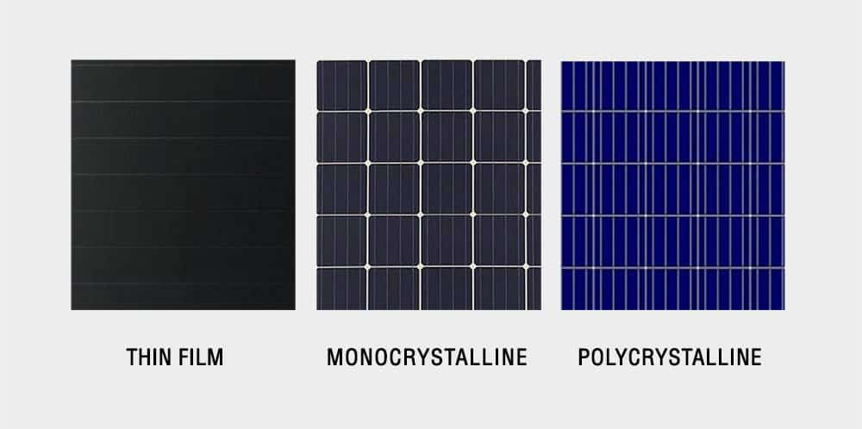
Figure 7. Solar panels

In terms of the wiring comparison for solar panels, they can be done either in series or parallel. Watts are the sum of volts and amps. As an example, if we have three panels at 150 Watts for a total of 450 Watts, we know that we have 150-Watt panels at 17.5 Volts, which gives us around 8.6 Amps of current on each of those panels. If we wire them in series, the panels will be connected to a string, resulting in the three 150 Watt panels being merged into a single 450 Watt panel. The positive connection on one panel will be attached to the next negative connection on another, and that second negative negative line will be connected to the third positive line on the solar array. When electrons pass over a wire, an electrical current is created. Photovoltaic cells are connected in series, which produces an output voltage. Typical voltage outputs are between 12 and 24 volts DC. The output watts or power is directly proportional to the panel's efficiency as well as the square foot coverage.[6]

The solar cell efficiency, which relates to the quantity of sunshine energy transformed into electricity, is used to calculate how excellent photovoltaic panels are. The angled position and the environment surrounding the site of the photovoltaic panel are non-mechanical elements that impact solar cell efficiency. Both contribute to the annual energy production. Reflectivity efficiency, thermodynamic efficiency, charge carrier separation, and conduction values are all technical factors that influence photovoltaic efficiency. The quantum efficiency, Voc ratio, and fill factor of the measurement unit are utilized to determine the challenging parameters.

When we wire the solar panels in parallel, we are essentially doing the reverse of what we would do if we wired them in series. Each of the 150 Watt panels will continue to be independent panels. Individual panels will produce individual quantities of electricity at 17.5 Volts. The only thing that will change when connecting them in parallel, where a positive and negative line comes out of one and a positive and negative line comes out of the next one, so on and so forth, none of them are linked together, therefore the amps of the solar array will vary.

The PV efficiency of our microcontroller and its components, such as LEDs, displays, and sensors, has a negative correlation. This is because the more components utilized or the quantity of electricity necessary to power all of these may necessitate the use of higher grade, more efficient solar panels to provide the extra power required.

3.1.2 Solar Panel Manufacturing Methods
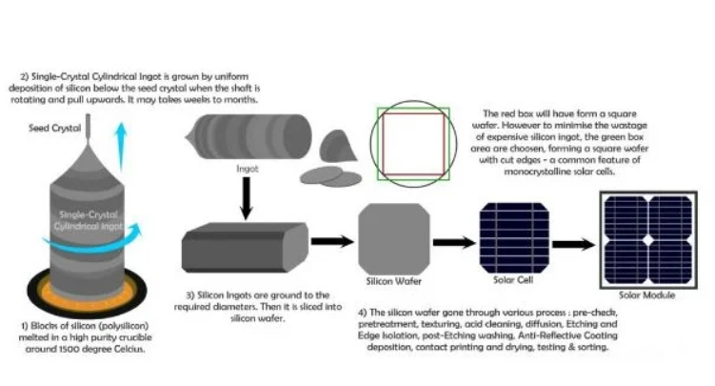
Solar panels are made from a form of pure silicon called polysilicon, which is derived from beach sand heated in a furnace at very high temperatures. This process relies on highly reactive gases using metallurgical-grade silicon (obtained from quartz sand), hydrogen, and chlorine, and is costly and requires a lot of energy. Solar cells are made from silicon boules, which are created by dipping a seed crystal of silicon into melted polycrystalline silicon. After withdrawing and rotating, the liquid is slowly cooled from the button up to form a cylindrical ingot.
Figure 8. Methods

From these ingots, wafers are sliced using a multi wire saw. This process may cost about half of the silicon in the ingots. The purpose of this method is to be able to fit the wafers side by side on a solar cell, hopefully fitting them in a way to utilize all the available space on the front surface of the cell. Wafers are then manufactured into solar cells by chemically texturing the wafer surface, removing saw damage and increasing how much light comes inside the wafer once it is exposed to sunlight.

In order to maximize electron production, the pure silicon must be doped, meaning producers add small amounts of impurities (boron and phosphorus) to the pure silicon during a process called the Czochralski process. Once again, the wafers are heated in the presence of phosphorus gas, who’s atoms burrow into the silicon, further doping it. Moreover, electrical contacts must be placed inside the solar cell so that produced current has a place to travel through. They connect each cell to one another , and must be very thin so that they don’t block sunlight. The contacts are placed, then the solar cells obtain anti-reflective coating.

Pure silicon reflects up to 35% of light, and to reduce this, an anti reflective coating is added on top of the silicon wafer. These coatings are primarily made up of titanium dioxide or silicon oxide. There are three ways that these coatings are applied to the solar panels, the first of which is heating the coating material until its molecules boil off onto the silicon to condense. The second method of coating application is called sputtering; this process involves a high voltage being used to knock molecules off the material and deposit them onto the silicon at the opposite electrode. The third and final method is to allow the silicon to react with a nitrogen containing gas to form silicon nitride.

A process called tabbing and stringing is used, consisting of utilizing copper ribbons plated with solder to connect the silver bus bars on the front surface of one cell to the back of the adjacent cell. This interconnected set of cells is organized face-down on a sheet of glass which is covered with a sheet of polymer encapsulant. Then, a second encapsulant sheet is placed on top of the face-down cells, followed by a piece of glass or polymer backsheet. The stack of materials heated in an oven to laminate, making the module waterproof. Once the anti-reflective coating is applied, the complete photovoltaic module is encapsulated, and sealed into ethylene vinyl acetate or a form of silicon rubber. These are then placed into an aluminum frame, and a junction box is added in which the ribbons are connected to diodes, preventing the backwards flow of electricity.

3.1.3 Solar Panel Testing & Certification Standards

Below are some solar panel testing and certification standards that are used in the photovoltaic module industry.

IEC 61215 | Tests for electrical characteristics, mechanical load test, climate tests, temperature coefficient, open-circuit voltage, and maximum power output
IEC 61730 | Addresses module’s construction and the testing requirements to evaluate electrical, mechanical, thermal, and fire safety
IEC 62716 | Determine a module’s resistance to ammonia and ammonia corrosion
IEC 61701 | Determine a module’s resistance to salt mist; undergoes a series of salt sprays in a controlled environment
IEC 60068-2-86 | Tests how well a panel holds up in a sandy desert environment, and determines how exposure to abrasive sand can wear a panel down, leading to physical or mechanical defects over time
UL 1703 | Panels with this certification go through simulated climatic and aging tests and have been deemed as safe in regards to mechanical loads, fire, and electrical hazards
UL 61730 | Allows for complete international approval in regards to a panel module’s safety and performance
Table 3: Certification Standards

3.1.4 Battery

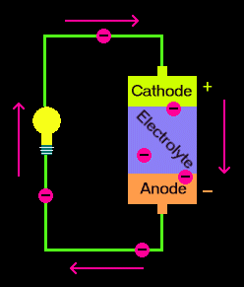
A battery is a power pack that contains chemicals and converts the chemical reactions into electrical energy at the time that it is needed. Batteries come in a variety of sizes and can even last for years. The beauty of batteries is the convenience, where we can receive energy at the time that we want, such as our car. Inside a battery, there are three parts that cause the battery to produce electrical energy: the cathode, electrolyte and anode, as illustrated in the diagram to the left.

The cathode is on the positive side of the battery, whereas the anode is on the negative side of the battery. The electrolyte is in the middle part of the battery and prevents electrons from entering the cathode from the anode. In figure 7, we can see that as electrons naturally move toward places with fewer electrons, it is very necessary for the electrolyte to be placed in between the cathode and anode to prevent issues such as overheating. Some common batteries are the single use only battery but we can also see the rechargeable ones. When recharging batteries, the process goes in reverse, where both the cathode and anode are restored and are able to provide full electrical energy again.

Rechargeable alkaline, nickel cadmium, nickel metal hydride, lithium ion, and silver oxide are just a few of the chemical components utilized in rechargeable batteries that will be addressed. Alkaline rechargeable batteries offer a long shelf life, a large capacity, and the ability to work at extreme temperatures. Their voltage progressively decreases as the battery is used, whereas lithium and silver oxide batteries maintain a constant voltage throughout their lives, with a drop-off at the end. Nickel cadmium batteries have a low internal resistance and strong conducting qualities, allowing them to provide large currents while being quickly recharged.
Figure 9: Battery Design

Furthermore, looking at lithium-ion batteries, lithium ions travel from the anode through the electrolyte to the cathode, where they recombine with their electrons and electrically neutralize. The lithium ions are small enough to enter through a micro-permeable divider that separates the anode and cathode. Electrodes in these kinds of batteries can be made of a variety of materials. The most common configuration is lithium cobalt oxide (cathode) and graphite (anode), which is found in electronic devices including cell phones and computers. Over time, lithium ion batteries have advanced significantly, as new products are released, these batteries hold more power, get charged much faster and deteriorate at a slower pace. This type of battery continues to be used in the majority of the devices we use today and they continue to perform at their highest level and beyond.

Lithium ion batteries have proven to be quite popular due to their extremely high energy density. Polymer batteries, on the other hand, can provide lower-profile, more flexible, and more durable designs. They also have a lesser possibility of electrolytes draining and causing thermal runaway. Moreover, the life cycle of a lithium-polymer battery is short, and the batteries store less energy than Li-ion batteries of the same size. These batteries can deliver up to 3.6V, which is triple the amount for other types of batteries. Lithium-ion batteries pretty much do not require much care, as they do not need to be cycled as much compared to other batteries. This type of battery is currently being used in many of the new battery-powered vehicles such as the Tesla Model S.

Nickel Cadmium batteries are also hazardous to the environment due to the poisonous elements that make them up. Nickel metal hydride batteries offer a higher energy density per volume and weight than nickel cadmium batteries. These batteries are utilized in applications that need frequent charging and rapid discharge. Nickel metal hydride batteries, unlike Nickel Cadmium batteries, do not contain hazardous chemicals.

 | Nickel metal Hydride | Nickel Cadmium | Lithium Ion
Energy Density | 60-120 | 45 - 80 | 100-150
Cycle Life | 300-500 | 1000 | 500-1000
Charge Time | 2-4hrs | 1-2hrs | 1-2hrs
Cell Voltage | 1.2V | 1.2V | 3.7V
Internal Resistance | Low | Very Low | Low
Discharge per Month | 30% | 20% | <5%
Cost | Moderate | Moderate | High
Table 4. Rechargeable Battery Comparison
There are also some limitations to using lithium-ion batteries, such as the effect of high voltages. Implementing high voltages can cause a lithium-ion battery to overheat. These batteries can also age over time, which can cause performance to decrease and lower the capacity of the battery over a period of years, potentially leading to battery failure. Also, the cost of this battery can be a bit of a high price compared to other batteries such as a nickel-cadmium battery. For the sake of this project, the lithium-ion battery was the best choice for this charger.

3.1.5 LCD Display

A liquid crystal display, or LCD, is a type of video display that uses liquid crystals’ light modulating properties to display images and text to a screen. It is a flat-panel kind of screen that may be used to show material both inside and outdoors. Computer monitors, TVs, cellphones, calculators, digital cameras, and other electronic devices all employ LCD screens. An LCD can be used in conjunction with an Arduino microcontroller. It is possible to program an Arduino to display the desired text or images; this is done by connecting the Arduino to the pins of the display.

Liquid crystals are in a wide range of phases at any time, however, the most common are nematic or smectic. The crystals behave like a liquid in the nematic phase, allowing the molecules to restructure themselves while trying to remain oriented in a uniform direction. It includes digital input/output pins, as shown in Figure 8, which allows for information to transfer between the board and the LCD.

There are different types of LCDs that the microcontroller is compatible with. The selection of LCD depends on what the user wants to achieve. With the LCD you can easily view the information on the display instead of the serial monitor. There are a variety of display devices on the market that are compatible with Arduino and have great libraries. However, selecting the proper display for the project is a critical effort since you must evaluate numerous factors like price, size, resolution, ease-of-use, library availability, and so on. The displays mentioned below are one of the most popular in the market:
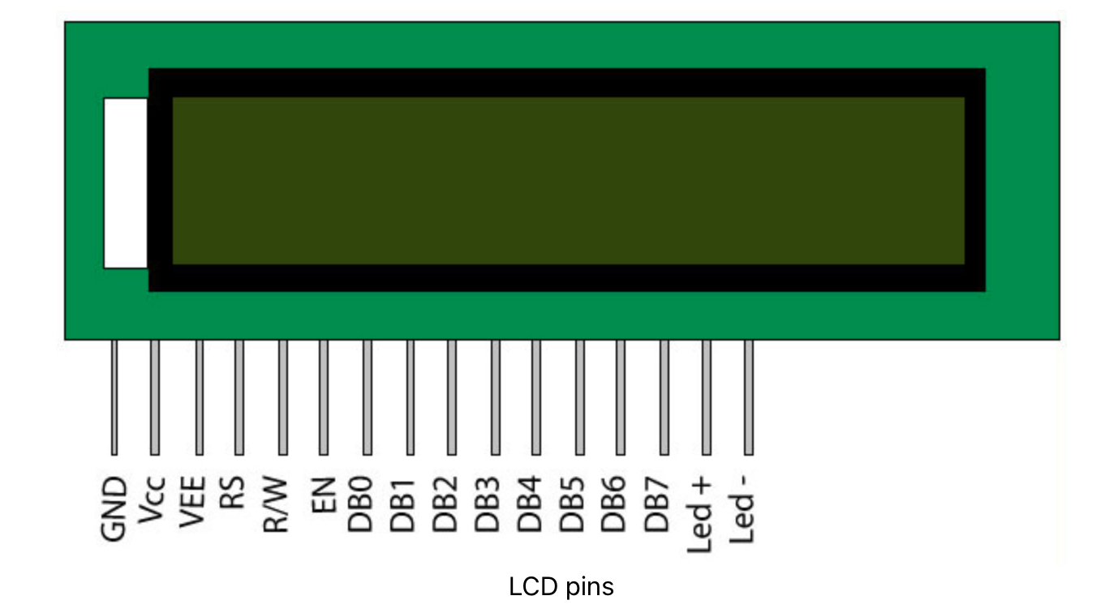
- 16x2 LCD: This display is able to show numbers and letters. The number 16x2 denotes the number of characters, 16, per row and the total number of rows, 2, as shown in figure 9. This display is also available in a slightly larger variant known as the 204 LCD. The only way for Arduino to connect with a 162 LCD is either 8-bit or 4-bit Parallel Communication. Because this interface consumes a large number of Arduino pins, PCF8574-based I2C add-on boards for 162 LCD are being developed.
Figure 10

- OLED display: The monochromatic OLED Display is the next relevant display device for Arduino. OLED displays contain self-illuminating pixels, which means that each pixel can generate its own light. As a result, there is no need for a backlight. When it comes to communication, OLED Displays have two interface options: SPI and I2C. The only difference between these two devices is that their pins are different. The benefit of OLED over standard Character LCDs is that it is a Graphical Show, which makes it very easy to display bitmap graphics and characters in various fonts.

- 128x64 graphical LCD: It features a resolution of 128x64 pixels, which is higher than that of a Nokia 5110 LCD. Furthermore, the LCD is large, with a lot of real estate to work with. When the pins of a common 128x64 LCD are examined, they are quite similar to those of a 162 LCD, but with a couple extra pins. Essentially, the interface is identical to that of a 162 LCD, in that it supports 4-bit or 8-bit parallel communication. However, it may also be set to function with an SPI-like Serial Interface, considerably lowering the necessary Microcontroller pins without the use of any extra hardware.

Because the Arduino can output power, the LCD can be powered by connecting the pins VSS and VDD to the microcontroller. Some of the LCDs come without the pins so they have to be soldered before using and that way it can be adjusted however the user might need it. It can also come with an I2C interface depending on the model and specification. Also, the contrast in the screen can vary and can be adjusted by connecting a resistor to V0 or by implementing a potentiometer. A lot of LCDs come with built in series resistors for the LED blacklight.

Once the wiring is done, the Arduino can write the test to the LCD using programs loaded onto the microcontroller. However, it is very important to know what kind of LCD controller you are using so that you can address the proper pins and controllers in the code. Some of the most common controllers for the code are: KS0108, SSD1306, ST7920, SH1106, SSD1322. These coded programs can be loaded using Arduino’s free open source software. There are a couple of different libraries that can be added in the code to help access certain built in functions that help control the LCD from the Arduino. The microcontroller will be programmed to control and display the system's battery level. It ensures that there is sufficient power to charge the device.

3.1.6 Microcontroller

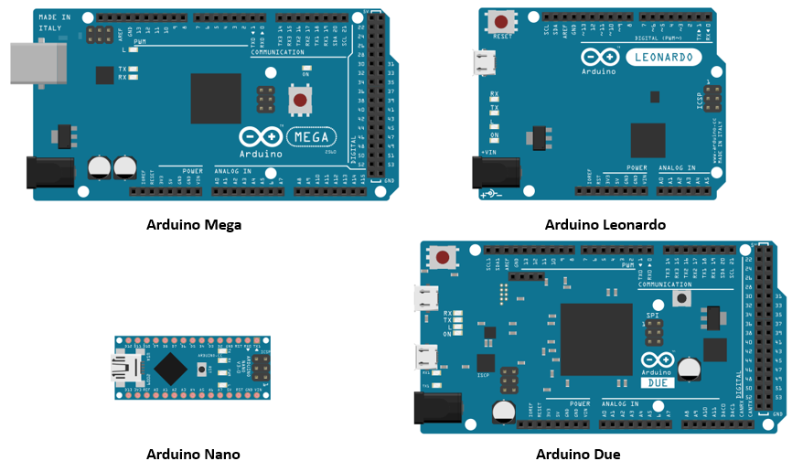
When looking for a microcontroller, it is important to look at different microcontroller options to have our project running and be able to do what is needed to do, such as displaying the voltage percentage. Some of the microcontrollers we look into are the Arduino. Arduino boards are very common in different projects since it includes a lot of free open source software. Free hardware is defined as devices whose specifications and diagrams are accessible to the public, allowing a lot of users to replicate them or modify them. This means that Arduino provides a foundation for anyone or any company to develop their own boards, which can be unique but equally functional when built on the same foundation.
Figure 11. Arduino Models

These boards can be readily attached to various modules such as obstacle sensors, presence detectors, fire sensors, GSM modules, GPS modules, and so on. Because this board functions as a tool, its primary job is to control electronics by reading inputs and converting them to outputs. There can be different types of boards, however, they can all use the same IDE. Some of the most Arduino boards include Arduino Nano, Arduino Uno R3, and Arduino Micro, others are shown in Figure 10. Some of the main characteristics for each are:

- Arduino Uno R3: This Arduino board is powered by an ATmega328P microprocessor. When compared to other types of arduino boards, this one is incredibly simple to use and has 14 digital pins. Apart from all current Arduino Boards, the Arduino Uno is the most often used board and the standard shape. This board is really beneficial to beginners.

- Arduino Nano: This is a small board based on microcontrollers such as the ATmega328P or the ATmega628 but the connectivity is the same as the Arduino Uno. This type of microcontroller board is compact, long-lasting, versatile, and dependable. This board primarily consists of analog pins-8, digital pins-14 with the set of an I/O pin.

- Arduino Micro: The Arduino Micro board is primarily based on the ATmega32U4, which has 20 sets of pins, 7 of which are PWM pins and 12 of which are analog input pins. This board comprises several components such as an ICSP header, RST button, a small USB connection, and a crystal oscillator with a frequency of 16MHz. The USB port is built-in.

- Arduino Mega: It has several digital I/O pins, six analog inputs, a reset button, a power jack, a USB connector, and a reset button. It includes everything needed to support the microcontroller; simply connect it to a PC through a USB wire and power it up with an AC-to-DC converter or battery. This Arduino board's large number of pins makes it ideal for building projects that require a large number of digital i/ps or o/ps, such as several buttons.

Most of these boards are available online and are available in different versions and prices. Furthermore, they vary in size, processor, memory size, and the number of pins.

Arduino can be used to develop generic elements, as well as connect to devices and communicate with both hardware and software. Arduinos are able to read inputs, turn on a motor or follow different directions. The microcontroller includes communication ports as well as input/output ports, which allows users to connect various types of peripheral devices to the board. The information from these connected peripherals will be forwarded to the microcontroller, and it will be in control of handling the data coming through them.

Users can instruct the board what to do by sending a set of instructions to the board’s microcontroller. Some of the important features for our project lies in the microcontroller, which allows us to build programs in either java, C, C++ or python programming language, and this way be able to talk to the LCD to display a text or image. Some of the common and basic functions in Arduino are being able to read and write the digital value of the given pin, the analog write pin writes the value of the pin and the analog read pin reads and returns the value. The best way to choose an Arduino board is to examine and distinguish the trade names on the original boards.

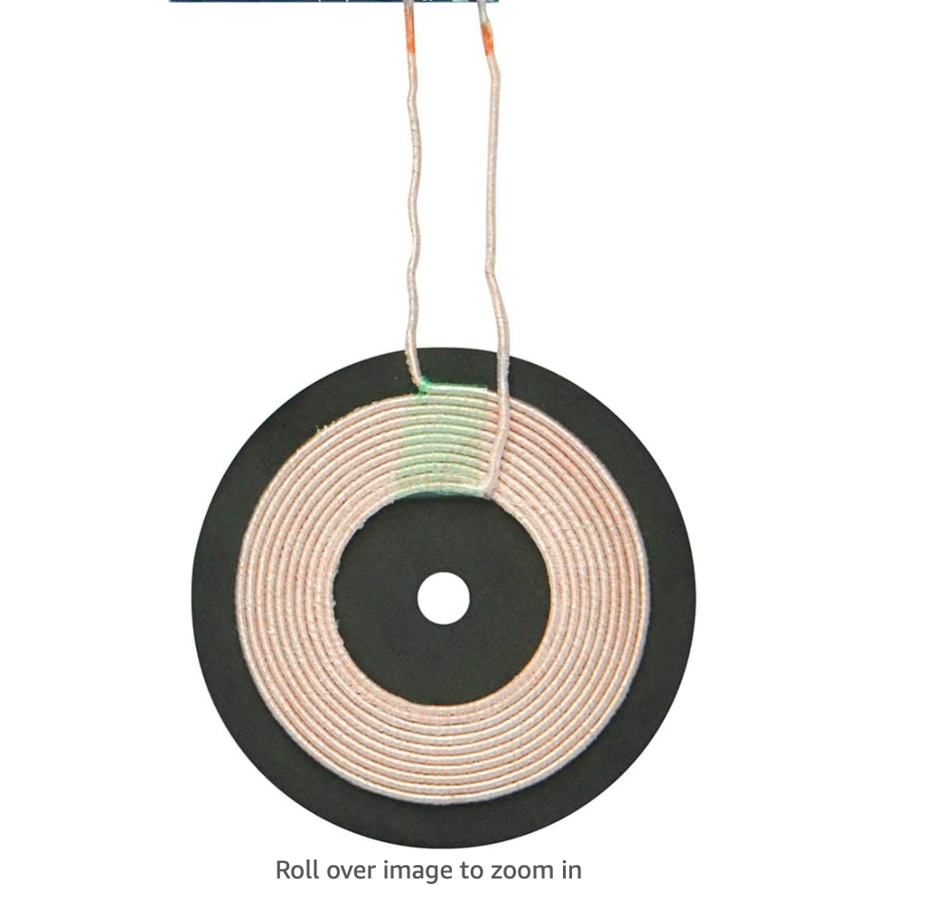
3.1.7 Wireless Charger

Wireless charging has the advantage of eliminating unnecessary cords and allowing for more flexible phone positioning. Wireless chargers have been around for a while and have become more popular since the iPhone x and 8 , although many Samsung and Google phone customers have been relying on charging ports for years. As long as the phone is within range, the cellular device may be put in various locations on the wireless charger and it will still operate. Wireless charging technology has become more feasible and competitive in the market as the price of electronic components has decreased due to technological advancements. One of the advantages of people using qi charger is that users won’t require many cables lying around.
Figure 12. Wireless charger

The power transmission is the first notion to grasp in the wireless charging procedure. Wireless charging requires the presence of two components: a transmitter and a receiver. The first step in creating a circuit for this project is to understand how wireless charging works. Wireless charging, at its most basic level, necessitates an AC supply and coil on the transmitter side, as well as a coil on the receiver side. To power the load, the receiver takes the electrical signal, rectifies, filters, and controls it. Adjusting the magnetic field's power is the key to controlling it. Wireless charging, also known as inductive charging, is based on electromagnetic fields that transmit energy from one location to another. Electromagnetic induction is the term for this. A copper coil generates an oscillating magnetic field that may be sent wirelessly, while a second coil transforms the floating field back to energy. A transformer, or a device that transmits energy between two circuits, is formed by the two coils.

Communication is also a key aspect of wireless charging. To establish the regulatory setpoint, communication between the transmitter and receiver is required. The communication and power transmission use the same coils. To improve battery performance, the communication can be expanded to include bi-directional communication. The mobile device must be positioned correctly on the coil, and when the transmitter identifies an item, it delivers an 8-bit data stream. The receiver will respond with a signal indicating the intensity of the field.

Object detection is another component of wireless charging that is crucial for reliable functioning. Metal items that come into contact with a wireless charging system may couple a portion of an electromagnetic field and heat up. The identification of foreign items around the system, particularly metallic or magnetic objects, is critical because of their propensity to absorb energy from the wireless power supply field in the form of heat and potentially pose a threat. When a foreign item is placed between the transmitter and receiver, a problem develops. The item warms up to hazardous levels, endangering both the consumer and the mobile device. According to simulations and studies, simply 500 to 1000 mW of power wasted in a metal item such as a coin, a paper clip, or a gold ring may elevate the object's temperature to 80°C. The transmitter will occasionally emit a magnetic field to detect the receiver, and if there is power consumption, the transmitter will know there is a device.

Checking if the power consumption matches what the receiver sends, as used in the Qi standard, is one technique to detect alien items. The receiver will estimate the amount of energy it expects to use, while the transmitter will compute losses and estimate the amount of power it will emit. Loss balance is the term for this procedure. The receiver will send the transmitter the quantity of power it received throughout the charging process. This information is used by the transmitter to determine the difference in power emitted and received. If there is a significant difference between these numbers, the transmitter will stop transferring power.

Magnetic resonance is another approach to wireless charging. It allows power transfer across wider distances between transmitter and receiver while increasing efficiency by varying the amount of energy that can be stored in each coil and coil size. The further a charge can travel, the larger the coil and the more coils there are. Magnetic resonance is significant because it truly severes the chord. It also enables the charging of many devices with a single set of coils.

These two distinct wireless charging technologies have lately come into play as major smartphone manufacturers decide which technology to embrace. The Qi Standard employs an inductive charging technology that employs tiny coils and short distances.

3.1.8 Voltage Boosting
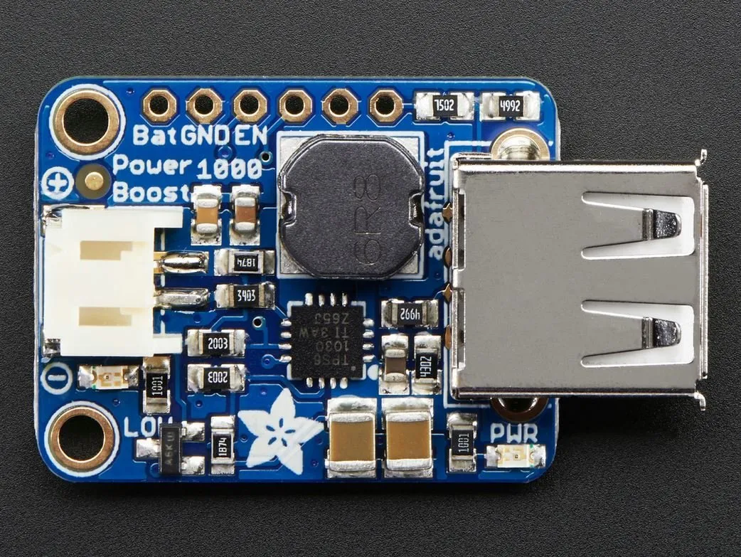
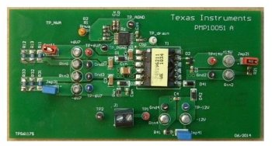
Many products that are created have specific components for specific features. In this project, the group considered and followed through with finding a part for the wireless charger. We researched the use of a voltage booster and how efficient it can be for the project. After researching, the voltage booster increases the output voltage through a load. The voltage booster stores energy in an inductor and causes it to be released by the load, resulting in a higher output voltage. Even though having a higher output voltage sounds like an amazing thing to have in the project, there are other factors that may be able to cause issues. The group is well aware of these possible disadvantages and will be prepared for any sudden outcomes during the prototyping and final stages of the project. Some of the possible and sudden outcomes with using a voltage booster include short circuits in the project, possible voltage overload as the voltage booster could possibly draw maximum voltage outputs and possible overheating. The voltage booster may have its downfalls, but with the proper steps, connections and calculations, the voltage booster should not cause any issues whatsoever and provide us with the extra boost of voltage needed for the project.
Figure: 13 Adafruit PowerBoost 1000 Basic
Voltage Booster
Figure 14: TI-TPS61175 Voltage Booster

Even though voltage boosters can be purchased as one module/component, there are many other methods to manually build a voltage booster in other instances. For example, an article online provided by Instructable Circuits [7] gives an illustration of a simple voltage booster circuit made by hand. As said in the article, this specific circuit has no implementation in a project due to the layout of the components, but it can be used as a reference for any project. The circuit has a switch, inductor, diode and a capacitor. With a large amount of current passing through the inductor because of the switch, a large voltage crosses through the inductor. The current charges the capacitor and since the diode presents any discharge from the capacitor, the result is an increasing voltage. This example provided starts at an input voltage of 3-9 V and outputs a voltage of 100-200 V. This simple circuit was not used for powering anything but could provide a shock to a person with a simple touch. As the group continued to further their knowledge on voltage boosters, we continue to learn and become more aware of using this device correctly and to our advantage in the project. Below is a table comparing these two voltage boosters.

Manufacturer/Model | Input Voltage | Output Voltage
Adafruit PowerBoost 1000 Basic | 1.8V or higher | 5.2V
TI-TPS61175 | 2.9-18V | 2.9-38V
Table 5: Manufacturers

3.1.9 3D-Printer Technology
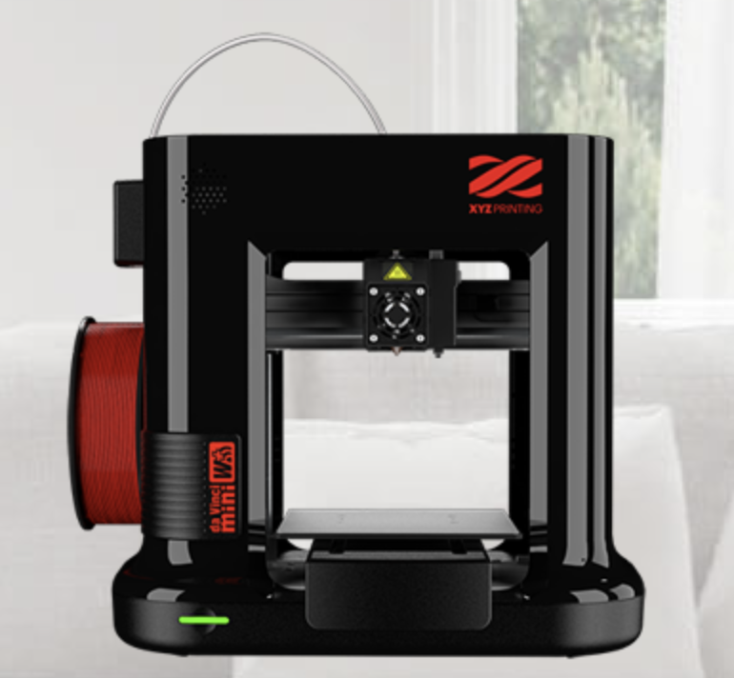
The theory of 3D-Printing has been around since the 1940s, where engineers were using inkjet type devices to print metal objects. Back then, however, they were extremely limited by the technology of their time. Nowadays, in the 21st century, we have all sorts of amazing technologies. Some 3D-Printers are mainly designed for home use, such as printing small toys, cups, or other small objects. Other printers, however, are actually considered industrial grade machines.

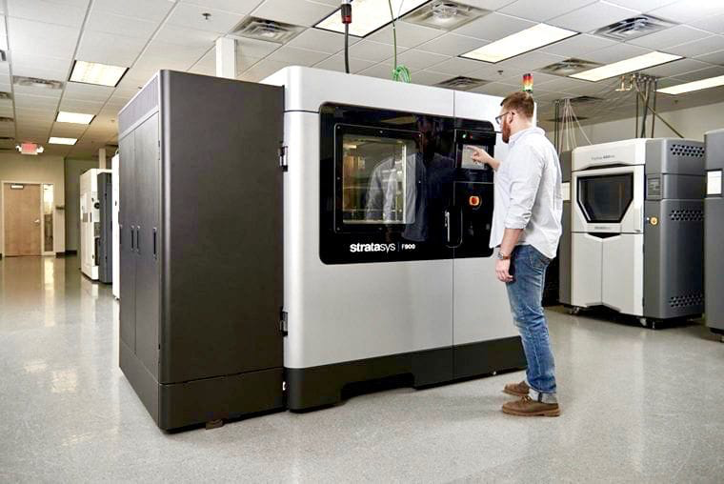
Although 3D-Printing technology still has a long way before it can be used everywhere and for everything, it has a huge potential. 3D-printing has numerous advantages including: speed, weight, ease-of-use, and durability. These are just a few of the many advantages presented by this emerging technology. First of all, modern industrial 3D-printers are extremely fast. Many companies are beginning to use 3D-printers to produce metal parts. Traditionally, companies would take a block of metal, and use a laser or other tools to cut out the shape of the desired item. This works, it gets the job done, but it’s terribly inefficient. 3D-Printing does things differently - the printer metals the metal block, and then prints the desired item layer by layer. This can be done quicker than traditional methods because the machine is not wasting time cutting out the excess material, it is simply printing exactly what is needed. Additionally, printing layer by layer allows the machine to save on weight because generally it will be less dense (depending on the desired item).
Figure 16: Industrial 3D Printer
Figure 15: Home 3D Printer

Adding on to my previous statements, this save on weight is also a save on materials. 3D-printers print only exactly what is needed. Therefore, there is no excess material like traditional methods. Also, going layer by layer saves on the material that is inside the item itself. All of this saved material equates to saved time and money (since companies will spend less time and money ordering more materials).

One of the biggest concerns companies and individuals have about 3D printing is durability. They think that because the materials are mostly plastic or they are made in layers, that it makes them weak. However, depending on the design of the model you are printing, 3D-Printing actually makes the design stronger. This is because the layers are interwoven together creating extremely strong bonds. This is extremely important for companies who wish to use 3D-Printing technology for automotive purposes. Car and truck parts need to be extremely durable to survive the rough and long environments they are subjected to. Thankfully, new and emerging industrial 3D-printers are capable of producing parts that meet this standard.

At this time, 3D-printing is still slowly being adopted. Yes, many companies and other individuals are using 3D-printers, but they are still working their way to large companies. The adoption of 3D-printing is slow for many reasons. First off, we have cost - 3D-printers have a load of benefits, and small home printers can be purchased for a couple hundred dollars. Industrial printers are very expensive, even for large companies. Additionally, companies already have systems in place that work! Eventually, the benefits of 3D-printing will outweigh the cost, but that is not the case just yet.

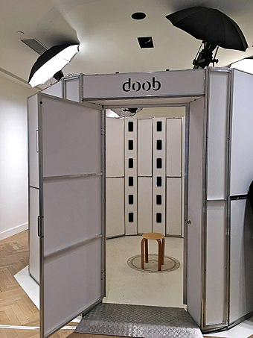
Another fun benefit to 3D-Printing is how the models are created. Many companies and home users have special software, such as AutoCAD, to develop models from scratch. This software is very important to create anything using a 3D-Printer. However, thanks to new tools and software, there are other more effective ways to create models. Some 3D-printer companies offer apps that use multiple pictures to create a model of an object. Also, there are entire booths filled with cameras that can automatically generate 3D models of anything you put inside the booth. This is extremely useful for, let's say, making a chair. It sounds silly, but it is a practical application. If we have a plastic lawn-chair we built, we can take that lawn-chair, and put it inside the booth. Then, this booth will take tons of pictures and compile a 3D-model automatically. Then, we can use that model and send it over to our industrial 3D-Printer to create a mass number of these to put on the market.
Figure 17: 3D Model Generator
One of the fun things about 3D-printing is users can select from a massive variety of material to print with. Most home printers, like the one we will be using for this project, use plastic. Industrial printers have the ability to print all kinds of metals, basically anything that can be melted. While testing the printer, we also selected a FDA approved plastic from XYZ printing (this is the same company our printer is from). This plastic can be used for silverware including plates, cups, and forks. We printed a cup, and the water stayed in it! Plus, it is perfectly safe for anyone to drink out of. One day, most people will have a 3D-printer in their home. This means that if someone needs an extra plate or cup, they can just print one! That is the excitement of 3D-printing, there are so many possibilities and we have barely scratched the surface. Although designing our project as a 3D model will be challenging, we are super excited to have the opportunity to work with this emerging technology.

3.2 Market Product Comparisons

To give ourselves a better idea of what we want our project to look like and for it to work, we must do a market comparison. There is always another comparable product accessible for each use in the realm of technology. It is common to look at different pros and cons of a product to quantify its usefulness, and price and accessibility is also a main aspect that customers look at. We listed some devices that are similar to what we want to work on in the sections below. Existing technologies incorporate solar power and batteries, but with various designs and different integration approaches.

3.2.1 White Kaiman Solar Panel Mobile Charging System

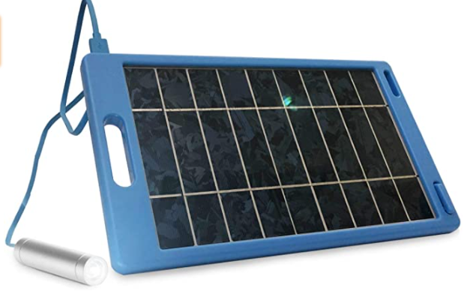
This White Kaiman charging system that I found on the market is unique because you can connect a USB device directly to the photovoltaic module without the need for a secondary battery. This makes things very simplistic, and it doesn’t have to siphon the voltage through an arduino like our project does. The price range for this system is $13 and we can see an example of it in Figure 10. Furthermore, this system is weatherproof and shatterproof, and the developers claim that they have thrown it in the air and even ran over it with a car and it still works perfectly, though they wouldn’t recommend you try this. Unfortunately we couldn’t find the exact water resistance rating, but the manufacturers claim that they’ve submerged the unit in water and it still works as intended, however we can speculate that the solar panel may not receive enough sunlight in the water, because water is a medium that warps light, and the specifications of the solar panel is only regulated at 5V. Moreover, the device provides 1A/6W of charging for any kind of device that charges with a USB cable.
Figure 18: White Kaiman Solar Panel Mobile Charging System

The package dimensions are 14.41 x 9.65 x 1.1 inches, and it weighs 2.19 pounds. As a bonus, a 3400 mAh backup battery bank is included in the package, and there is an LED flashlight in case you are on the go and need extra juice. 3400 mAh is around the standard battery size of most of the flagship phones right now, so this would be satisfactory. However, customer feedback implies that the panels only work in full sun, and by giving the system a little load the system will crash. They are not impressed with the 1A claim, and state that one should probably combine them in parallel so that the voltage would remain level enough for a USB connection. Additionally, customers say that you shouldn’t expect a quick charge, but it’s worth the price that they paid for it, which is $13.

In comparison to ours, this system is a bit more efficient and preferable. It may have the same charge time because of the 6W of output. The benefits of this system over ours is the weatherproof and shatterproof aspects, and how there is no need for a secondary battery. Furthermore, it can be submerged in water, and will still theoretically work. Additionally, the system comes with a battery backup which has enough juice to fully charge a phone from 0% battery.

On the other hand, some advantages of our system is that we will have an arduino reading the exact amount of voltage that the solar panel will be producing in real time. This means that a user will be able to deduce how quickly their phone will be able to charge based on the amount of sun our solar panel is getting. Another advantage of ours is that we’ll have a secondary battery source (not a battery pack) that will be charged by the solar panel when a load (phone) is connected to it, and on the arduino we will have an LCD displaying the battery’s percentage.

3.2.2 FosPower NOAA Emergency Weather Radio Portable Power Bank with Solar Charging

This $30 FosPower portable solar charger that I found on the market is quite unique because of the radio that it has attached to it, as seen in Figure 11. For starters, the frequency AM:520-1710KHz, FM:87-108MHz, WB:162.400-162.550MHz.The radio can provide access to emergency weather and news broadcasts, and has a 4 LED reading light and a 1W flashlight. Additionally, the IPX3 water resistance rating means that it is protected against spraying water when tilted up to 60 degrees. The dimensions of this product are 6.2 x 2.9 x 2.1 inches, so it is smaller than the White Kaiman and our system. There are many different power sources in this system. The system has a battery backup that has 2000mAh of charge, so it's about half or two-thirds of a charge from zero percent on a normal flagship phone. Additionally, it requires 3 AAA batteries, which are included with the package, and this provides power in the absence of light for the solar panel.

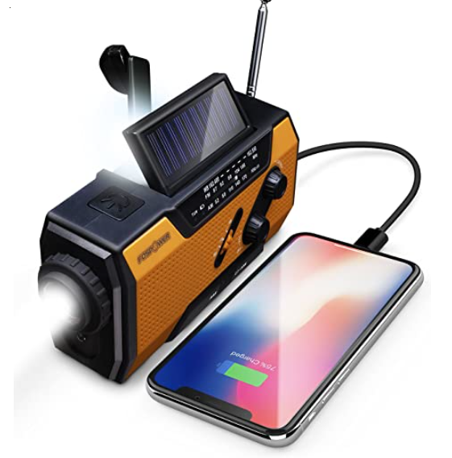
There are two ways to charge the battery backup. The first way of charging is by using the small solar panel on top of the module, which is rated 4V / 500mA / 2W, using the photoelectric effect to generate power. The second way is to use the regenerative crank on the side of the module to manually provide full battery power, and this ensures that you will have power whenever you need it. On top of the three power sources (AAA batteries, solar panel, and crank lever), there are five ways to power the radio. We’ve already mentioned the solar panel, AAA batteries, hand crank, and 2000mAh battery backup, the system also comes with a microUSB charging port, which can also charge the system. This provides a multitude of different ways of providing power, and there should always be a way that the system will have charge.
Figure 19: FosPower NOAA Emergency Weather Radio Portable Power Bank with Solar Charging

In comparison to ours, this system is advantageous because of how many different ways the system can gather power, whether it's the solar panel, crank, or AAA batteries. Additionally, the IPX3 water resistance rating is a nice benefit, especially if the purpose of the system is to be an outdoors emergency weather/news radio station. This enables the module to be used effectively in an outdoor environment. The system also has a variety of different features, including a flashlight, an LED reading light, and SOS alarm.

On the other hand, our system has some advantages. Our battery backup is rated at 10,000mAh, which is much larger than the 2000mAh battery on the FOS module. This means that we have up to 5 times as much battery capacity. Our solar panel is 8.3 x 4.4 inches and the rating is 6V / 530mA / 3.5W, which is superior. Moreover, we have an Arduino hooked up to the solar panel, displaying the voltage that’s being generated from the solar panel in real time on a small LCD screen. We will also have the battery charge percentage being displayed. Furthermore, we have a wireless Qi charger, which is better than the normal USB.

3.2.3 Solar Charger Power Bank 20000mAh, Solar Charger with Dual USB 5V Outputs & LED Flashlights

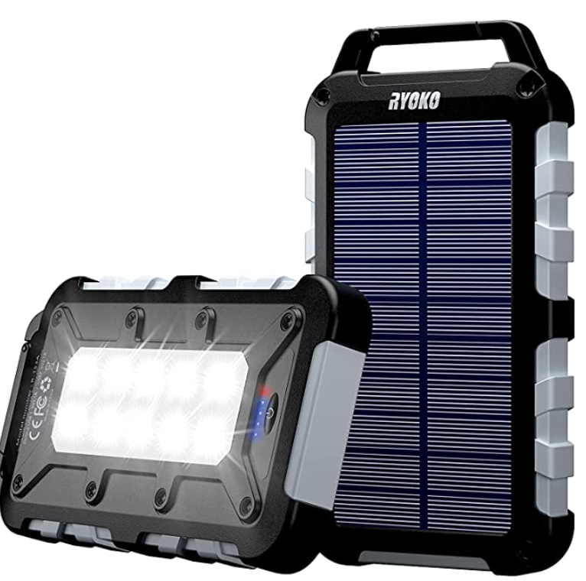
This $30 Solar Charger Power Bank is one of the best ones on the market because of its super large battery capacity. It’s a high density polymer cell, and at 20,000 mAh, this can store enough to charge a normal flagship phone six to eight times, and even tablets and laptops can be charged with it. Additionally, the dimensions of this solar panel is a mere 6.5 x 3.5 x 0.75 inches, which is very miniscule and portable. Not only is the system that small, but it houses a 20,000 mAh battery behind a solar panel rated at 1.5 Watts. The solar panel provides 5.5 V / 200 mA, and the system contains a variety of different features. It contains 10 bright LED bulbs to form a flashlight, and contains a built-in chip that protects devices against overcharge, overdischarge, excessive currents, short circuits or overheating.

The system has a multitude of different ports for charging devices. It has dual USB ports rated at 5V / 2.1A. These Dual Quick Charge 4.0 outputs are capable of delivering an optimized charge of up to 18W. This is ultra fast, and can fully charge a smartphone in a little over an hour. Technically, two devices can be charging at the same time. The battery will discharge power to the devices that are connected, while the solar panel will be used to recharge the battery. The module has another way to charge the battery backup, which is a Micro Input rated at 5V / 2.0A. Furthermore, 4 small LED’s on the back signify how much charge is in the battery, showing 25%-50%-75%-100%, which is great because you won’t have to guess whether it needs charge or not. Other features that the system has is an IPX4 water resistance rating, which means it is protected from splashing water, no matter the direction. The system is also dustproof, shockproof, and is enclosed in a fireproof casing. All of these features show that this device is perfect for an outdoor camping trip.
Figure 20: Solar Charger Power Bank 20000mAh, Solar Charger with Dual USB 5V Outputs & LED Flashlights

In comparison to ours, this system is advantageous because of its ultra fast charging capabilities. It can charge at ratings of up to 18 W, while ours can do almost around 4W maximum. This makes sense, considering our charger is a wireless Qi charger. Furthermore, the charging capabilities of this system is better since it can charge twice as many devices as ours can, and at a faster rate. This module also has a battery backup of 20,000 mAh, while we have a backup of 10,000mAh, so theirs has twice the capacity of ours. The IPX4 water resistance rating is also a big advantage over ours, since our system doesn’t have any resistance to water.

Some of the advantages of our system are that our solar panel has a stronger rating than that of this system. Their solar panel is rated 1.5W, while ours can sustain 3.5W. Since we don’t have the battery backup capacity that this system does, we make up for it by having a solar panel with a higher rating. This will enable our battery to charge faster. Additionally, our Arduino will display the amount of voltage that the solar panel is producing in real time so you’ll be able to make sure the system is operating correctly. The LCD display will also exhibit the battery backup’s real percentage, instead of just using 4 LED’s to signify 25-50-75-100%. Another advantage we have is that we have a wireless charger, which removes the need for any cords.

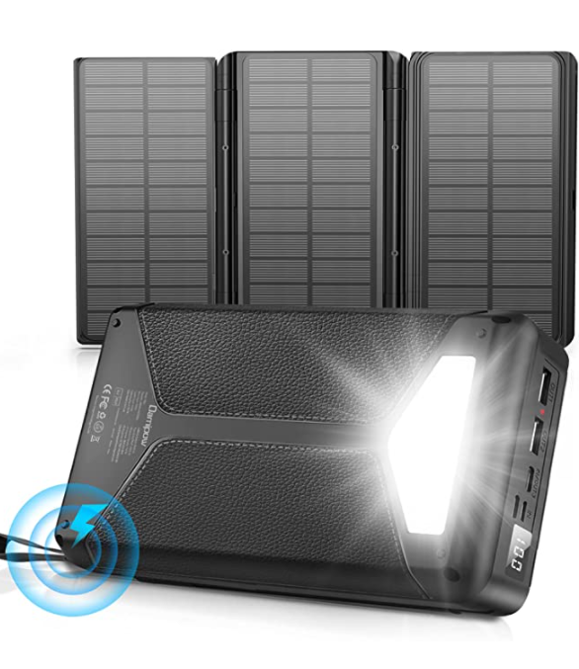
3.2.4 Solar Power Bank 26800mAh, Damipow Portable Wireless Charger Foldable Solar Panel Charger 4 Outputs 5V/3A USB Type C, Flashlight Waterproof External Battery Pack Compatible with iPhone & Android

This $40 Damipow portable wireless charger is one of the better systems we’ve seen on the market, largely because of the gigantic 26,800mAh battery pack. This massive lithium polymer cell can charge a regular flagship phone (iPhone or Android) five to six times consecutively, and can even charge an iPad three times. Furthermore, there are 3 different ways to charge the battery. One could use the micro B input, which is rated 5V / 2A, or they could use the USB-C input, rated 5V / 3A. These two are definitely the faster way of charging the battery, with the latter being the quickest. The third and final way of charging the battery pack is by using the three solar panels that fold out. Unfortunately, the ratings of these solar panels are not given. The dimensions of the system (before unfolding the solar panels) are 6.9 x 3.9 x 1.3 inches, making this device conveniently portable, and advantageous for outdoor camping use. Additionally, the system can be brought on planes because the battery bank 99Wh is lower than the restricted 100Wh to be carried on the airplane.
Figure 21: Solar Power Bank, Wireless Charger, Portable

Some more features contained in this system are the flashlight, wireless charger, and LCD display. The LED flashlight has three modes, normal, SOS, and strobe and you have to long press the power button for 2 seconds to turn on the light. Unfortunately, the ratings of the flashlight are not given. The wireless charger comes attached on the front of the solar panel module, which means the device can’t be charged using solar power while a device is wireless charging. It can still be charged by the input channels. Additionally, the wireless Qi charger charges at a rating of 5W. By turning the device on and placing your phone on the wireless charging area, the phone will automatically start charging. Moreover, the LCD displays the battery backup’s percentage which is very convenient since you don’t have to guess. You also know how much power the solar power bank can get from the sunlight, when placed under sunlight.

Another great feature is the IPX5 waterproof rating. An IPX5 rating basically means that the module can resist a sustained, low-pressure water jet spray. This is a better rating than all of the other solar charging modules that we’ve done research on, and can sustain much more powerful water blasts than ordinary rain.

In comparison to our solar charger, this one is far more advantageous in every way. Additionally, it has more features than all of the other market product comparisons we’ve researched up until now. We can start with the battery. Our battery contains 10,000 mAh, while this system’s battery contains 26800 mAh. Their battery has far more capacity, and the display even shows the battery backup’s percentage, while most of the other products we’ve done comparisons on don’t show this. Additionally, it shows the amount of voltage that the solar panel is producing in real time. These two features were the real selling points of our module.

Four devices can be charged at the same time using this system with the 3 USB ports and the wireless charger, while only one can charge on ours. Additionally, in this system there are two different methods of charging a mobile phone (wireless and USB) to our system’s 1 method. Furthermore, the flashlight has different modes of shine, normal, SOS, and strobe, and our system does not contain a flashlight. Lastly, the Damipow system has an IPX5 water resistance rating, and our module will have no water resistance whatsoever.

3.2.5 Market Product Comparison Summary

In conclusion, we have researched 4 different solar chargers on the market and have done comparisons on each of them. We chose a wide ranging priced variety of chargers so that we could get a sufficient understanding of the products already on the market. We found that each device has some kind of water resistance rating, with the lowest being an IPX3 rating. The first solar module was very cheap, and the amount of features reflected the price. It was a $15 device, and basically was one solar panel with a USB port attached to it. It also came with a 3400 mAh charger, which can only give the average flagship cellphone one full charge.

The second device, the FosPower bank, was $30 and it’s basically an emergency radio attached to a portable power bank. There are a multitude of different ways to charge that module, including a regenerative crank, batteries, a micro USB input, and the solar panel. However, it has the smallest battery backup out of all the devices we researched, rated at 2000 mAh, which is not enough to charge a flagship phone.

After these first two, we start moving into the higher quality devices. The Solar Charger Power bank has a massive battery backup, containing 20,000 mAh, enough to charge a phone six to eight times, or even tablets and laptops. Additionally, the two charging output ports have the capacity to deliver 18W of power, which would basically be the fastest charging setting of the current market phones right now. Another great feature of this system is that it’s the first one that we researched that actually displays a rough estimate of the amount of charge the battery backup contains. It has settings to display 25%-50%-75%-100%, which means you won’t have to guess/estimate how long your battery backup will last. Furthermore, up to three devices can be charging at the same time.

The final device that we researched was a $40 Damipow system, and was by far the best module that we found. With its humongous 26,800 mAh power bank, the system contains enough juice to charge a phone seven to nine times, including laptops and tablets. One of the greatest features of this module is that there is an LCD that displays the battery percentage and amount of voltage being produced, which was going to be the real selling point of our module. Furthermore, it’s similar to our system because it has a wireless charger that is rated at 5W.

 | White Kaiman | FosPower NOAA | Solar Charger Power Bank | Damipow Power Bank
Dimensions (inches) | 14.41 x 9.65 x 1.1 | 6.2 x 2.9 x 2.1 | 6.9 x 3.5 x 0.75 | 6.9x3.9x1.3
Price | $14 | $30 | $30 | $40
Battery Pack Capacity (mAh) | 3,400 | 2,000 | 20,000 | 26,800
Water Resistance Rating | IPX3 | IPX3 | IPX4 | IPX5
Battery Percentage Display | N/A | N/A | 25%-50%-75%-100% | Number Display
Flashlight | No | Yes | Yes | Yes
Solar Panel Rating |  |  | 1.5W
Wireless Charging Capability | No | No | No | Yes
Table 6: Product Comparison

3.3 Part Selection

The first part in designing the solar panel charger is to choose the parts that are going to be needed to put this together. This includes the various hardware components such as solar panels, battery, battery charger and others. We also explore how these technologies work, what they include and what other items we might need to include. Both the technical and non-technical components of the project must be closely connected in order to support one another in a mutually optimum manner.

3.3.1 Solar Panel

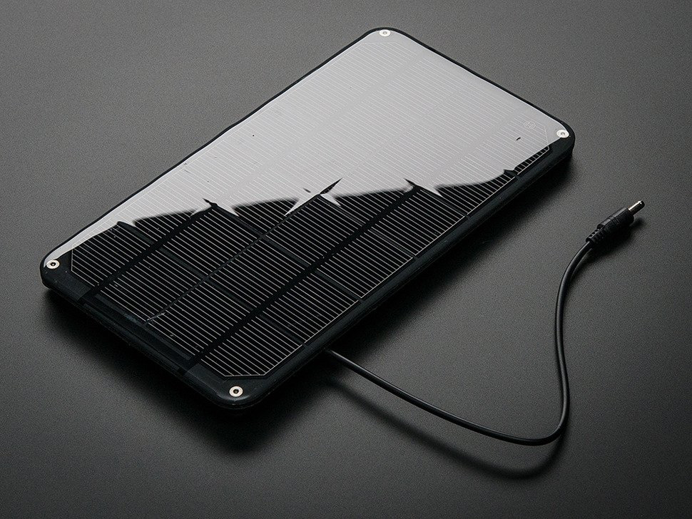
The solar panel is the main component in our project since we are trying to get solar energy in order to charge a phone. We needed to find a solar panel that could meet multiple requirements. Regardless of the manufacturer, we need a panel with a high enough power output to charge a battery and a phone at the same time. Also, we wanted to look for a solar panel that would have a long life cycle, since they can be perfect for the environment as they do not contaminate their surroundings or use fossil fuels in any manner. Solar cells have been shown to survive longer and have lower operating costs than many other alternative energy sources.
Figure 22: Solar Panel Image

Additionally, this panel needed to be as small as possible for portability purposes. Ensuring compatibility and functionality is just as important because all of our components need to be able to communicate and work together effectively. Although most components should work together well, if designed correctly, we still made an attempt to select as many parts from the same manufacturer as possible. This reduces our chance of error because the manufacturer can offer a better guarantee of performance since they test their own parts in multiple systems. Another requirement was looking for a solar panel with a DC barrel connector; this will allow us to connect with the battery charger described below.

Some of the solar panels we looked at where made of the following:

- Monocrystalline: Monocrystalline silicon wafers are formed from a conical silicon ingot manufactured in a lab. The ingot is created by melting silicon rocks at 2500 degrees Fahrenheit, followed by lowering a seed crystal to a molten slush. The seed crystal is gently dragged upwards while spinning as it is dropped. Because the ingot is circular, a lot of material is wasted when it is cut into the square shape of a solar cell. As a result, monocrystalline panels feature rounded corners to save waste. Round cells are used in older monocrystalline panels.Monocrystalline panels are the most space-efficient and long-lasting of the three kinds of solar panels.

- Polycrystalline: Instead of being derived from a single silicon crystal, they are derived from many silicon crystals. When polycrystalline silicon is sliced into wafers, there is far less waste material from the square ingot than there is from the circular monocrystalline ingot, making the polycrystalline production process less expensive. The manufacturing technique has a direct impact on the cost of solar panels, with monocrystalline being somewhat more expensive than polycrystalline. Due to increased production efficiency, the price differences between monocrystalline and polycrystalline panels are minor. They are also less heat tolerant, making them less efficient in high-temperature settings.

- Thin-Film: Though not as efficient as monocrystalline or polycrystalline panels, amorphous or thin-film panels have advantages such as being less expensive, lighter, more flexible, and sun tolerant. Thin-film panels convert sunlight into energy with considerably less semiconductor ingredients, resulting in a reduced production cost and lighter on the boards. Thin-film solar panels are manufactured from a variety of materials, including Cadmium Telluride and Copper indium gallium selenide, and are typically 2-3% less efficient than crystalline silicon. In comparison to silicon technology, these emerging technologies are still in their infancy. Within the next ten years, thin-film technology is expected to boost its efficiency from 10% to 16 percent.

In terms of prices we have put together a table that shows a more in detail description and we decided to compare three different panels from different companies.

Model | SLP190S-24 Silver Monocrystalline | Amerisolar AS-6P 340W Polycrystalline | AdaFruit Monocrystalline
Size | 62.2×31.8×1.38 in | 77 × 39.1 × 2 in | 8.3" x 4.4" x 0.2"
Cost | $245.00 | $212.00 | $45
Weight | 41.9 lbs | 50.7 lbs | 140g
Power Output | 190W | 340W | 3.5W
Current | 5.16A | 9.07A | 530 mA
Temperature Constraints | -(0.5±0.05)%/ °C | -0.41%/K | n/a
Annual output | 267 kWh/Year | 478 kWh/Year | n/a
Efficiency | n/a | 17.52% | 19%
Voltage | 24VDC | 37.5VDC | 6V
Table 7: Solar Cell Comparison

The solar panel we chose is the Adafruit Large 6V 3.5 W Solar Panel, which is shown in figure 15. The cells for this solar panel pack were created with the help of Voltaic Systems, and they make very high-end packs. The panels were designed to be waterproof, scratch resistant, and UV resistant. The cells themselves are monocrystalline cells, which are highly efficient as mentioned above, and it convinced us the most after researching the different materials.

The photovoltaic cell of the panel receives direct sunlight and transforms it to electrical energy. The panel can produce a voltage of 6 volts, and the charge passes through it at 530 mA through a 3.5 mm x 1.1 mm DC connector; this allows for a whopping 3.5 W output. What we liked about these panels is that it comes with a cell housing, the cell housing was made with durability and portability in mind because it was made from an aluminum and plastic composite. According to the manufacturer, the pack can survive being dropped and leaned on, as well as other typical outdoor conditions.

Additionally, the device comes with mounting holes and screws for added project compatibility. This will help us when mounting it on the side of our 3D printed prototype and still be able to attach it to the other components. The size of the solar panel is around 8.3" x 4.4" x 0.2", it will be a good size to adapt to and to think about when designing the 3D printed bouncing house. The cell is a monocrystalline with a cell efficiency of 19% or greater. The peak power is 3.69 watts, and the weight is 140 g. See the technical drawing below for more information.
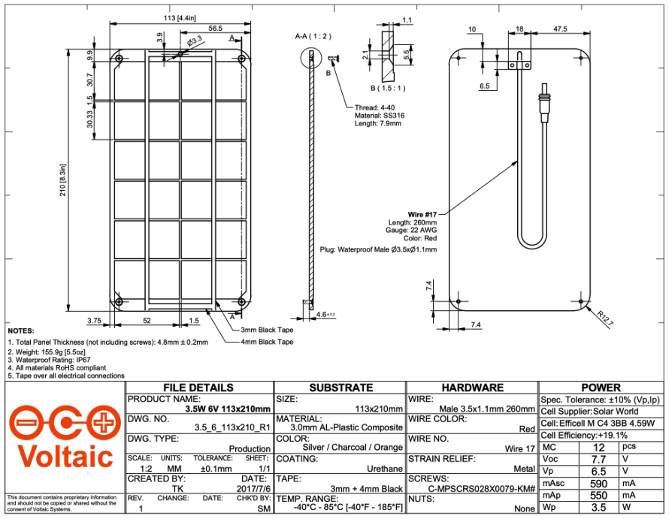
Figure 23: Solar Panel Technical Drawing

Overall, this was the perfect solar panel for us. It used the right connector, was a decent size, and had a high power output. This should be very effective when it comes time to build our prototype unit, and begin harnessing power from the sun.

3.3.2 Battery

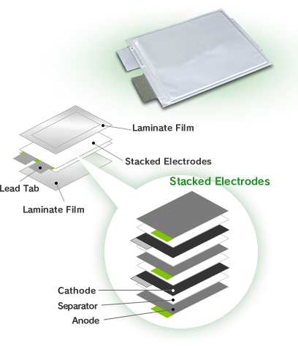
The battery is one of the main components we will need to make our system work. After looking at different batteries, comparing brands and specifications we decided to go for a battery that would be reliable and would output the necessary voltage. The battery will start powering the arduino and qi charger whenever the sun is not available to us, which can be whenever it is raining or if we decide to use our prototype indoors. We started looking at some batteries that would be long lasting, small, and rechargeable and we looked at lithium ion polymer batteries. A lithium ion polymer battery is the most frequently used battery because it is rechargeable and has a greater current capacity than others. These kinds of batteries are thin, light and powerful. When fully charged, the output voltage ranges from 3.7V - 4.2 V and the capacity is 10,050mAh for a total of 37Wh.
However, there can be different types of lithium polymer batteries such as:

- Lithium cobalt oxide battery: This is the first commercially available lithium battery cathode material. The lithium cobalt oxide battery features a solid construction, a high capacity ratio, and exceptional all-around performance. The rated voltage is 3.7V.

- Lithium-ion ternary battery: Compared to the battery above, this battery is not hazardous but the voltage is very low, with a nominal value of about 3.6V.
Figure 24: Battery Design

- Lithium-ion manganese oxide battery: This battery is very common for electric cars due to its high energy, power density, and long cycle life. Its safety and cost are fairly high.

- Lithium ion battery: The major benefits include high rated current, extended cycle life, superior thermal stability, increased safety, and tolerance for heavy usage. It also offers a high level of safety, a long cycle life, an abundance of raw material supplies, and low environmental contamination. A more in depth design is shown in figure 16, explaining the different layers the battery includes.

Lithium cobalt oxide battery | The lithium cobalt oxide battery has a stable capacity, great thermal stability, but at elevated temperatures its decomposition generates oxygen, which is dangerous because its an exothermic reaction
Lithium-ion ternary battery | The ternary lithium battery has high energy density, charge, and discharge efficiency, but is not resistant to high temperatures
Lithium-ion manganese oxide battery | The lithium manganese oxide battery has long-term reliability, therefore it’s used in electric cars and other devices. It has a very high temperature tolerance, and has stable discharge capability.
Lithium ion battery | The lithium ion battery has a very high energy density, meaning it packs a high energy capacity in a small size. This battery has a low self-discharge rate, and outputs constant full power throughout the discharge.
Table 8: Battery Comparison
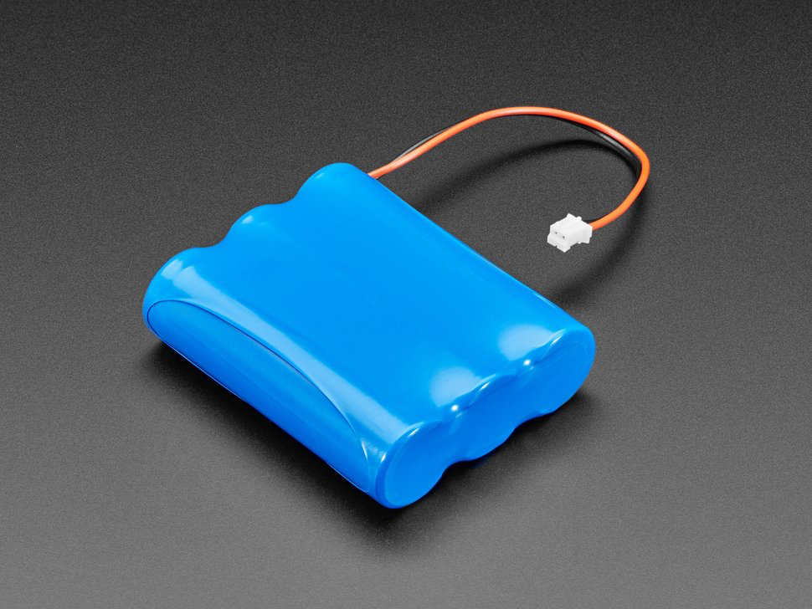

After our research selection, we decided on the battery and we picked the Adafruit Lithium Ion polymer battery, which is 3.7V and it is shown in Figure 17. We chose this battery because after looking at the comparison above, we found out this battery was long lasting and had little environmental impact. One of the advantages of picking this part is that it comes pre-attached with a 2-pin JST-PH connector. The battery includes a protection circuitry which keeps the battery from overheating and from overusing, as well as protection from output shorts. These kinds of batteries have higher specific energies than other lithium batteries and are frequently used in systems where weight is a consideration such as in mobile devices. The storage voltage for the Lithium Ion polymer battery is 3.7-3.85V, which will work for our project for when we don’t have access to sunlight. The battery will be able to power the arduino and qi charger. Lithium Ion polymer batteries, also known as LiPo batteries, can produce large amounts of current for high power applications while requiring very little maintenance.
Figure 25: Battery Pack Adafruit

In terms of charging, the standard charging time is 8 hours at a constant current of 0.2C, and constant voltage of 4.2V 0.01 C cut-off. In addition, the maximum constant charging current is 3000mA. The anode delivers lithium ions to the cathode while the battery discharges and provides an electric current, resulting in a flow of electrons from one side to the other. When the device is plugged in, the cathode releases lithium ions, which are absorbed by the anode. Polymer batteries utilize colloidal electrolytes, which provide more stable discharge properties and a bigger discharge platform than liquid electrolytes. However, one of the advantages of lithium ion batteries is that they lose charge slowly while not in use.

Lithium is also a reactive element, which means that it can hold a lot of energy. A standard lithium-ion battery can keep 150 watt-hours of power in 1 kilogram of battery. This makes them a considerably superior competitor to other forms of batteries, when compared to a lead-acid battery, which can only store 25 watt-hours per kilogram. The charge and discharge cycle of a lithium polymer battery can surpass 500 times under typical conditions. Because of its lightweight, minimal mold opening cost, and excellent safety, the lithium polymer battery is gradually increasing its market share. It will be very effective when used with our solar panel, arduino, and qi charger; the power input and output should be enough and efficient.

Although a lithium-ion battery appears to be ideal, it does have a few drawbacks and trade-offs when compared to other chemical types. The fact that a lithium-ion battery is the most expensive of all the possibilities is one of the most significant trade-offs that will affect the budget. To avoid operation outside of the cell's safe maximum charge, minimum charge, and temperature limits, Lithium Ion batteries require a battery management system. Overcharge protection, over-voltage protection, short circuit protection, over-temperature protection, and over-discharge protection will all be included in the Lithium Ion batteries used in this project.

Characteristics | Adafruit Battery Pack | EEMB Battery
Nominal Capacity | 9500mAh | 2000mAh
Discharge cut-off voltage | 2.5V | 2.7V
Maximum constant charging current | 3000mA | 2000 mA
Storage Voltage | 3.7 - 3.85V | 2.7 - 3.2V
Dimension | 2.6" x 2.2" x 0.7" | 1.36” x 2.2” x 0.41”
Continuous discharging current | 3000mA | 400 mA
Weight | 5.2 oz | 2 oz
Table 9. Battery Specifications Comparison

3.3.3 Programming Language

It is necessary to select a programming language that is suited for the project's specific requirements. The microcontroller that we are looking at is an Arduino and it supports different languages such as C, C++, Java and Python.

It's best to pick a programming language that makes the most of the hardware. However, if one piece of hardware has to connect with another via interrupt signals, the code may get complicated. The issue with long code is the difference between the quantity of flash memory required and the amount available on each piece of hardware. In the table below we compare and contrast some of the key factors for some of those programming languages.

 | Language
 | C | C++ | Python
Key Factors | Easy to learn.  Used to develop at a low level.  High memory management.  Most drivers are developed using C  More complex syntax  Variables are declared.  It is a compiled language  Contain 32 keywords  Doesn’t support inheritance  Doesn’t support exception handling | Object Oriented.  An extension of C.  Specializes in embedded firmware and client-server applications.  Mechanism for quick processing and compilation  Variables are declared  It is a compiled language  Contains 52 keywords  Supports both single and multiple inheritance  Supports exception handling | Easy to learn.  Advanced programming language.  Object oriented.  Integrating systems as a scripting or glue language allows you to work faster.  No need for variable declaration  It is an interpreted language  Contains 33 keywords  Supports all 5 types of inheritance  Exception handling is supported

Table 10: Coding Languages
Moreover, C programming is a language that is used to create low-level and system programs such as graphics packages, spreadsheets, word processors, compilers, assemblers, and operating system development. The C programming language may be used to address a wide range of technological requirements and is compatible with the Raspberry Pi and Arduino devices. One limitation of the C programming language is its lack of support for higher-order data structures. Memory management is an important aspect to consider when learning this language. To support abstract data types, advanced syntax is required. Most of our team members already have an idea of C programming, so this will be beneficial to start our project and code the Arduino. Even if we don’t have much experience with this language, it will be easy for us to learn and catch up.

On the other hand, Python is a sophisticated programming language that can be used for a wide range of tasks. Python is a simple language that may be used to develop quick code with no prior knowledge. It is based on semantics that are both flexible and resilient. It is very famous because there are many open source libraries you can use and work with.

Lastly, C++ is a middle-level programming language that is a C language extension. It is used to create computer programs, packaged software, games, office applications, video editors, and operating systems. The C language has the same applications. The C++ programming language may be used to satisfy a wide range of technological requirements and is compatible with the Raspberry Pi and Arduino.

All of these languages also have different types of main declarations. In both C and C++, the method of defining main is the same. We should return something integral at the conclusion of the code since we declared int main, where int stands for return type, so that it builds without errors. The code is usually written in between curly braces. Whereas in python you don’t need a main declaration unless you will declare a function. In python we don’t use curly braces for main.

In C and C++, the data type of the variable is declared first, followed by the name of the variable. Integer, char, float, double, and other data types are examples. Python is not a "statically typed" programming language. We don't need to define variables or their types before utilizing them. One of the advantages of python in this case, is that we don’t have to worry about knowing the data type before using the variable. An example of what the code looks like in each language is shown in the image below.

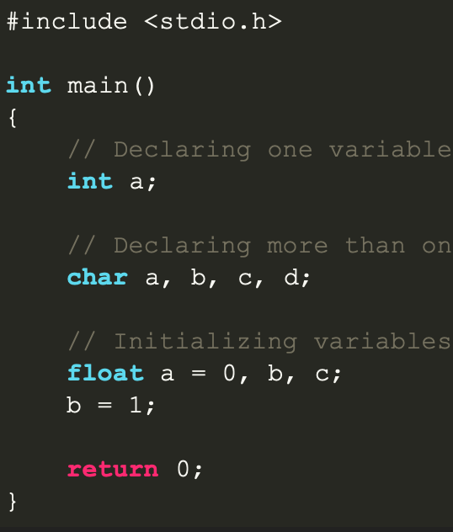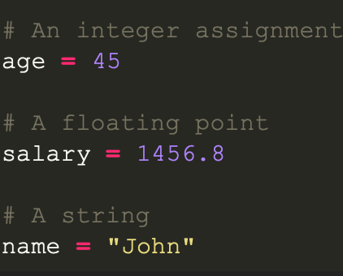
Figure 26. C, C++ and python example

The advantages of using an Arduino is that it is open source, its website contains tons of resources that include the use of variables, functions and runtime depending on the language that user decides to code on. There is also active development of the Arduino Software hosted in GitHub, where users can develop the microcontroller in any way they need it.

3.3.4 Battery Charger

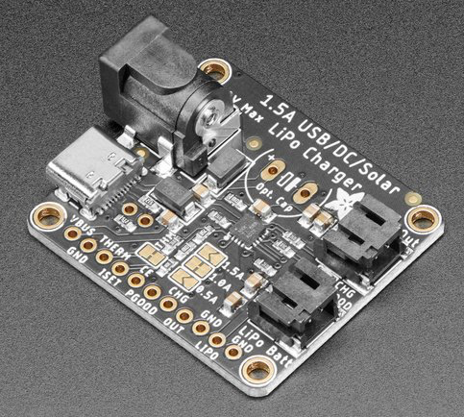
The battery charger is one of the most important components of any battery related system. This is because the charger is responsible for regulating the incoming voltage from the solar panel and distributing it evenly between the battery and the load (our load is the wireless charger and the Arduino). Additionally, this charger needs to transfer the voltage from the solar panel and reduce it to a voltage usable (and safe) for the battery to prevent any accidents from occuring. The reduced voltage will be applied to the load as well. We needed a battery charger module with a DC port for power from the solar panel as well as another power port to charge the battery from a wall outlet.

The battery charger module we selected for the project is the Adafruit Universal USB / DC / Solar Lithium Ion / Polymer Charger (bq24074). We selected this charger in particular because of how smart it is. First and foremost, this charger will always keep the battery topped off while preventing it from overcharging. The charger we selected allows for two modes of charging: DC and USB-C. The DC connection will be used for our solar panel, while the USB-C port will be left available in the event the user wants to charge the battery when there is no sunlight available. Also, when the DC and USB-C port are both connected, it will identify which one has the higher voltage and use that source. The DC and USB-C inputs are both capable of a wide voltage range: 5 V - 10 V. Even better, the model will reduce the current it is drawing whenever the input voltage drops under 4.5 V (this allows us to use a wide range of solar panels). This module was specifically designed for solar energy, however, the user can use a 5 V or 9 V charger for either the USB-C or DC ports.
Figure 27: BCM

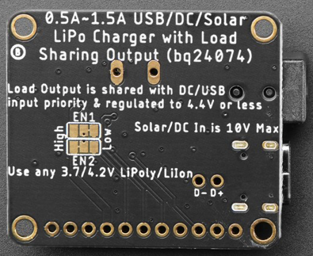
This battery charger module is all about convenience, starting with the manufacturer choosing to use a USB-C port. Most modern phones and devices have made the switch to USB-C chargers, meaning just about anyone will be able to charge our battery pack when sunlight is not available. The maximum input charge rate is 1.5 A, the maximum input voltage is 10 V, and the device is protected up to 28 V. However, it is important to note that the standard max charge rate is 1 A, but it can be adjusted between 500 mA and 1.5 A by soldering closed a jumper connection. When solar energy is available, the device will always draw the most current possible from the solar cell. Additionally, this module’s load output is regulated to never surpass 4.4 V, which means it is safe for 3.3 V regulators or 5 V boost converters. Unlike other chargers in its class, this one does not require a stabilization capacitor (although it can be added if needed). To prevent from unnecessarily discharging the battery, this module will switch to DC or USB-C inputs when available (to preserve battery life). The max load current is 1.5 A. There are two LED indicators on the module: one to indicate if the charger is working (Good LED) and another that tells you when the battery is charging (CHG LED - on when charging, off when battery full). This module will charge the battery and the load whenever solar energy is available.
Figure 28: BCM Underside

This device comes equipped with 4 ports: USB-C, DC, BATT, and LOAD. The USB-C and DC connections were discussed above; the USB-C requires a simple USB-C cable and the DC requires a DC barrel connector. The BATT and LOAD ports are both 2-pin JST (Japanese Solderless Terminal). These ports, and their corresponding cables, allow us to easily make connections between these modules without the use of a breadboard or soldering. However, if needed, the cable can be easily adjusted to accommodate for breadboard (or soldering) projects. As a final note, the manufacturer recommends using a solar panel between 6 V and 10 V (which works with our solar panel).

Battery Charger Module Specifications
Type | Measurement | Input | Output
Voltage (V) | Max | 10 | 4.4
Voltage (V) | Min | 5 | 3.3
Current (A) | Max | 1.5 | 1.5
Current (A) | Min | 0.5 | 0.5
Table 11. Battery Charger Details
We chose this battery charger module because it was a perfect fit for our project! It is optimized for solar panel use, it transfers the current efficiently between the load and the battery, and all for a great price.

3.3.5 Wireless Charger

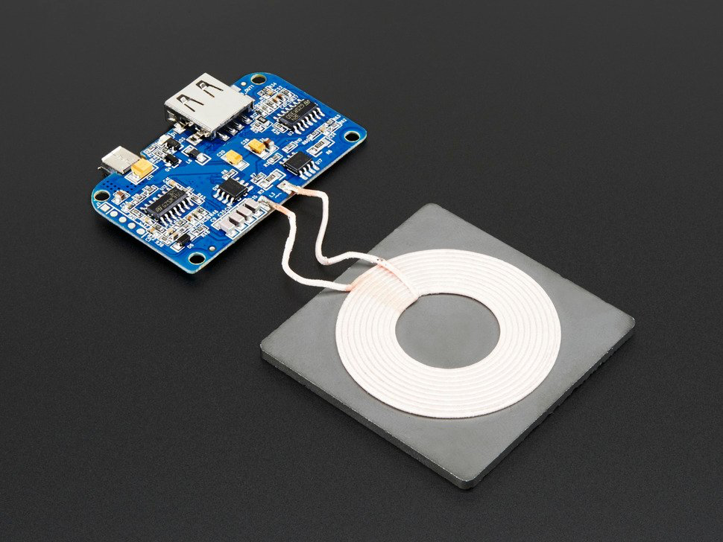
One of the most important components of this project is the wireless charger. This is because it is the actual component that is directly helping us reach our goal of charging a phone wirelessly. Wireless or inductive charging is a kind of charging that employs the utilization of an electromagnetic field to transmit energy between two devices by electromagnetic induction. In a dynamic electromagnetic environment, electromagnetic induction occurs when an electromagnetic force, such as voltage, is created through an electrical conductor. An inductive pad or charging station is frequently used with inductive chargers. When we first started looking for a wireless charger, our first objective was ensuring compatibility with the rest of the components. Therefore, we tried looking for a wireless charger from a similar company as the other components we ordered.

Additionally, we were looking for a charger with any kind of USB connector, although a DC barrel connector would work as well. Additionally, we needed this charger to take in an input of 5 V because that is what the Voltage Booster outputs (as described below). One of our other goals was obtaining a charger with a 5 W charge rate; this is because this is the low end of the standard for Qi charging. The Qi wireless standard is what allows smartphone wireless charging technology. The Wireless Power Consortium established the Qi standard, which uses a wireless charging station in conjunction with a compliant device to induce charging by electromagnetic induction. This charge rate will charge a phone, but modern cell phones will charge at a very slow rate. Unfortunately, we do not have the input power to allow us to use a higher wattage Qi charger (standard for Qi is between 5 W and 15 W). Additionally, we tried finding a wireless charger with a decent range; this will allow us to hide the charger underneath a surface. If the charger has a big enough range, we can hide the charger underneath the stadium.
Figure 29: Wireless Charger

The wireless charger we chose is the Adafruit Universal Qi Wireless Charging Transmitter. This charger requires a 5 V power supply which will be supplied through a microUSB port. Additionally, this module has a USB-A port for sharing the power, this allows us to add a separate cable charger to this module too, just in case we need to charge via a cable for testing or if we need to charge two devices simultaneously. The maximum output is around 5 W, which is 1000 mA at 5 V. This should be enough to charge most phones at a decent rate. The charging distance is 2 mm - 8 mm; this is a pretty small gap, but it should be enough to get through the stadium walls and through a slim phone case. This device was designed to only charge one phone at a time. This qi charger that we found is very good too because of its foreign object detection technology. It detects the presence of foreign metal objects in the vicinity of the wireless charging system and disables wireless power transfer when energy leakage exceeds a specified threshold.

Technical Details | Adafruit Qi Wireless Charger | Gikfun Qi Wireless Charger
Input Voltage (V) | 5V | 5V
Input Current (A) | 2A | 2A
Maximum Output Power (W) | 5 | 5
Operating Frequency (kHz) | 100 - 200 | NA
Charging Distance | 0.078 in - 0.3149in | 0.078 in - 0.3149in
Charging Plate Dimensions | 2.1 x 2.1 x 0.2 | 4.25” x 3” x 1
PCB Dimensions w/ Components | 2.2 x 1.5 x 0.2 in | NA
Weight | 1.6 oz | .81 oz
Price | $26.95 | $15
Needs to be soldered | No | Yes
Table 12. Technical details

This charger was perfect for our needs. It requires a 5 V supply, charges at a rate of 5 W, and has an additional charging port. This should serve well in the overall project, providing enough voltage to power and charge any device placed on the charger.

3.3.6 Voltage Booster

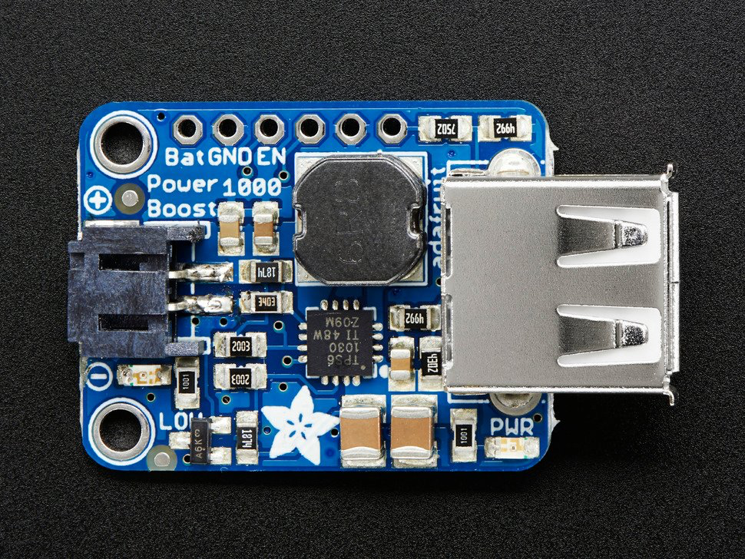
To reach the voltage needed to make our product work we need a voltage booster, we need enough power for the Arduino and charging components. We were looking for something that could be small and portable to complement our idea of a portable solar charger, as well as something to keep our project running while also recharging the battery. The voltage booster is a very important component in our project, since this would ensure that we would have enough power and current. We needed something that would be efficient and have enough power and control pins.

After looking at different voltage booster options we decided to go for the Adafruit PowerBoost 1000 Basic. We mainly decided to go for an Adafruit voltage booster, because a lot of our parts are from the same manufacturer so this ensures compatibility between all of them. It is a DC/DC boost converter module that can run from a 1.8V source and convert it to 5.2V DC. The 5.2V is suitable for all 5V-powered systems such as Arduino or Raspberry Pi, which in our case we will be using an Arduino, while eliminating unpleasant brown-outs caused by USB cable resistance during heavy current demand. The 1000 version includes a 2-pin terminal block that can be soldered to the output location where the USB connector would be.
Figure 30: Voltage Booster Adafruit

This product includes a couple of power pins and control pins as well as LEDs to show the power state. The USB connector included is a 5V power pin, this pin is perfect to charge the battery. The BAT connection is the battery input, which is directly linked to the JST connector. It will range from 3.0 V when it is pretty close to being dead, to 4.2V when fully charged, at least for most Lithium batteries. Higher voltages allow you to take higher current and are more efficient. The Vs pin is the battery charger's load shared output. When 5V is applied to the micro-B USB power connector, this pin will contain about 5V on it as well. When there is no USB charging, the voltage on the Vs pin is the same as the voltage on the Bat pin.

For a more compact power pack, you can skip the connections and go with 22 AWG wires soldered directly in. This voltage booster includes a TPS61030 boost converter from TI, which helps with low battery detection, it includes a 4A internal switch, synchronous conversion, and it has high efficiency, it also has a 700KHz high-frequency operation. It includes an indicator of low battery when the voltage drops below 3.2V, the LED turns red, making it ideal for LiPo battery use, such as the Adafruit Lithium Ion polymer battery we are going to be using. The synchronous conversion means you can disconnect the output by having the enable pin (EN) connected to the ground and it will completely turn off the output. Overall, we think this voltage booster is going to be a great addition to our components and it will help our battery and charger work well together with a good voltage output.

Specifications
Input Voltage | 1.8
Output Voltage | 5.2V
Dimensions | 1.1" x .9" x .1"
Weight | 6g
DC current | 2000mA from a 3.7 LiPo battery
Charging rate | On-board 1000mA charge-rate
Frequency Switching | 600kHz ~ 700kHz
Table 13. Voltage booster

3.3.7 Charging Cable

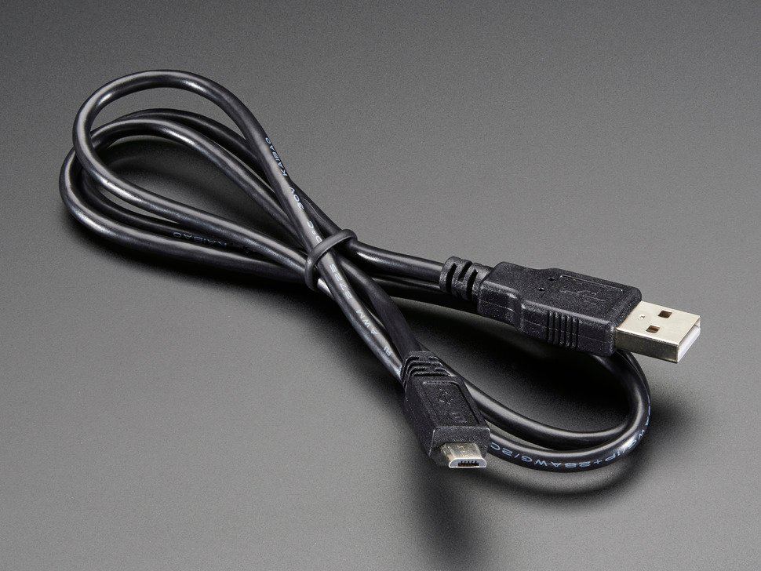
We needed a charging cable that would connect the voltage booster to the wireless Qi charger. The voltage booster uses a USB-A output and the wireless Qi charger has a Micro-B USB input. Therefore, we needed to find a cable that would connect USB-A to Micro-B USB.

The cable we chose is the Adafruit USB Cable - USB A to Micro-B. We chose this cable because it has the connectors we need: USB-A and Micro-B. Additionally, this cable can be ordered from the same company that we are ordering other parts from, which will save on shipping costs. This cable is approximately three feet, or one meter, in length. We will be using it to connect our voltage booster to our wireless Qi charger, but in reality, this is a standard cable that can be used for any other purpose as well. Finally, this cable is extremely cheap in cost, coming in at $2.95; one of our main goals is to keep the project costs as low as possible while providing a functional and appealing device.
Figure 31: USB Cable

3.3.8 Arduino Uno R3

Technical Details Comparison
 | Arduino Uno R3 | Seeeduino V4.2
Microcontroller | Board based on the ATmega328P | ATmega328P
Input voltage | 7-12 V | 3.3 V
Digital I/O pins | 14 | 14
DC current per I/O pin | 20 mA | 40 mA
Clock speed | 16 MHz | 16 MHz
Size | 2.7 in x 2.1 in | 4.5 in x 3.1 in x 0.98 in
Table 14. Arduino Comparison

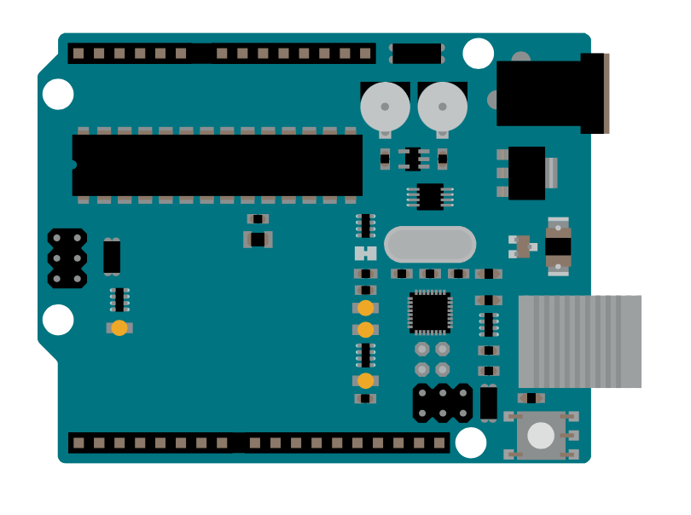
We wanted to look for a microcontroller that would be affordable, easy to work with and one that would require enough voltage to have our prototype working. We also wanted to ensure compatibility between most of our components. We decided to work with an Arduino, however, there are different models for Arduino that we could choose from and we compared different models as shown in the table above. We wanted an Arduino with a good size, voltage and an Arduino that we could do a lot with. For our project we decided to go with the Arduino Uno R3, which is a microcontroller based on the ATmega328. The advantage of having the ATmega328 chip is that it is high performance, lower power and it can be easily replaced since it is not soldered to the board. Additionally, it includes a 1kb of EEPROM memory, which is not wiped when the device is turned off.

Arduino boards are highly popular in many applications since they offer a lot of free open source software. This microcontroller has a 16 MHz crystal oscillator which provides the clock signal and basic timing and control to the board, 14 digital input/output pins and has a recommended input voltage of 7-12V, a USB connection that serves as both a power source and a communication channel, a power jack, an ICSP header, and a reset button. Moreover, the Arduino Uno has communications like UART serial, SPI and I2C. It also features six analog I/O pins, each with a resolution of ten bits.
Figure 32. Arduino Uno R3

We plan on putting the microcontroller to sleep whenever we don’t have a phone charging or possibly having an on/off switch to reduce battery usage. The Arduino UNO includes built-in voltage regulation and power management. In contrast to older boards, the power source is chosen automatically. You can power it directly with a USB cable or an external power supply. We will be using a breadboard to test connections between the Arduino, solar panels and charger, that way it will be easier to change things around and modify them without having to solder.

The advantage of working with an Arduino Uno is that it is primarily made and used by beginners for electrical projects and programming so we should not have that much of a problem when working with it. To make the board fit for the project's usage, the board undergoes frequent innovation and a bug correction in the design. It has two types of memories: program memory and data memory. The data is kept in data memory, while the code is kept in flash program memory as we can see in the image architecture below. The Atmega328 microcontroller contains 32kb of flash memory, 2kb of SRAM, and 1kb of EPROM and runs at 16MHz. We can see in figure 24 a lot more detail of how the Arduino Uno works and the processing details, which convinced us even more to choose this piece.

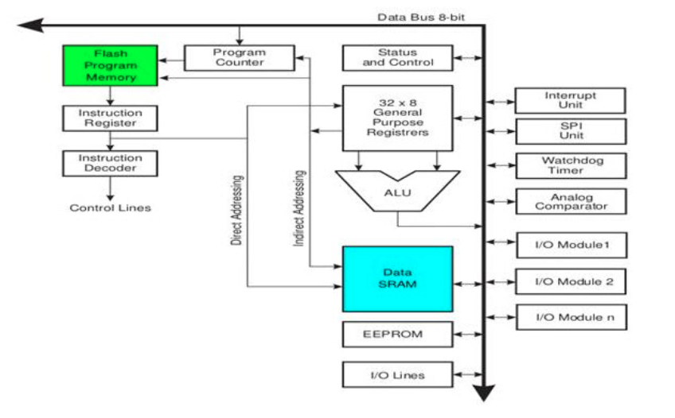
Figure 33. Arduino Architecture
One of the purposes of having an Arduino is so that we can code it and can track the battery percentage and display it using the LCD. You can use different software to code the arduino, some of the most common are the Arduino IDE, Arduino CLI and a web editor, they can all be coded online and offline. Since the amount of light received by the solar panel from the sun determines its voltage output, we might need to use a voltage regulator in order to supply a constant voltage to the arduino.

An advantage of using a microcontroller such as Arduino is that since it is open source, the code for the hardware is always being updated on GitHub making it up to date and the users can also modify it in any way they may require it. The Arduino software is available for any platforms such as Windows, Linux or MacOS. It is also possible to develop code in the cloud and use it for IoT projects. Users can either download a specific IDE to code or Arduino also provides the ability for users to code online and the software is being saved in the cloud. One example of the online IDE is provided in the image below.

Another reason why we chose the Arduino Uno, is because of its size, it won’t take much of the space in our design and it has the necessary connections for our qi charger and usb charger. Also, the price of the Arduino Uno R3 ranges from $15-$30 which fits into our budget system, although we already owned one from a previous starter kit. Furthermore, an advantage of having a microcontroller based on ATmega328 is that it can be user friendly and its logic is easier to understand when interacting with an LCD for user interface output.

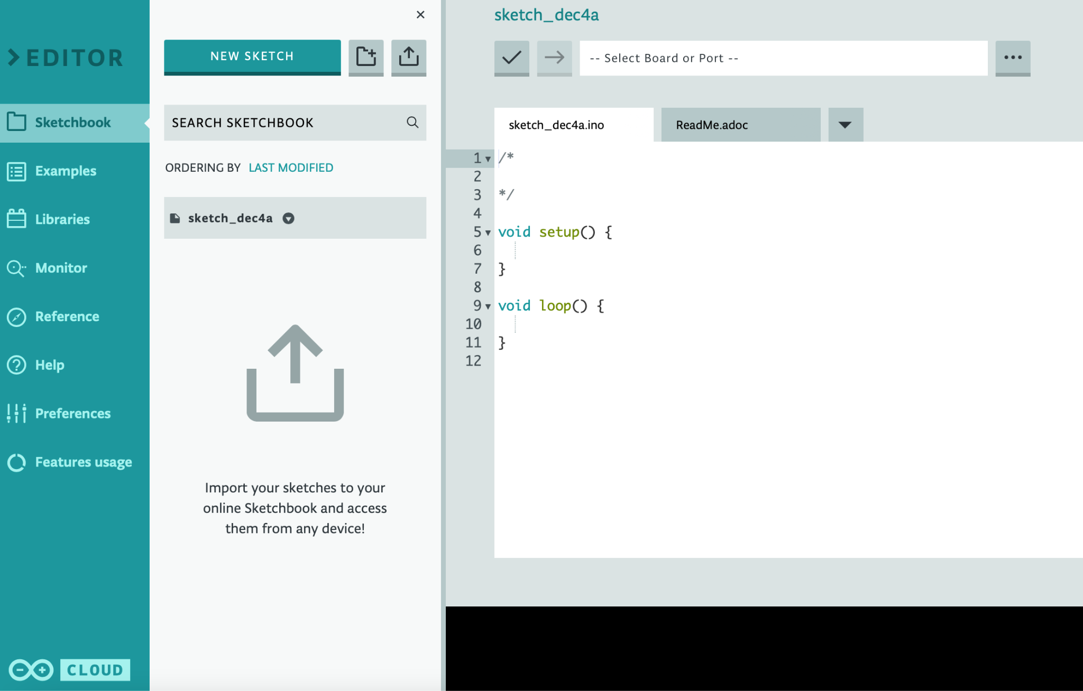
Figure 34. Arduino IDE and cloud

3.3.9 1602 LCD

One of our needs is that the power output be visible. As a result, the LCD display is a critical component, and certain parameters must be addressed while choosing the right display. The size of the display, the cost, the amount of power consumption, readability in outdoor conditions, and compatibility with the microcontroller we're using are all considerations we evaluate when choosing a display for the project.

Manufacturer | Arducam
Voltage | 5V
Part # | C0048
Module Dimension | 80mm x 35mm x 11mm
Pins | 16
Table 15. LCD Specifications

The LCD we selected for our project is the 1602LCD that comes in an Arduino Starter Kit, however, the price of an LCD ranges between $3-$9. This LCD has pins pre soldered so we don’t have to worry about soldering or messing things up in the process. It also makes it easier for testing and connecting it to a breadboard. Also, cost was an important factor when selecting parts and since it was included in the kit it fit our budget, and it will be perfect for testing and our developmental stage. During our coding process we will specify what pins we will be connecting to so that the Arduino and LCD work together. It is made up of 5x7 or 5x11 dot matrix positions, for each position it displays one character.

The number 1602 indicates that two rows of 16 characters each can be shown on the display, which will be perfect to display the battery voltage and percentage. LCD1602 connections are classified as eight-port or four-port. When the eight-port connection is used, all of the Arduino Uno board's digital ports are almost completely occupied. There will be no more ports available if you connect more sensors. The operating voltage of the 1602 LCD ranges from 4.7V to 5.3V. Moreover, it is alphanumeric, meaning it can display letters and numbers, helping us display any text if necessary and the battery percentage of our battery. To display anything on the LCD we might need a potentiometer to adjust the contrast, we will have to move it forward or backwards to adjust it.

3.3.10 3D-Printer

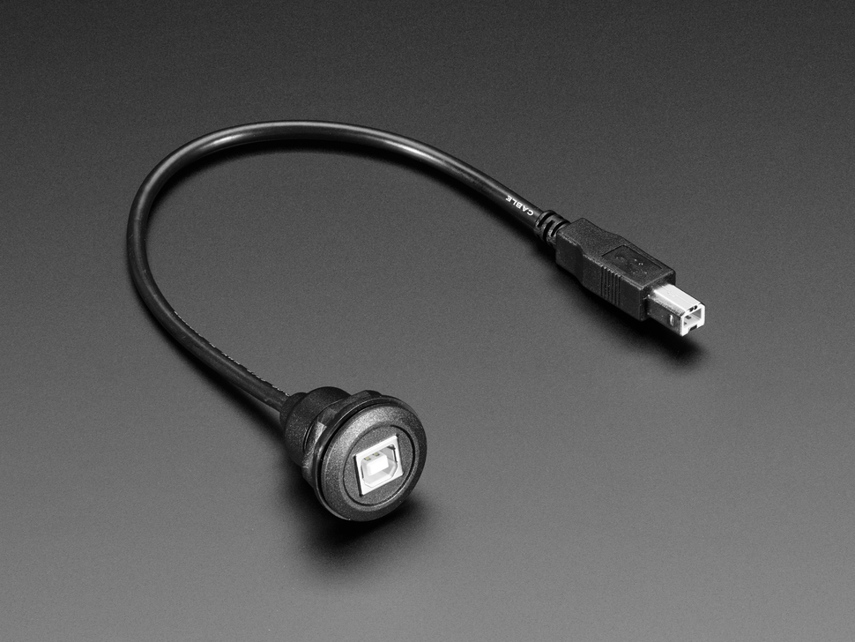
We needed to find a 3D-Printer that was capable of printing our stadium. The stadium itself will not be too complicated, so we do not require a very expensive and complex printer, just one that can print simple designs. Additionally, the printer will need to be compatible with multiple software options for design purposes as well as have multiple filament options (allowing us to determine the durability of our stadium design). The power of 3D-Printing is that a design can be printed in multiple parts and connected later with glue or another means. This means we do not have to spend hundreds if not thousands of dollars on larger pieces of equipment. As long as the printer can print a few inches of design at a time, we should be good to go (our stadium should be no bigger than a foot in any direction). We also wanted a printer that could connect wirelessly, and via a cable if needed, to a Mac or a Windows machine to allow any of the team members to print objects. Finally, we needed to find a printer that would be cheap; as students, we do not have a large budget - plus, we would like to save that budget to pay for other parts of the project.

The printer we chose is the Da Vinci Mini Wireless 3D-Printer. We chose this printer because it was the cheapest option: one of our team members already purchased a 3D-Printer for a highschool project, so we will reuse it for our Senior Design Project. By not purchasing another printer, we are saving a huge amount of our budget for the actual product we are creating.
Figure 35: Printer Cable (Used for Arduino and 3D Printer)

The Da Vinci Mini Wireless 3D-Printer can print objects within a 6 inch by 6 inch by 6 inch box (Length by width by height). Therefore, we should be able to print our stadium in very few separate parts - this is great news from a durability standpoint because we will have a more rigid structure without relying on glue or other means of connection.

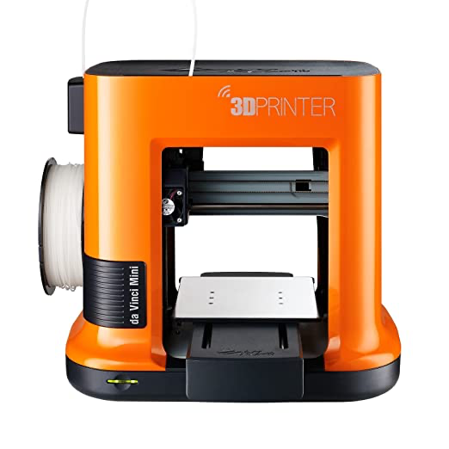
This printer is extremely simple and convenient because it is very much press and print. This means that all you need to do is send it your drawing, press start on whichever type of computer you are using, and let the printer do the rest. There are different colored LEDs on the front to indicate printing conditions (Solid green is done, flashing green is printing, orange means there is a problem or the user has paused the printer via the connected computer). We can connect to this printer in two ways: either via a USB-AB cable, pictured to the right, or via a wireless connection. When a user first connects to the printer, however, they will need to connect via a USB-AB capable before they can take advantage of the printer’s wireless capabilities. After the initial physical connection, the printer will be connected to the user’s home WiFi network, allowing the user to print from anywhere their WiFi can reach.
Figure 36: 3D Printer

To connect to the printer, the company (XYZprinting) created its own software called XYZware to connect to the printer over a cable and over a WiFI network. This is a more basic software that prepares whatever design you have selected for printing. This software will take your design, slice it up for printing in parts, send it to the printer, and then continue to monitor the printing status until it has been completed. This is a huge bonus for user simplicity and functionality because slicing up our design will be a major part of developing our product; the design will be too large to print all at once. Additionally, having one control hub to monitor the status and any issues that occur during printing is a huge plus. As far as printing design goes, the company offers multiple 3D design softwares, an entire gallery of designs, and even a curriculum for users to design 3D printable models. As we progress further in our project, we will further discuss the software solution we choose to design our model. Furthermore, we are going to take advantage of the gallery for design inspiration and learn how to use the software of our choice by watching and learning from the curriculum provided on their website.

In terms of filament, this printer is only capable of printing filament from XYZprinting directly. Unfortunately, this limits our selection of filaments to choose from. On the bright side, the company offers a huge variety of colors and types of filaments to choose from. This printer will only use bio-compostable, non-toxic PLA filament (this is great for the environment because the material is not toxic to us or the environment, and it will degrade if it ever ends up buried in the ground or washed into our oceans). One of our main goals was to help the environment with this project, so this was a huge plus for our team goals.

3D-Printer Dimensions
 | Length (inches) | Width (inches) | Height (inches)
Printer | 13.19 | 15.36 | 14.18
Printable Space | 5.9 | 5.9 | 5.9
Table 16. 3D Printer DImensions
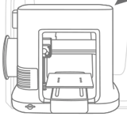
XYZprinting actually produces a huge variety of 3D Printers. Some of which are very similar to ours, while some are quite different. At this point, it is safe to say that we have a very basic printer. The da Vinci Mini is the smallest and simplest printer that they sell. Other printers are much larger and they have a greater printable space for printing designs; this means users do not have to separate their designs into as many parts. Additionally, many other 3D Printers have the capability of using multiple filaments simultaneously. This means that users can print designs in multiple colors. Our stadium for example, is really just one color: metallic gray. However, if we wanted to make a small model of the beach, we could use tan for the sand, blue for the ocean, etc. As much as we would love to own a printer with this kind of capability, it is out of our price range - we had to think economically here, not just about the best kind of equipment. I believe this is extremely important for any team project; determining what the team needs and does not need is crucial for maintaining a budget and completing the task on time. Anyways, the company also produces printers that are much faster than the one we have. Our printer will print anything we ask it to, but it will take time - other printers can create a complex design within the hour. The difference really is about how the printer operates. Most expensive printers drive their 3D Printer module by a series of belts and high powered motors. Ours works in a similar fashion, but it reduces the series of movements necessary by moving the board that the project sits on as well. This process greatly reduces the cost of the machine, and allows us to still create amazing projects.
Figure 37. Printer Schematic

This printer was a perfect choice. Not only did we not have to dip into our budget to buy it, but it also suits our needs perfectly. It can print in nice sized parts, it uses environmentally friendly filaments, and it is very ease-of-use focused. We are looking forward to beginning the printing process.

3.3.11 3D-Printer Filament

While looking for a filament, we knew we needed to find one that was compatible with the 3D-Printer we had selected. Additionally, we wanted to use a filament that was environmentally friendly as possible. Our 3D-Printer can only print using one filament at a time which limits us to use only one color for our design. We also needed a filament that was not crazy expensive to help keep our costs as low as possible while still providing a durable product.
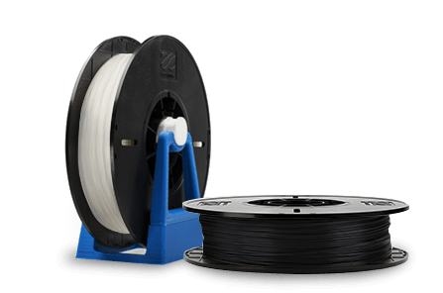
The filament we chose was PLA filament from XYZprinting. The main reason we chose to purchase filament from the same company we bought our printer from is because that is the only filament the printer will support. This filament produces high quality prints with a great durability. The filament is made from bio-compostable materials too, which helps us to reach our pledge of helping the environment whenever possible while building our project. Plus, 600 g (21.16 oz) of this material comes in at $22.95 - as far as filament prices go, this is a very competitive price. In order to reduce the price of our project, we were looking for a cheap yet durable filament.
Figure 38: Filament

The greatest part about the filaments produced by XYZprinting is there are so many options! For example, in a high school project, we were using the 3D-Printer to design objects. For this project, we decided to design and print a cup that could actually be used by a person to drink out of. We designed and printed the cup, but what really made this project different was the filament. Unfortunately, most plastics are not FDA approved, which means they cannot be used as eating and/or drinking utensils. However, XYZprinting offers an FDA approved filament. We used this filament for our cup and we were able to drink water out of our cup.

These filaments are perfect for our project because they are:

- Affordable, they beat out market competitors

- Durable. The PLA filament is extremely strong, it will protect our components from any damage

- Customizable, there are so many different colors and styles of this filament available from XYZprinting’s website

- Environmentally friendly, these spools are made from biodegradable materials that will be non-toxic for humans as well as other plant and animal life

3.3.12 JST Jumper Cable

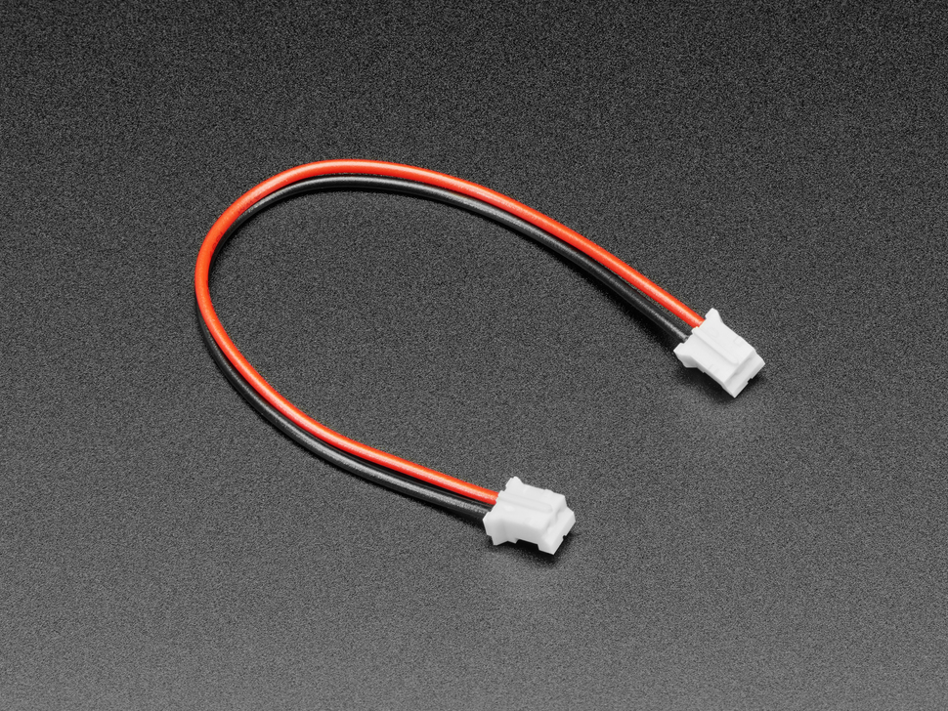
We needed to find a cable that could connect our battery charger to our voltage booster. This cable needed to be compatible with ports on both modules. Thankfully, both of the modules we ordered - the battery charger and voltage booster - use JST connectors. Therefore, we need to find a cable with a JST connection on both sides. The benefit of JST is that it can be broken up if required; this can be done because it is simply a positive and negative line with a connector on each end.
Figure 39. Adafruit Cable

The cable we selected was the JST-PH 2-Pin Jumper Cable as shown in Figure 28. This cable is very similar to the one that is built into our battery pack. The only difference is there is another JST connector on the end of our cable instead of a battery. Both ends of the cable have the same JST-PH 2mm pitch 2-pin plug. Between the two connectors is 100mm of red wire (which stands for power) and 100mm of black wire (which stands for ground). The convenience of having the JST connectors is that we will not need to use any soldering between our components. This is extremely useful because it saves time, money, and prevents permanent errors from occurring. If absolutely necessary, we also have the ability to remove the JST connector from one or both sides, depending on what we need our cable to connect to. In our case, we should not need to cut either connector off. Additionally, this is an A-A cable, which means both ends have the same polarity (flipping the cable around will still result in a pin 1 to pin 1 connection).

JST Connector Specifications
Wire | Color | Length (mm) | Connector A | Connector B
Power | Red | 100 | JST 2-pin | JST 2-pin
Ground | Black | 100 | JST 2-pin | JST 2-pin
Table 17. JST Connector Specs
Overall, this is the perfect cable that we needed. The length is long enough to give our project flexibility without compromising charging speed. Plus, it has a JST connector on each side - this ensures compatibility with our other modules. Finally, it comes in at a wonderful price of $0.95.

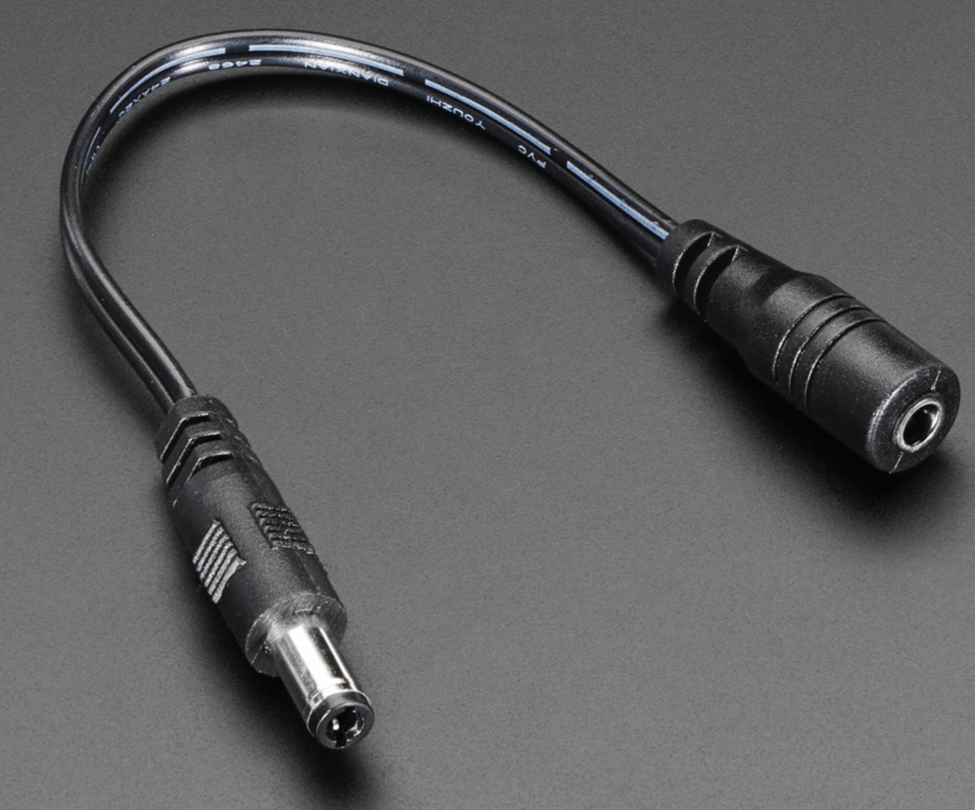
3.3.13 DC Jack Adapter Cable

For the project, there were adapters that were needed to connect certain components with others. We will be using a DC Jack adapter to connect the solar panel to the battery charger. This DC adapter has a 2.1 mm diameter and a 5.5 outer diameter. This adapter is needed at all times, when the solar panel is charging the device, as well as when the battery is powering the device.
Figure 40 .Jack Adapter

4. Design Constraints and Standards

Engineering design is the process of creating a system, component, or process that meets desired objectives and standards while working within restrictions. It is an iterative, creative decision-making process that employs basic sciences, mathematics, and engineering sciences to transform resources into solutions.

We discuss our economic constraints, time constraints, manufacturing constraints, etc. Additionally, we discuss the standards we hold ourselves to. Both of these constraints and standards are extremely valuable in this process. Constraints are important to knowing things that will challenge us and hold us back - this helps us prepare in advance to avoid issues because we already know what the issues will be. Setting standards is like setting a goal; it gives us an end design to meet, we just need to pave the road to get there. Using these constraints and standards will allow us to complete a solid project.

4.1 Design Constraints

Throughout the project development we are going to be facing different constraints. The Accreditation Board for Engineering and Technology (ABET) emphasized several of these constraints that we studied and looked at during class time. The portable solar charger might include various hardware and software constraints that need to be addressed and looked at during and after the building of the prototype. Each constraint needs to be evaluated individually at first, and after they all have been looked at, the complete set of constraints are applied to the design. All constraints need to be realistic and we need to look at other constraints within them to make sure we address them all. It is critical for engineers to consider project restrictions in order to design a product that is functional and safe for the user and the environment. Furthermore, a variety of limits in terms of cost, tools, monetary values, and so on must be addressed in order to appropriately develop a gadget that is within the available funds and objects.

4.1.1 Economic Constraints

Economic constraints are very important when thinking on how the project will be designed and implemented. The economy is dynamic and might change based on the country or market in which the project is developed. The cost of designing the project will be a major constraint since we currently do not have a sponsor and all the expenses will be covered by the team members. The maximum budget we have is $600, however, after looking at parts it should not be that high. Due to economic constraints, the most advanced technology in component selection may not be available. It will also affect what parts we can take for testing purposes.

We will take into consideration different points such as:
- Our research done in parts’ prices and all the options we found on our materials research to create our budget and material shopping.

- We will also have to look at shipping costs of the parts since not all of the websites offer free shipping. In some websites the cost of shipping is higher than the component itself.

- Another economic limitation is that the cost of production must be maintained as low as feasible for marketing purposes. In a fair scenario, the team would develop the system with the top grade parts and the greatest number of features. However, because of the economic constraints, a balance between cost and quality must be established.

Before a workable prototype is completed, component testing and prototyping may cut into the budget. It is critical to do as much research as possible in order to prevent any unrecoverable budget losses caused by events such as component failure or change of part selection after order.

4.1.2 Time Constraints

There are also time restrictions that we have to keep in mind. We have a couple of deadlines set in order to complete our project. Time will also affect the quality of our model, we have to have a working prototype by a certain date. It is critical to examine time restrictions realistically, meaning that if one approach, which may provide a greater outcome, exceeds the time limits, another way should be chosen to fulfill deadlines.

We have some deadlines along the semester such as:
- Delivering an initial document proposal during the first two weeks of the semester

- Delivering a 30 page document to see our progress and set a meeting with the professor to discuss possible changes.

- We will have to deliver a 60 page document before a checkup meeting

- Deliver 100-120 page document to finalize our research and planning of our project.

Our paper and prototype design has to be done by the end of Senior design 1, and we have to finish our final project model by the end of Senior Design 2 and present it to a panel. The ability to effectively manage shipment timelines and the availability of certain components will be critical in ensuring that the criteria are satisfied. To compensate for any unanticipated delays, contingency preparations will be implemented. The time limitation should be a parameter that is continually focused on and monitored.

4.1.3 Manufacturing Constraints

Manufacturability is a broad principle that states that a design should be simple to produce. We want to do this by utilizing commercial materials that are accessible for purchase online by any consumer. The components necessary to make a portable solar charger, software for the application, and any other portion of the project all have manufacturability limits. One manufacturing constraint to consider is the availability of the chosen materials. Some parts can get damaged during our prototype building stage and when we test connections using a breadboard, therefore, we should look into the type of materials we are acquiring and the manufacturer.

Additional thought should be given to carefully routing any cables around any removable sections of the device. This is in case the connection is jostled or strained in any way. In terms of aesthetics, external wiring will need to be adequately shielded and disguised as much as feasible. The use of keyed and properly labeled connections between all electrical and electromechanical components is required to meet this standard.

We could run into a situation where we don’t have enough parts and will have to wait to order new ones. It will also depend on whether the materials we need are in stock for when we need to buy them. To guarantee that the project can be completed within our budget and timeframe, each component of the project was designed or developed utilizing widely accessible or easily purchased elements. For this project, the team will make use of facilities and technologies given by the University of Central Florida's College of Engineering and Computer Science.

4.1.4 Sustainability Constraints

Sustainability restrictions arise from the project's capacity to be supported and maintained after it has been developed and completed. To provide a long-lasting product, this limitation necessitates that all components of the build be of excellent quality. Due to the outside use of our project, sustainability criteria are particularly crucial to our design. Once a product is released, it must be maintained to guarantee that it stays usable over the duration of the product's life.

Moreover, we expect this to have a reasonable weight and size, but it will all depend on the amount of solar panels that we end up using. We will have to look at the amount of energy that one solar panel can output and based on that we will determine how many solar panels will need to be used and the final size of our 3D printed design to hold our components. As of now we plan on using two solar panels that are connected, by doing this we can have an overall design and size, but it can change during our testing and building process. Unforeseen problems might surface long after the design phase has ended. Our project should allow for possible upgrades if needed.

4.1.5 Environmental Constraints

Environmental limitations are restricting considerations because of the impact of utilized materials, such as manufacturing, disposal, and energy consumption. Our project should be energy efficient. For environmental constraints, even though renewable energy seems to be environmentally friendly, we have to think on what to do with solar panels when they break. Solar modules can currently be disposed of in the same manner as other types of e-waste. Countries that lack robust e-waste disposal infrastructure are more vulnerable to recycling-related issues. However, this shouldn’t be a problem in our case, because of the size of our project.

Another choice influenced by this was the type of photovoltaic solar cell to be used. Due to the cell carrying a significant quantity of cadmium, which is a very dangerous material, it was determined that our product could not use the Cadmium Telluride solar cell type after much thought.

Our project should be easy to use, however, sunlight is not always available. Solar energy can be a drawback since we don’t have access to solar energy at night or whenever it is raining, requiring us to store excess energy made during the day for later use or have an alternative connection as a power source. Moreover, we are implementing a battery for whenever we don’t have access to solar energy, so we have to think about the lifetime of that battery and how it can be replaced without damaging the environment.

4.1.6 Ethical, Health, and Safety Constraints

Moving on to our design's ethical, health, and safety restrictions. This section will go into whether or not the battery overheats and causes harm or damage to the human body and what this could cause. Burning is a potential safety hazard while handling a PV module, especially if it has been exposed to the sun for an extended period of time. When the PV module is exposed to the sun for an extended period of time, it heats up, which in turn could cause the module to melt. However, the solar panel we chose includes a case that should redirect most of the heat to keep the panel safe from overheating.

Soldering wires improperly onto PV modules, faulty wiring hookups between components, and neglecting to make essential electrical connections are some instances of hazards. Exposure to extreme weather such as rain or wind, poor wiring connections, static electricity, and inappropriate handling are all examples of how the PV module might internally short. It is important to note all of these possible constraints to address beforehand and have a successful project.

4.1.7 Software Constraints

An early awareness of the overall real-world restrictions put on the program is a vital aspect of the design process. These restrictions may originate from the programmatic client or the institutional implementing organization. The program's specific constraints are a subset of the limitations, standards, codes, and laws that the client or implementing company operates under. Typically, trade-off analyses cannot be used to modify these limits. When this subset is defined, it becomes a set of programming requirements. After these restrictions have been established, requirements may be further specified by setting performance criteria.

During the development of our program, we had to ensure that all of the required components were completed within a certain length of time. Some of our team members have programming knowledge, and we are all eager to assist; unfortunately, we have little experience with coding an Arduino. We will have to get some practice with coding and do some testing between the Arduino and the batteries.

In addition to that, if we run into some problems with the coding, we have to be able to address them in a timely manner so that we don’t delay any of the building process. There is some debugging that will have to go into the programming phase until we get our code working and it will be a learning curve.

4.1.8 Testing Constraints

Testing is a critical component in any kind of engineering development. For this project, many devices and components need to be evaluated individually and in conjunction with another. As a consequence, it is critical that the project's testing stage begin early and be handled in such a way that smaller components of the project be evaluated independently using unit testing during development to guarantee that individual parts operate well before they are joined together. Hardware testing is an important part of development and we should do it frequently during the project’s development.

We will need to test the solar panels to see the amount of energy they are producing and to verify in which way we will connect them together. The project's software also needs thorough testing. Because it will reveal all of the battery percentage information

4.1.9 Portability Constraints

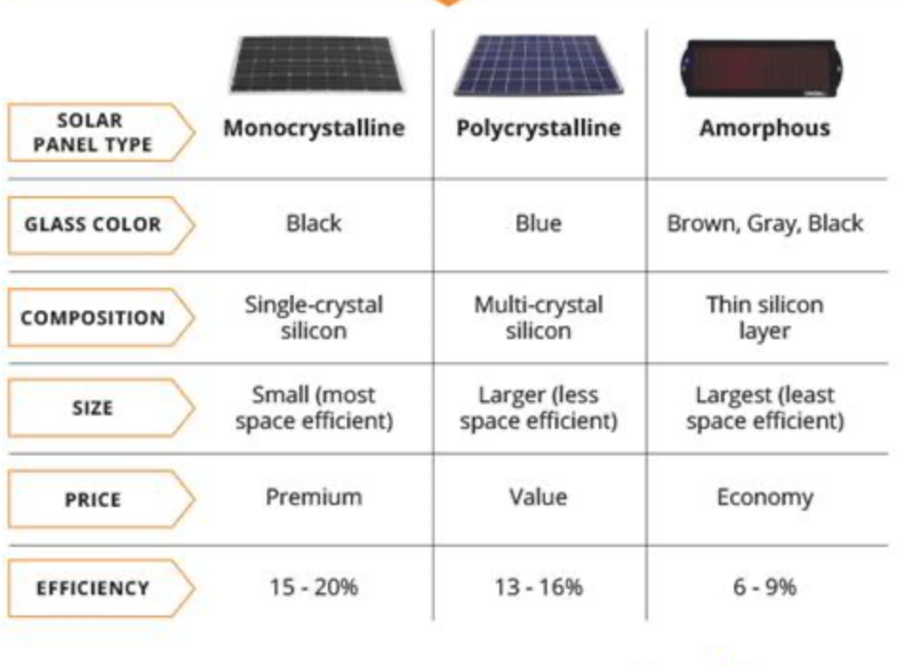
One of our primary aims for our design was portability. We intended on making a portable solar charging station that we would be able to carry around on a hiking trip. Solar panels are classified into three types: monocrystalline, polycrystalline, and thin film cells. We compare the solar panels in the following image and we can see that some can take a lot more space. Most solar panels are noted for being huge, taking up a lot of room, and being highly heavy. Therefore, we need to make sure that the solar panel chosen isn’t too heavy and can fit the size of our design. The user should be able to carry the portable solar panel charger around so we will need to look out for the weight and size of the final project.
Figure 41. Comparison

4.1.10 Battery Constraints

Batteries, whether tiny or huge, can cause catastrophic damage if mishandled or malfunction. The battery problems with certain phones are a good example. Aside from the safety concerns, such phones were banned in many countries, and it cost the company billions of dollars to correct the problem and recover from it. As a result of these factors, the electric and electronic industries have tight standards in place. In our project, we will adhere to all of the manufacturer's safety regulations and recommendations for appropriate and optimal operation.

We will also make sure we do the proper testing so that we don’t run into future problems and we can account for any possible issues. However, one of our constraints with the battery is that it ends up not fully charging therefore our charger won’t be working indoors.

4.2 Design Standards

This section outlines the several standards that influenced the design. Engineering standards are protocols that specify the qualities and technical requirements that must be met by all products that apply this standard. When designing, it is critical to consider the complete life cycle of the product or process, including maintenance, troubleshooting, probable failure modes, environmental implications, and societal repercussions.

Standards are used to guarantee that all of the goods and systems that implement this standard may interact with one another in a consistent and repeatable manner. Standards are also crucial for safety and to make sure that the product will be adequate. They ensure that potentially harmful technologies are applied in a safe and acceptable way.

4.2.1 Cost of Development
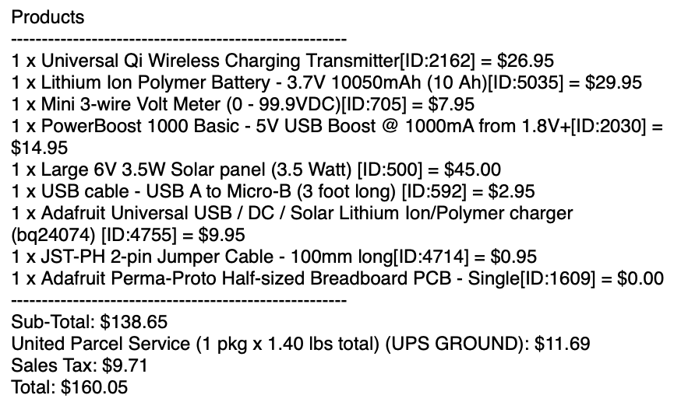
One of the first standards we need to talk about, even before we talk about the design, is our cost of development. Our main objective, like many other engineering companies, is to design a product that works well for as little money as possible. The first step in ensuring we kept our costs low was doing plenty of research on competing products currently available as well as taking plenty of time to come up with our part selection. Ultimately, we decided on the parts listed above because they are compatible and effective at a competitive price.
Figure 42: Bill of Materials

We were able to cut costs significantly because there were many parts we did not need to order. The solar panel, wireless charger, and battery system we had to order. However, all of the necessary hardware to build the Arduino voltmeter we already owned. Additionally, the 3D-Printer and filament we already own too (except we may need to order more filament depending on how much the printed design requires). The solar panel, wireless charger, and battery system all came in around $160. Although we have a budget of $600, we are still going to try our very best to remain as far away from that budget limit as possible. At this moment, we have $440 of our budget remaining. At this point, the only other thing we may need to purchase is more filimanet, but we will not know for sure until we finish our stadium design. Currently, we have an entire spool of filament which should be enough for many small projects, but we are not sure if we will be able to build the entire stadium with it; possibly only a few parts. Thankfully, we will not have to purchase a 3D-Printer because the one we have is totally fine. It will be able to print the stadium, but in multiple parts. However, if we did have a bigger 3D-Printer, we would be able to print the stadium in fewer and larger parts.

Other than the parts we already ordered and 3D-Printer filament, we should not have to order any other parts. However, if something does go wrong, we can always order replacement for the parts we have and stay under budget. Additionally, we have all of the Arduino parts already. Many people on our team already purchased large Arduino kits for other classes. Each of these kits includes an Arduino Uno unit and all kinds of jumper wires, resistors, LCD displays, and more. Since we have multiple kits, there should be no need to replace any of the Arduino units or their parts and accessories. The real cost of this project will be our time and energy because we will need a lot of both to make this project come together into something great.

4.2.2 Programming Language - C Standard

This standard will have a number of effects on the software design. C is a popular broad sense programming language that is easy to learn and use. It is a computer structured programming language that is widely used to create diverse applications. The code will be developed by one of the members of the group, however, it will be evaluated and compared among everyone. In addition to the criteria that must be followed, linking this standard with our design will allow definitions and code code to be introduced into the design that were previously unknown to the software designer. While C language was taught in some courses, new programming approaches may be learnt by looking into similar projects and applying previously gained information.

Coding should be designed as carefully as the hardware design, and everything should be thoroughly documented so that if we run into problems we can trace it back to its source. As with any language, definitions, notations, ideas, conversions, and a variety of other contributions all contribute to the language's construction. The standard defines two types of notations: italic, which represents nonterminals, and bold, which represents terminals. A colon that comes after a nonterminal introduces its definition. Syntactic categories are not emphasized in the main text, and spaces are used instead of hyphens. The organization of specific sections can affect readability, efficiency, and usability. Certain features of programming, such as commenting, coding style, headers, and code layout, should be uniform.

C is an independent language that may be extended and used to simplify programming. C is both structure based and procedural, making it simple to recognize code structure and fix software faults in case we run into any bugs. It also has dynamic memory allocation, which means that even if we don’t know how much memory is required, the program can still run since memory is assigned as it runs.

C also appears to lack exception processing, which is a critical feature in programming languages since it allows us to notice problems when a fault or anomaly occurs during compilation. C also lacks constructors and destructors, thus the programmer must exercise caution while allocating memory to avoid a memory leak. C also has a minimal level of abstraction, which results in limited data concealing and security. C is quite easy to learn on a surface level. Some of our team members have some knowledge on C so we will get more hands-on experience and knowledge.

4.2.3 Battery Standards

The IEEE provides guidance for a potential user’s objective evaluation of lithium based batteries for energy storage solutions for any application. This standard specifies the procedures for maintaining, testing, and installing lithium-ion batteries. The standard also aids in the recommendation of different battery types based on the project parameters. If we don’t have a battery in our project, our system would only work on sunny days. For this reason, the battery might be considered a foundation and important piece. Therefore, choosing the best battery that matches our needs is of great concern.

We discussed the ways of maintaining and testing different battery kinds using material from the IEEE website to help prepare us for determining which one would be best for our prototype. The more charges the battery consumes, the less capacity it possesses. All lithium (Li-ion, Li-polymer) batteries must be purchased with and stored in a fire and explosion resistant battery bag while not in use.

Standard | Description
IEEE 1578 | This is a recommended practice for stationary Battery Electrolyte spill containment and management.
IEEE 450 | Recommended procedure for battery management, testing, and replacement in stationary applications.
IEC 62133 | Standard that evaluates the battery's construction quality, beginning with the stress that the case can withstand, then moving on to an external short circuit, a free fall, and ultimately an overcharging test.
UL 2054 | This is a standard for commercial batteries. UL provides a solution to bridge the gap between IEC 62133 and UL 2054 by executing a battery pre-assessment procedure. This standard contains 18 tests to ensure that batteries meet device specifications in the United States. This improves the safety of each battery pack and reduces the risk of bringing it into public and private areas.
BS EN 619602- 2 | This standard is applicable for portable applications, which in our case it will be a portable solar panel so it is important to understand how it will work in a portable manner while meeting the requirements of the standard.
IEEE 1187 | This is a recommended standard that discusses the recommended design and installation of batteries for stationary applications.
IEEE 1625 | This standard is for rechargeable batteries which applies to our lithium-ion rechargeable battery.
ISO 14000 | This standard focuses on the environmental aspect and how to dispose of batteries. This project makes use of rechargeable lithium-ion batteries. Battery specifications are regulated by fire and safety laws. To minimize damage to the environment, local battery stores are compensated for accepting used batteries for recycling. Batteries are controlled to ensure that, once made, the costly process of storing the energy inside a battery is reduced due to a substantial negative influence on the environment.
Table 18. Battery standard description

4.2.4 Solar Panel Standards

We also have some standards we have to follow for solar panels. The primary goals of these standards are to ensure that the finished product is safe to use and meets the requirements established by those standards. We discussed and followed the many standard codes that apply to solar panels in this part. It contains the following items: The International Electrotechnical Commission (IEC), Underwriters Laboratories (UL), the Institute of Electrical and Electronics Engineers Standards Association (IEEE), and the International Standards Organization (ISO) are all organizations that provide certification for electrical and electronic products.

Standard Code | Description
IEC 61730 | Assesses if a solar module is safe enough to be authorized. The standard specifies the series of tests that must be performed on photovoltaic modules. These tests evaluate if a photovoltaic module may fail outside or inside, perhaps resulting in a fire, electrical shock, or other bodily damage.
IEC 61216 | The 2016 standard specifies the standards and certifications for solar module performance. This data is then used to assess if the solar module will survive in various settings or climates with extended exposure.
UL 1741 | A standard that describes how to utilize various electrical equipment, such as converters, charge controllers, and interconnection systems, in stand-alone (not grid-connected) or utility-interactive (grid-connected) power systems.
UL 61646 | The guidelines still demand that solar panels be tested in outside circumstances, but the tests do not need a plus/minus criteria to be completed. Instead, the test needs a certain percentage of minimum power output to be met. This eliminates the need for technology-specific preconditioning in order to effectively quantify the test's effects. This will be needed if we end up using thin film solar panels.
IEC 60904 | Solar simulator performance requirements for all different types of solar panels available in the market.
IEEE 1547 | A standard that establishes a standardized norm for the connecting of dispersed resources with electric power systems. It specifies the standards for the interconnection's performance, operation, testing, safety concerns, and maintenance.
IEC 60904-1 | PV current-voltage parameters for photovoltaic devices are measured.
IEC 60904 | A standard that comprises the following sections: requirements for reference solar devices, open-circuit voltage method of determining the equivalent cell temperature (ECT) of photovoltaic (PV) devices, and solar simulator performance criteria.
IEE 1526 | A performance standard for stand-alone photovoltaic systems.
ISO 9488 | A standard developed by the technical committee of the International Organization for Standardization that comprises fundamental terminology to be used when discussing solar energy in a scientific setting.
Table 19. Solar Panel standards description

4.2.5 Design Impact of Solar Panel Standards

The photovoltaic module standards regulate which solar panels may be supplied in the industry. We do not need to be concerned about this since we will be obtaining our solar panels from an internet retailer, in this case Adafruit, and we can presume that the solar panels we are acquiring have previously met industry requirements. We are not mounting our solar panels for industrial reasons, but rather for prototyping, thus we do not need to be concerned about conventional standards for attaching photovoltaic modules and panels.

4.2.5 PCB Standards

The Association Connecting Electronics Industries (IPC) is an organization that develops PCB-related standards. IPC standards are standards adopted by the electronics industry for design, PCB fabrication, and electrical assembly. These standards include natural PCB and multichip module specifications, technology considerations and board layouts, and PC card form factors.

Standard Code | Description
IPC-2222 | Specifies the precise standards for the design of organic rigid printed circuit boards.
IPC-2223A | Specifies the design criteria for flexible printed circuit applications, including component mounting and interconnection structures. Single-sided flexible printed wiring with one conductive layer, Double-sided flexible printed wiring with two conductive layers, Multilayer flexible printed wiring with three or more conductive layers, and Multilayer rigid and flexible material combinations with three or more conductive layers are all examples of PCB types.
IPC-2221A | Specifies the general standards for organic printed board design.
Table 20. PCB standards description
These IP requirements are extremely significant and should be adhered to since they assist the designer in producing only the highest quality products. They also make it easier for the designer, manufacturer, assembler, and tester to communicate.

4.2.6 Software Testing Standards

The International Software Testing Standard's purpose is to be a recognized collection of software testing standards that come after any Software Development Life Cycle model in generating software. These are international norms that define, prepare, specify, and regulate the evolution of a project during its formation. They are significant because they can help both consumers and developers. Software testing will be mostly handled by the team member who is in charge of the code, however, we will need help from everybody to connect parts and make sure the code and microcontroller is communicating with the rest of the components. In the table below we discuss in depth some of the standards we found for software testing. The standards of ISO/IEC/IEEE 29119 family of software testing standards was created with the goal of defining an internationally agreed-upon collection of software testing standards that may be utilized by any organization for any type of software testing. We describe each subsection of the standard in the table below.

Standard Code | Description
ISO/IEC 333063 | This standard explains how to properly test using certain protocols, tools and techniques, and the procedures that should be followed.
ISO/IEC/IEEE 29119-4 | A standard that compiles all software testing techniques and approaches into a single global standard.
ISO/IEC/IEEE 29119-2 | ​​A standard that specifies the test criteria while attempting to establish a general paradigm for software testing. It may also be used at any step of the software development life cycle. It is divided into three categories, the most important are comprehensive organizational, dynamic, and board testing.
ISO/IEC/IEEE 29119-2 | Aims to create test documentation templates that span the whole software testing life cycle. While implementing the standard, the templates supplied in the standard can be customized to meet the project's specific requirements.
UL 60950 | Standard UL 60950-1 provides safe functioning of the equipment regardless of power source for the majority of electronic components utilized on this product. To avoid electric shock, it stipulates that all conductive materials must be grounded. It also guards against dangerous industrial design. When evaluating each unique product, the standard is utilized to search for fault situations, possible abuse, subsequent defects, and environmental elements including temperature, altitude, debris, and moisture.
Table 21. Software testing standards description
Organizational test requirements, test management, and dynamic testing are all covered under a three-layer process model used in the testing process. The standard takes a risk-based approach to testing, stating that it is the best-practice method for designing and managing testing. When you use a risk-based method for software testing on a project, you guarantee that the most essential features are prioritized and that the product satisfies requirements in the most efficient way possible.

4.2.7 Wireless Charging Standards

Since we are going to be implementing wireless charging using a Qi charger, we need to look at some standards that can apply to the qi charger. The Qi standard, developed by the Wireless Power Consortium, defines wireless or inductive charging across a four-centimeter distance. The standard was initially introduced in 2008 and is now found in over 160 smartphones, tablets, and other devices. One of the most popular devices that implement this standard are Apple, Google, HTC, Xiaomi and others. The conventional setup comprises a charging station and a Qi-compliant device that requires 5-15 watts.

The Qi wireless standard defines wireless or inductive charging, a method of charging that uses electromagnetic fields to transmit energy between a device and a receiver via electromagnetic induction. When an electromagnetic force, such as voltage, is formed through a conductor in a changing magnetic field, this is referred to as electromagnetic induction. The energy delivered to the device can subsequently be utilized to charge the device's battery. If there is a larger distance between the device and the charger, resonant inductive coupling must be employed. A Qi wireless charger often features a flat surface, known as a charging pad, on which a mobile device may be placed. As previously stated, coupling tightness is an important component in inductive charging efficiency.

In terms of interoperability, the Qi standard intends to ensure that all Qi-Certified products, independent of country of origin, version, manufacturer, and so on, will operate together in any situation. Qi standard provides a wireless power transfer and data communication between a wireless charger and a charging device. Qi enables the charging device to regulate the charging process. Through signaling, the Qi-compliant charger is capable of altering the transmit power density as required by the charging device.

For safety, the Qi standard includes several safeguards, such as heat shielding and the detection of foreign items on the receiver pad. The standard also recommends looking for certified products to avoid any issues.

4.2.8 Design Impact of Wireless Charging Standards

We must verify that our wireless charger can safely charge gadgets. Noncompliance with Qi regulations may jeopardize safety, particularly when it comes to foreign object identification, heat shielding, and power supply. Each potential safety concern and its significance will be discussed in further depth.

Because of the Wireless Power Consortium's Qi requirements for foreign object identification, our transmitter and receiver devices must adhere to them in order to assure the safety of our solar powered battery design. If a foreign item overheats between the wireless transmitter and the receiving equipment, the user might be harmed.

When it comes to Qi heat shielding regulations, it presently needs thermal testing of wireless transmitters to establish whether or not their batteries are properly protected. Overheating in the batteries of the wireless transmitter and receiver devices is prevented by making sure the batteries are insulated for the receiver and the transmitter. If our transmitter equipment does not comply with the Qi standard, smartphone batteries may overheat, resulting in degraded and reduced battery life. Generally, cell phones heat up while charging wirelessly, but there should be no additional heating if the transmitter is not compatible with the Qi standard on heat shielding. This limits our design since we can only utilize a wireless transmitter that adheres to Qi specifications; otherwise, we risk hurting our smartphone devices.

All in all, our wireless power transmitter design must adhere to Qi specifications, particularly in terms of foreign object identification, heat shielding, and power supply. If our wireless transmitter was not compatible, we would endanger both our design and the safety of our users owing to overheating. We are doing everything we can to guarantee that our solar design complies with any standards that may arise, particularly those relevant to wireless charging. As a result, our overall design is bound by established standards, which is not an issue because we recognize that these standards were put in place to assure the safety of implementing wireless transmitters and receivers.

5. Project Design

Throughout this project, there are many different perspectives and ideas that each individual team member has and consider as input in this project. In this section, the main focus will be on the hardware components and their individual designs. Diagrams such as schematics will be illustrated to provide background information on the functioning of each component and the interaction between the components. This section will focus on the physical components of the overall project and their

5.1 Overall Design

The overall design of the project had gone in many different directions. This section will provide the very early block diagrams and basic ideas the group had for the project design, as well as other important factors such as power distribution and testing. The following sections below further explain about the design in depth.

5.1.1 Overall Design Details

This section of the report gives further explanation on the physical components of the project. At the beginning of the semester, the group created a “Divide and Conquer” document that included details such as initial parts, design and functioning of the project. The document gave a first draft to how and what connections will be made to what other components and gives more room for improvement such as swapping components for better ones and making the project work as efficiently as possible with the necessary components. Below is the first block diagram the group had thought about before coming up with a diagram with more specific components and bringing the idea more to life. As you can see it may be missing some components but the base of our project was a charger.
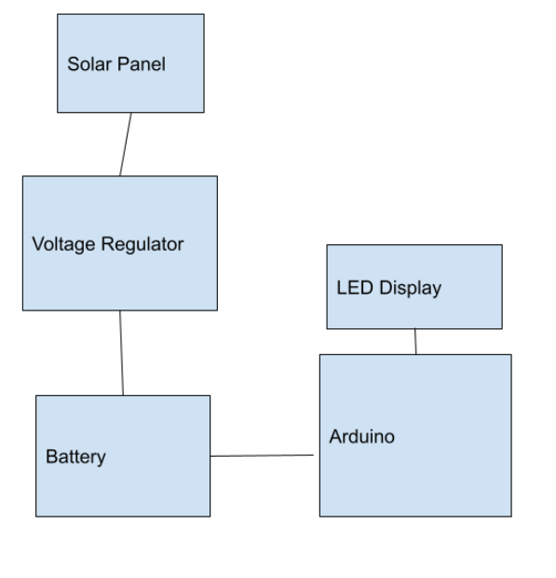
Figure 43. Block diagram
This diagram may not provide much information compared to the block diagram above, but it sparked more imagination and creativity, while also thinking deeper such as the connections, design and functioning of the project. As we continue along with the project, the design from both the old and new block diagrams may be different from one another, as researching more on different viewpoints can change the design. As the design of this project can also go in different directions, it is certain that the new tasks will be assigned to the appropriate group members. This diagram is very crucial as the group all collaborated and provided their input on what components work best with this project. If no beginning design was created, planning the project would be much more complex and creativity would not have sparked, giving us a much more simpler design, along with having more trouble in figuring out the specifics of the design. The following sections will further explain different design features leading to the final design of the project.

5.1.2 Power Distribution

For our project to function, we need to discuss power distribution. This phase of the device is what takes sunlight energy from the solar panels and stores it in our battery. This process begins at the solar panel where the solar cells convert sunlight into usable energy. This energy is then transferred through the built-in DC connector to our most important module - the battery charger. This device then distributes energy between our battery and our load. Energy is always sent to the battery unless there is no sunlight or the battery is full. This module will keep the battery topped off, preventing discharging, but will not consistently charge it to prevent overcharging. Additionally, the battery charger will divert power to our load - the phone charger components. Our load is not directly the wireless charger since it has to hit the voltage booster first.

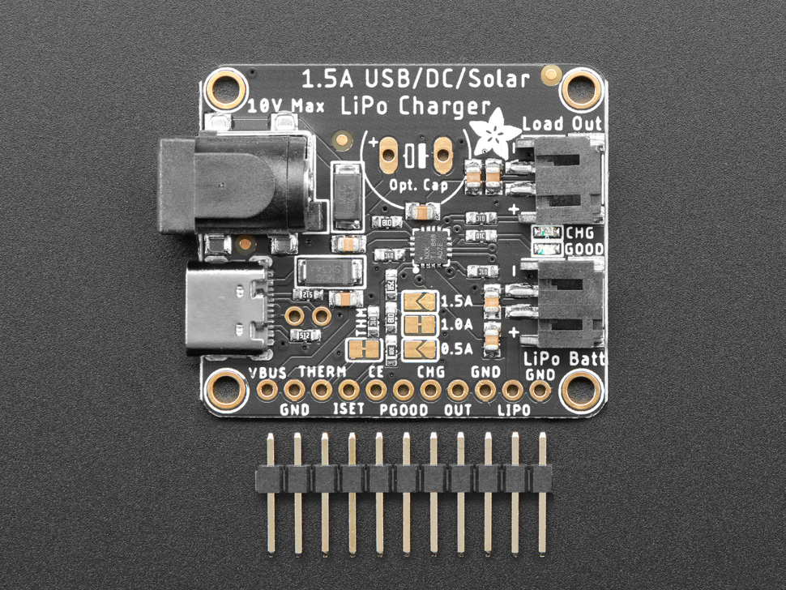
Either way, what is special about our power distribution network is the battery charger module automatically does many things. First of all, as mentioned above, it works to prevent discharging (by topping off the battery) and overcharging (by not charging when the battery is already full). Furthermore, this module charges both the battery and the phone charger simultaneously. In addition to that, this module will automatically redirect power when there is no sunlight. For example, if we are trying to use the charger on a cloudy day or at night, the battery charger module will route power from the battery to use for the phone charger when no sunlight is available. This functionality is extremely important when developing a portable charger because there are many instances where sunlight will not be available (ex: cloudy/rainy day, night time, charging inside, etc). Everything discussed above is our direct power distribution network. Every other module or component comes after the load. How power is distributed throughout the load will be discussed in following sections.
Figure 44: Battery charger

5.1.3 Breadboard Split

One of our many goals for this project is to measure the output voltage of our charger. In order to achieve this goal, we need to obtain the voltage at our voltage booster; this voltage will be immediately transferred via a USB cable to the wireless charger. The voltage booster module we selected arrived in multiple pieces. There is the module itself, and then there are the connectors, which must be soldered on. However, instead of soldering the ports on, we plan to use jumper wires and connect the module to a breadboard. By doing this, we now have the ability to make multiple connections to the same module.

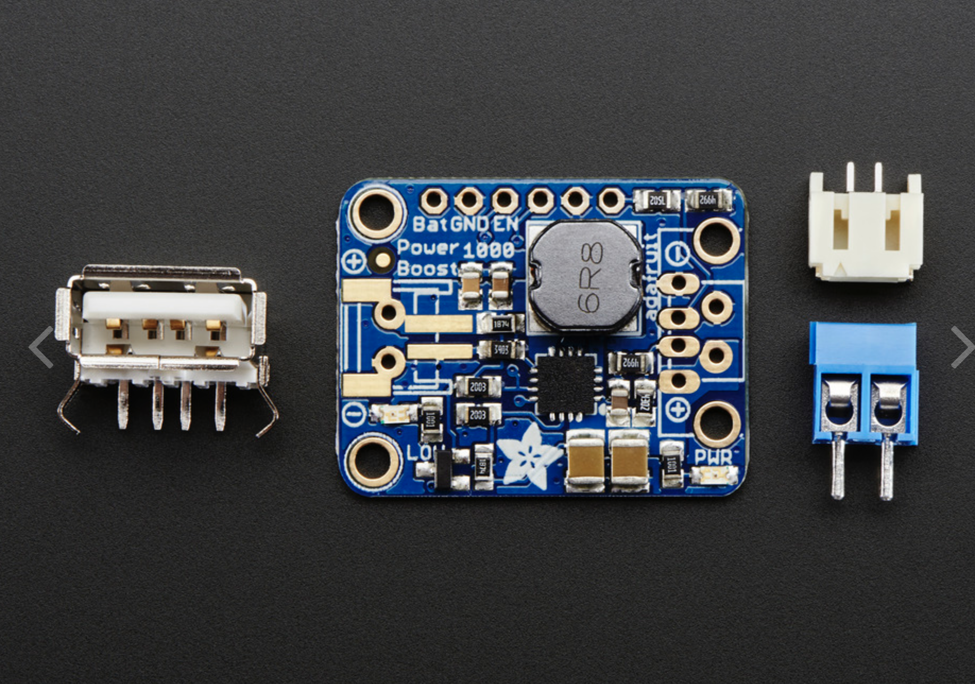
Once the module has been connected to the breadboard by jumper wires, we will then
connect the included USB port to the breadboard via jumper wires. This will allow the voltage booster to push the voltage through the jumper wires, to the breadboard, through more jumper wires, and back through the USB port. In between this, however, we will include our measurement device. We will connect two more jumper wires in parallel with this system. By doing this, the voltage over the Arduino will be the same as the voltage over the voltage booster, and therefore, the same voltage that is applied to the wireless charger. Basically, this is allowing the Arduino to receive the power it needs to operate while also displaying to a LCD the current voltage output of our charger.
Figure 45: Voltage booster

After these connections are completed, we will have access to the voltage that is being placed on the wireless charger. This information is extremely useful because it can help ensure our charger is receiving enough sunlight to charge a phone, and it could tell us how fast the phone will charge. Additionally, this information is useful in determining any errors in our project. If the voltage being read is something we did not expect, we know to make a correction.

Prior to implementing this design decision, we will first need to develop and test our Arduino. For all of our tests, we will plug the Arduino into a wall using a DC barrel connector to ensure the Arduino is receiving its optimal power input. If an Arduino is without its necessary power standard, it can perform unexpectedly - or worse, it could damage itself. Therefore, while testing the device, we will keep it plugged into a wall. After that, however, the Arduino should be able to operate off of the voltage output from the voltage booster. If the voltage booster is operating incorrectly, we will know because the Arduino will start to act up.

5.1.4 Charger Housing

One of our most important objectives is to design the charger to look like the University of Central Florida football stadium (the Bounce House). Unfortunately, this is a difficult task and would require lots of time and resources. Therefore, for our initial prototype, we have considered building a box structure for testing purposes. Designing the stadium will be extremely difficult because we will have to use the software provided by the 3D-Printer company XYZprinting (because that is the 3D-Printer that we have). This software is capable, but not nearly as powerful as other software like AutoCAD which is extremely expensive. Additionally, the stadium will require a massive amount of filament. So, for the time being, we will develop our project as a benchtop build. After that, we will design a box that can house all of our parts for mobility testing. Finally, we will create the stadium using the included software.

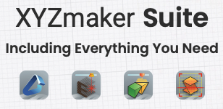
Our 3D-Printer is from XYZprinting - a new company that specializes in smaller scale, affordable 3D-Printers. In an effort to push their affordability, they included all sorts of free design programs and models on their website. We are going to use a software package called the XYZmaker Suite. This package includes everything we will need to produce a standard box for a prototype as well as a stadium for our final product. This software package includes the XYZmaker 3DKit, XYZprint, XYZengraver, and XYZscan Color. XYZmaker suite is an all-in-one software package filled with 3D design software applications that provide multiple tools for XYZprinting’s 3D printers. All of these products will be discussed in detail below.
Figure 46. XYZ maker suite

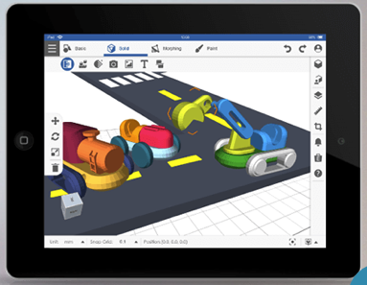

The first product in this software package is the XYZmaker 3Dkit. This is a 3D modeling application with an intuitive user interface, a wide range of interesting 3D modeling tools, and 3D model templates. This tool is available on multiple platforms including: iOS, Android, MacOS, Windows, and ChromeOS. One of XYZprinting’s goals is to allow everyone on any device to be able to design wonderful objects to be printed. In addition to its massive compatibility, it is also extremely easy-to-use, which is perfect for anyone not familiar with 3D modeling programs. This tool includes multiple functions that are perfect for designing models, including: Block, Pixelate, Chamfer, etc. Additionally, there are plenty of models available in a gallery for brainstorming. This tool is amazing because anyone can learn on a desktop, laptop, tablet, or chromebook. There is a vast amount of tools available within this software tool, all of which will help a user create a design from scratch or work on an existing design. For our purposes, we will be creating design from scratch. Two of the main tools available in this program are Block and Pixelate, and Fillet and Chamfer. The Block and Pixelate tool allows the user to stack and color blocks to build a 3D model. The Fillet and Chamfer tool allows users to create rounded corners, slopes, and angles. Additionally, there is the freeform tool which enables users to sculpt all kinds of shapes and models; this allows the user to create a unique 3D design like an action figure or a personalized character.
Figure 47 Modeling Application
Figure 48: Design figure

XYZmaker 3D-Kit Specifications
Default Format | 3D format: .3dk
Image formats | .png
Desktop
Other supported formats | .3dk, .amf, .3mf, .stl, .obj, .ply
Supported operating systems | Windows 10  macOS 10.13 / 10.14 / 10.15
System requirements | CPU: 4th Generation Intel® Core™ i5 Processor or more  RAM: 8GB  Hard disk space: 20GB or more  OpenGL 3.3.0 or newer version
Supported printer models | XYZ models
Tablet/Pad
Supported formats | .3dk, .amf, .3mf, .stl, .obj, .ply
Operating system | Android 5.0 or higher  iOS 9.0 or higher
Screen size | Minimum 7”
Supported printer models | da Vinci nano (with Wi-Fi box) /da Vinci nano w / da Vinci Jr. 1.0w / da Vinci Jr. 1.0 3in1 / da Vinci Jr. 1.0A (with Wi-Fi box) / da Vinci Jr. 2.0 Mix / da Vinci 1.0 Pro / da Vinci Pro 3-in-1 / da Vinci mini w / da Vinci mini w+
Devices suggested | iPad mini 2, iPad Air and above
Table 22: Printer Specs
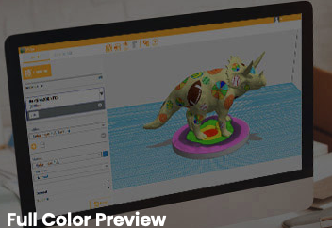
Figure 49 Preview

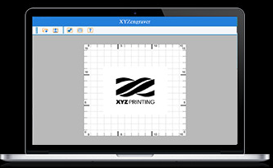
The next program in the XYZmaker Suite software package is XYZprint. This tool is what we will use to actually print the design we developed in the previous tool (XYZmaker 3DKit). This program is a slicer, meaning it will take our design and slice it into pieces. This is necessary for our project because the design is too large to be printed at once. Therefore, our printer will print the stadium in multiple phases, which we will then connect together upon completion of printing. If we had the budget for a larger printer, we could have printed the stadium at once, but that would require a very large and extremely expensive 3D printer. Furthermore, this tool allows the user to preview prints in full color and change numerous print settings prior to sending the model to print. This tool supports multiple file formats including: .stl, .obj, and .ply. For better quality prints, this tool offers customizable settings.

The third tool in the XYZmaker Suite software package is XYZengraver. This is an engraving tool that is meant to be used with a laser engraving module. The laser module and engraving software can be used on paper, leather, wood, and plastic (PP, ABS, PE). The tool has multiple modes including vector or raster, which enable users to use their own unique designs. The engraver software supports images in .jpg, .png, .bmp, .gif, and .tiff formats. The user can also shift, rotate, and scale the uploaded images to create the perfect engraving. As mind-blowing as this tool is, we will not be using it for our project because we do not have the laser module. More importantly, we do not need to engrave anything into our project for it to function as expected.
Figure 50 XYZ program


The fourth and final tool within the XYZmaker Suite software package is XYZscan Color. This tool is used for scanning real-world objects and using them to create a 3D design. This tool supports 360-degree full-color 3D scanning. After scanning an object, the user can easily import the model that was created into XYZmaker for editing. Additionally, the user can also send it to XYZprint to immediately print a 3D copy of the object that was scanned. For prints that have full color, this is a beautiful and amazing use of technology. Our printer, however, does not have full color. Additionally, we will not be using this tool because we do not have the physical scanner needed to transfer the object into a 3D model format.
Figure 51. 3D model

5.2 Individual/Multi-Component Testing

After all of the system's components have been chosen and ordered, it is vital to ensure that they achieve the intended outcomes. Functionality between these systems may be guaranteed by testing each system independently. This section will examine the testing of both the hardware and software components. Following the specification of the system components to be tested, a test will be developed and concluded as to whether or not the testing was successful.

5.2.1 Breadboard Testing

A breadboard is a plastic board in the shape of a rectangle that is used to build and simulate circuits. This tool has been around since the 1970s and has become very essential in the engineering industry and very critical in creating and building products. The breadboard is mainly used for prototypes, as there are certain factors that can be limited such as voltage and current, but these factors won’t affect a prototype whatsoever. Underneath the breadboard, there are strips of metal with holes on top. The middle of the breadboard has the holes connected vertically as the rest of the holes are connected horizontally. Below is a figure of how a breadboard looks, along with illustrating how the holes are placed.

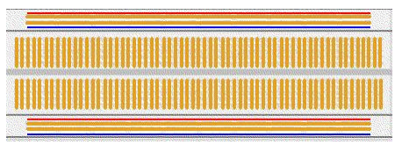
Figure 52. Breadboard

A set of two holes form a node, which is where the legs of the components are placed in the circuit. Usually, the horizontal rows on the top and bottom of the breadboard are used to connect the power supply, known as power rails, such as the voltage and ground. The middle, vertical rows of nodes in the breadboard are used for connecting components together, usually with jumper wires. The breadboard will be used in the solar charger’s prototype to make proper connections and to ensure there are no issues or errors once another design is created. We will be connecting the arduino, solar charger and LCD to the breadboard to ensure they all work together and individually. We will make sure to follow our schematic design to ensure the connections are well made. Once the device can be charged, the breadboard may be removed for the final design.

5.2.2 Arduino Testing

An Arduino board is a board that is used for control of electronic devices. This board is considered the “brain” of any project that it is used in and can be used to perform tasks such as turning on an LED. The Arduino is a device that is very simple to use when it comes to basic prototyping as it can also be used by those who have little to no background in any coding/programming or electronics. As the Arduino company provides this easy-to-use hardware and software that is open source, it provides a canvas for people to be creative and use their imaginations in applying the Arduino board in many different ways. Down below is a figure of the Arduino Uno R3 microcontroller board that we will be using for this project.

The Uno R3 microcontroller will be the “brain” of our solar charger, where it will be in controlling the LCD display that will be showing how many watts of power will be outputting to the Qi device being charged when placed on the Qi charger. Testing all of the hardware components as they are built to verify they are in appropriate working order is critical early on in order to avoid disrupting the flow of the milestone goals. As components continue to be gathered for the beginning of the prototype, it is also crucial to have schematics of each device in order to make the appropriate connections for the overall project to work as smoothly and efficiently as possible. Below is a schematic of the Arduino Uno R3 that will assist in connections with other components.
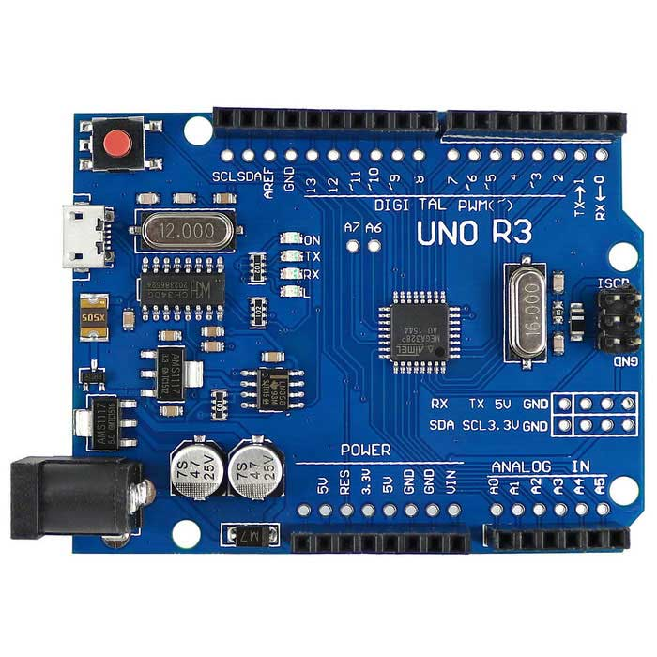
Figure 53. An Arduino Uno R3 microcontroller

The schematic of the Arduino will also help to create an overall schematic showing the connections for all of our components. Once we have that ready we can start doing some code testing into the Arduino in order to display the power that we output.

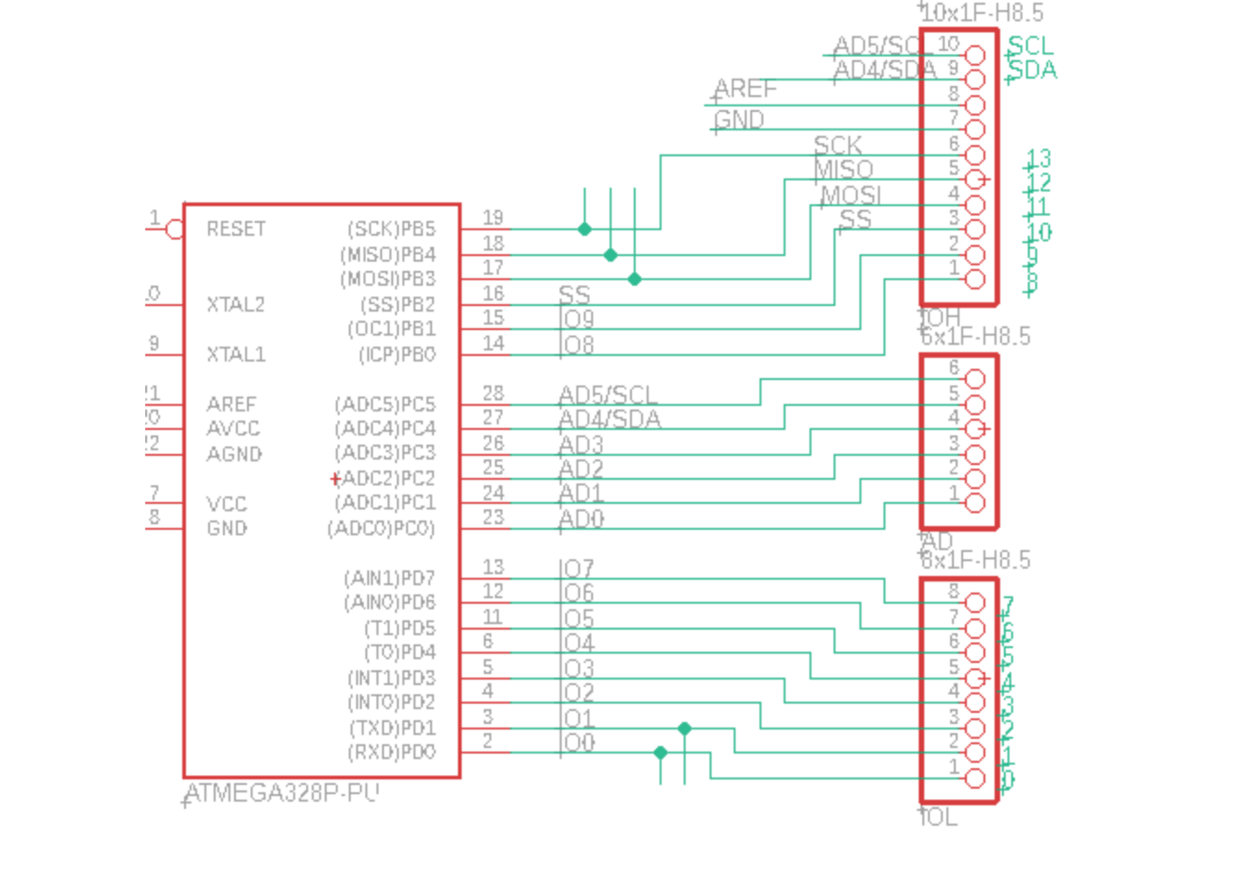

Figure 54. Arduino Uno R3 (ATMEGA328) schematic

5.2.3 Solar Panel to Battery

The solar panels are one of the most crucial, if not, the most crucial components in this overall project. The quantity generated by the solar panel linked to the battery and arduino is the most efficient part of our system. We should first test the solar panel with an LED before connecting it to the Arduino or any other component. This will ensure that the solar panel can turn on an LED and generate some electricity. After we've established that the solar panel provides electricity, we can link it to the rest of the system.

Just as any project can create a charger, the main goal in this project is to provide power to a mobile device, such as a cell phone, with environmentally friendly sources such as solar power. When using solar power to power the device, the solar panel will be powering everything in this project. When in use, the solar panel will be powering the Arduino microcontroller, which then powers the Qi charger, charging the mobile device.

In order to test it, we will have to make sure we have the right environment conditions. We will need to make sure we can test the solar panel outside and make sure it is gathering enough voltage to feed it to the battery and Arduino. We will also have to make sure that the battery gets enough power for when we use our prototype indoors. The solar cells must be checked and analyzed once they arrive. We will have to ensure that we are getting the most energy out of the solar panel that we will be using. Since we changed our design to only having one solar panel, we will have to ensure that it is enough energy to power the rest of our components and that it can still charge the battery. It is necessary to test the open circuit voltage, short circuit current, fill factor, and efficiency.

5.2.4 Battery to Arduino

This project will be using a 3.7V lithium ion polymer battery for powering components such as the Arduino microcontroller and the wireless Qi charger, powering the device placed on the Qi charger. We will also need to connect the battery to the battery charger to ensure connectivity and good flow of energy. The lithium ion battery already has circuits in it that prevents it from overcharging any device or overuse, even when it is dead at 3V. This will be highly unlikely as the capacity of the battery is 10050mAh, giving this battery life quite a while for powering a device at 5-7.5W. The battery will also be used when the solar panels will not be in use, such as when being used indoors, not making the charger entirely based on solar power, but also with stored power the solar panels harnessed.

Because of the nature of the surroundings and the system's architecture, the battery will be always in use, either charging or draining, or both, at any one moment. It is likely that energy will be lost as heat. We will need to monitor any energy lost as heat in harsh situations and examine the architecture to reduce this loss. This will guarantee that the system's most crucial source of power storage performs well.

The battery will be evaluated for discharge rate and capacity, as well as behavior during minor voltage and current overload. To avoid unsafe circumstances, it is critical to understand how the battery will behave to unclear activity. Following the completion of early tests, combinations of these components will be assembled to produce a dummy version of the solar charger.

5.2.5 Arduino to LCD Display and Battery

The Arduino microcontroller will also be powering the LCD Display, which will be an LCD 1602 Display. The display we'll be utilizing is known as a 16x02 display. There are sixteen characters wide and two rows. The first pin on the LCD 16x02 display is designated ground (GND), and pin 2 is labeled VDD, which is the 5 Volt power source for the display. Pin 3 v0 is the input pin for the display's brightness adjustment. The register select pin, denoted by the letter RS, is located on Pin 4. RW is the read/write pin on Pin 5. The enable pin is labeled EN on Pin 6. The team will be using the breadboard for testing the connection between the Arduino and the LCD, along with one team member creating the code to ensure that the LCD display will be displaying the power output to the device.

We're utilizing the LCD as an indication so the user can see how efficient the system is at generating electricity. The battery's original capacity will be saved as a constant in the application. The battery charge level may be estimated by comparing the current level of charge on the battery.

The LCD display is connected to the Atmega328 in our project using the architecture illustrated in figure 35. We also show a connection to the battery, this will mainly be used to test whether we can output the voltage used using the LCD, however, we will actually have a battery charger, battery and voltage booster.

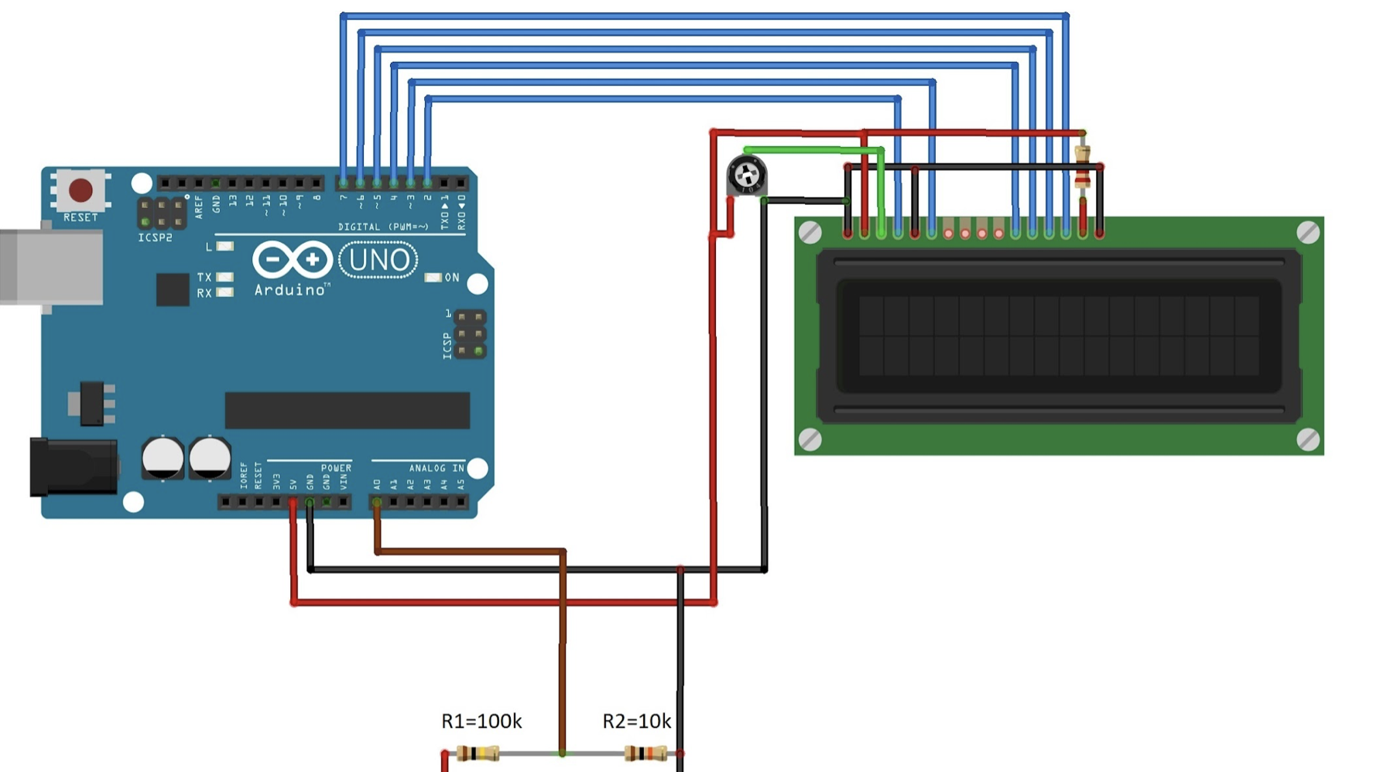
Figure 55. Wiring Diagram
The code might change once we start testing the parts. There are already some open source sites where they share some code snippets for Arduino that can calculate battery percentage and power output, so we would have to test and modify some of those snippets and see what can work with our model. One of the advantages of implementing the arduino in our project, is that there are many open source sites and libraries that we can use to our advantage and apply them to finalize our idea on how to display the power output and possibly the battery health or percentage.

In figure 56, we show a code example that could possibly work with our model, however, we would most likely have to modify it and adapt it depending on the connections, the battery position and our battery’s capacity. The pins on the LCD won’t vary in the code. We plan to code using C programming and use different libraries such as ‘LiquidCrystal.h’ and ‘LCD.h’. The display utilizes parallel data. We may operate the display in half byte mode to make fewer wire connections to the microcontroller, and in this instance, data pins D4 through D7 are utilized to communicate one half of a byte at a time. This reduces the amount of wires we need to run to our interface.

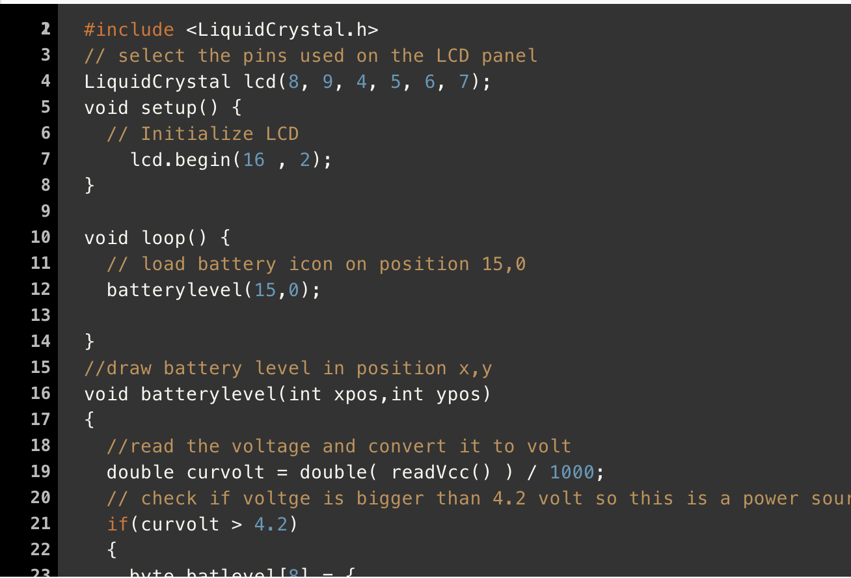
Figure 56. Code Snippet

During Senior Design II, we made some changes in the code as new necessities came around while testing. We realized some libraries were not available for our Arduino version so had to come up with other possibilities. The picture below shows a snippet of our updated code.
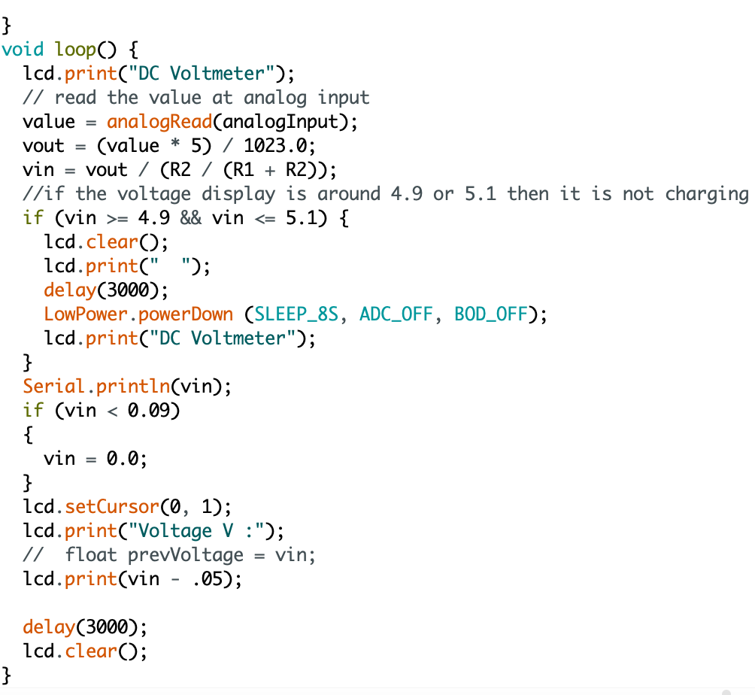

5.3 Overall Schematic

This section will be providing information regarding the schematics of the individual components in the project, as well as the overall schematic of the project. Below is more detailed information based on the schematics.

5.3.1 Block Diagram

At this point in our documentation and project progression, we only have a block diagram. Until we receive our parts, and begin building our project, we will have to hold off on developing a full-fledged schematic. The reason we are waiting until we have the project built is because we need to do all kinds of testing with the Arduino first. For our project, one of our goals is to use an Arduino to measure the voltage output from the voltage booster to the wireless Qi charger. In order to do this, we need to develop a hardware and software system using the Arduino and corresponding components. Until we have all of our parts in hand, which they have been ordered, we will need to postpone our full schematic. See the below image for a look at our solar battery pack basic schematic (block diagram).

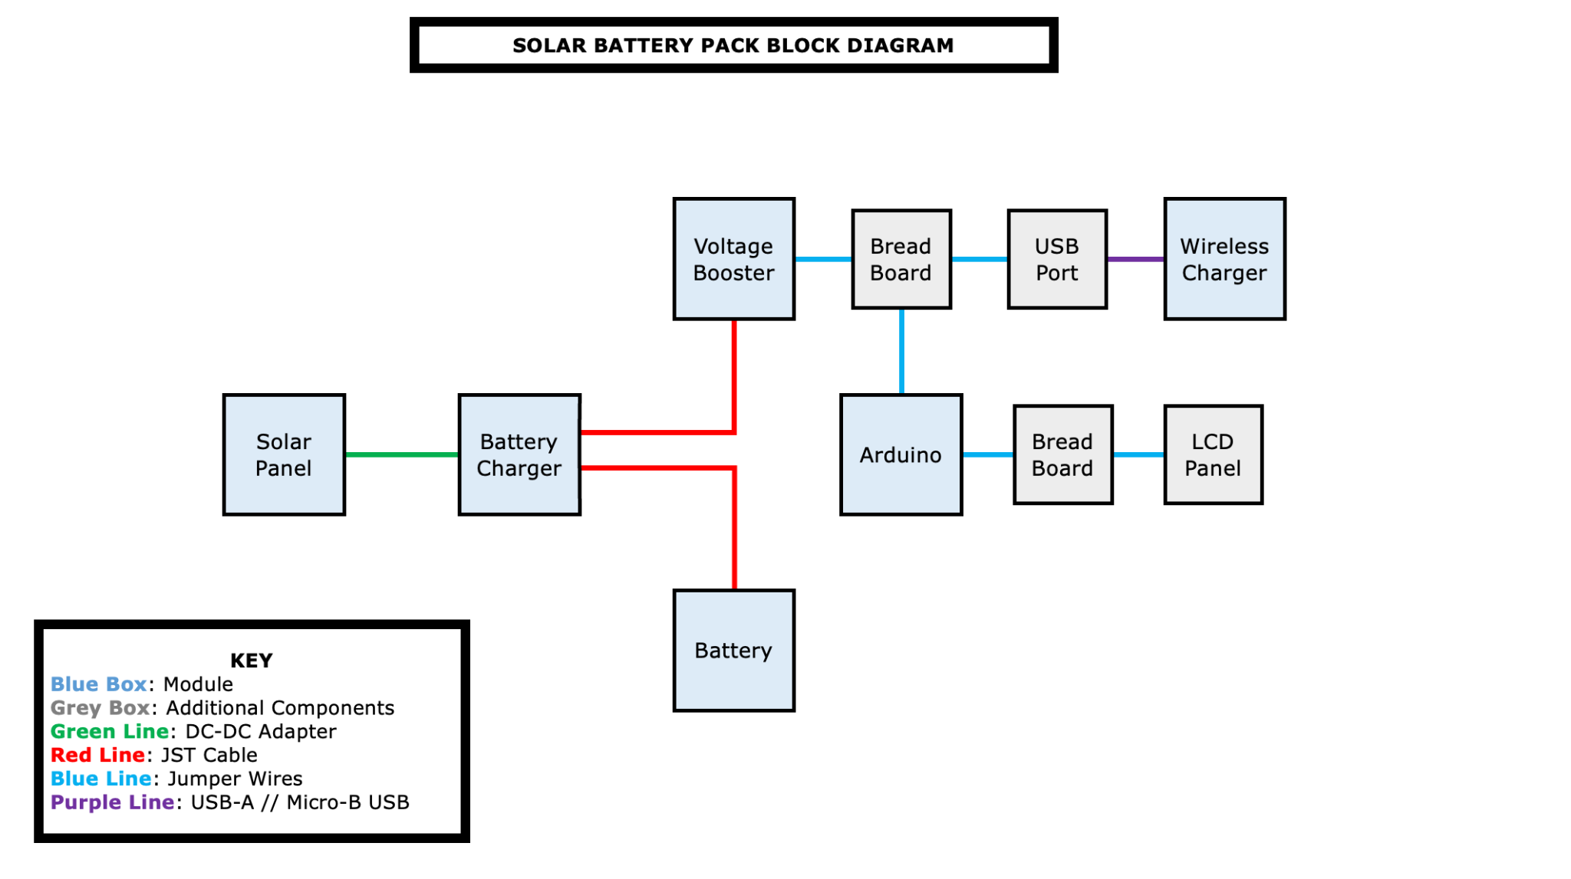
Figure 57. Block Diagram

In this diagram, the first thing we need to look at is the key. This details what each color and item represents within the block diagram. The blue box represents a module, which is one of the main components of the actual project (ex: solar panel, battery charger, battery, voltage booster, wireless charger, Arduino). The gray boxes are additional components, ones that are still important, but not a major focus of the project (ex: breadboard, USB port, LCD panel). We all are using four different cables in our project: a DC cable (green line), a JST cable (red line), jumper wires (a blue line), and a USB-A to Micro-B USB (purple line).

After reviewing the Key, we can now move on to the block diagram itself. The first block is our first module - the solar panel. More on the solar panel can be found in the parts section above, but what is important here is that it comes with an attached DC cable. This DC cable connects to a DC port in our second module - the battery charger. This battery charger (more on that in the parts section above) comes with two ports, both of which are JST ports. However, one is for a LOAD and another is for a BATTERY. The lower red line is a JST cable connection from the battery (the battery has a JST cable built in). The upper red line is another JST cable connection from the LOAD terminal of the battery charger to the input terminal of the voltage booster. After the voltage booster module (more on that above), we move to more complicated territory. The voltage booster connects via jumper wires (blue lines) to our first additional component - a breadboard. The whole point of this breadboard is to allow for our Arduino to measure the voltage output from the voltage booster. On the right side of the breadboard, there are more jumper wires (blue lines) that connect to a USB Port - our second additional component. This USB Port connects to the wireless charger (described above) using a USB-A to Micro-B USB (purple line). Moving back to our breadboard, we see that it also connects to our Arduino via jumper wires (blue lines). The Arduino, which is our final module, connects to a breadboard via more jumper wires (blue lines), and then connects to the LCD panel using additional jumper wires (blue lines).

This completes the written description of our block diagram. For the time being, this should be enough to guide us while developing the hardware and software. Until we have determined a solid and complete plan (after testing the device), we will need to wait to develop a full-fledged schematic. Once the device is working properly, mainly the Arduino, we can develop a schematic. The reason we are waiting is because there are so many ways to build an Arduino that can read the voltage of the voltage booster. However, until we have our hardware in hand, it will be impossible to determine what will work for our exact project. We have all used an Arduino before, but that does not mean we all have a ton of experience. Therefore, we will use the old trial-and-error method to develop a working system, and then create an in-depth schematic.

5.3.2 Schematic

At this stage in our project development, we have created an overall schematic for our project. This will be much more detailed than our block diagram pictured above. Our schematic features the modules and components we used in our project. The modules, however, will mainly be shown as ports. This is because the software we are using to create our schematic, Eagle, does not include the majority of the modules we need. Therefore, we will be representing our modules with the ports they include. This allows us to show all of the necessary connections without having the actual module footprint available to us (we even checked multiple online sources, including the manufacturer, and we were unable to find the modules we needed).

Additionally, we will include our Arduino setup within our schematic. The Arduino setup will include wiring, the Arduino board, a breadboard, and an LCD. As a reminder, this Arduino setup will be responsible for reading and displaying the voltage at the voltage booster (in turn, this will be the voltage entering the wireless charger). This is a separate system from the charger itself, but in this schematic, we will work to incorporate the two systems together. Eventually, we expect our schematic to change. At this point in time, we plan on using our Arduino as the voltage reader.

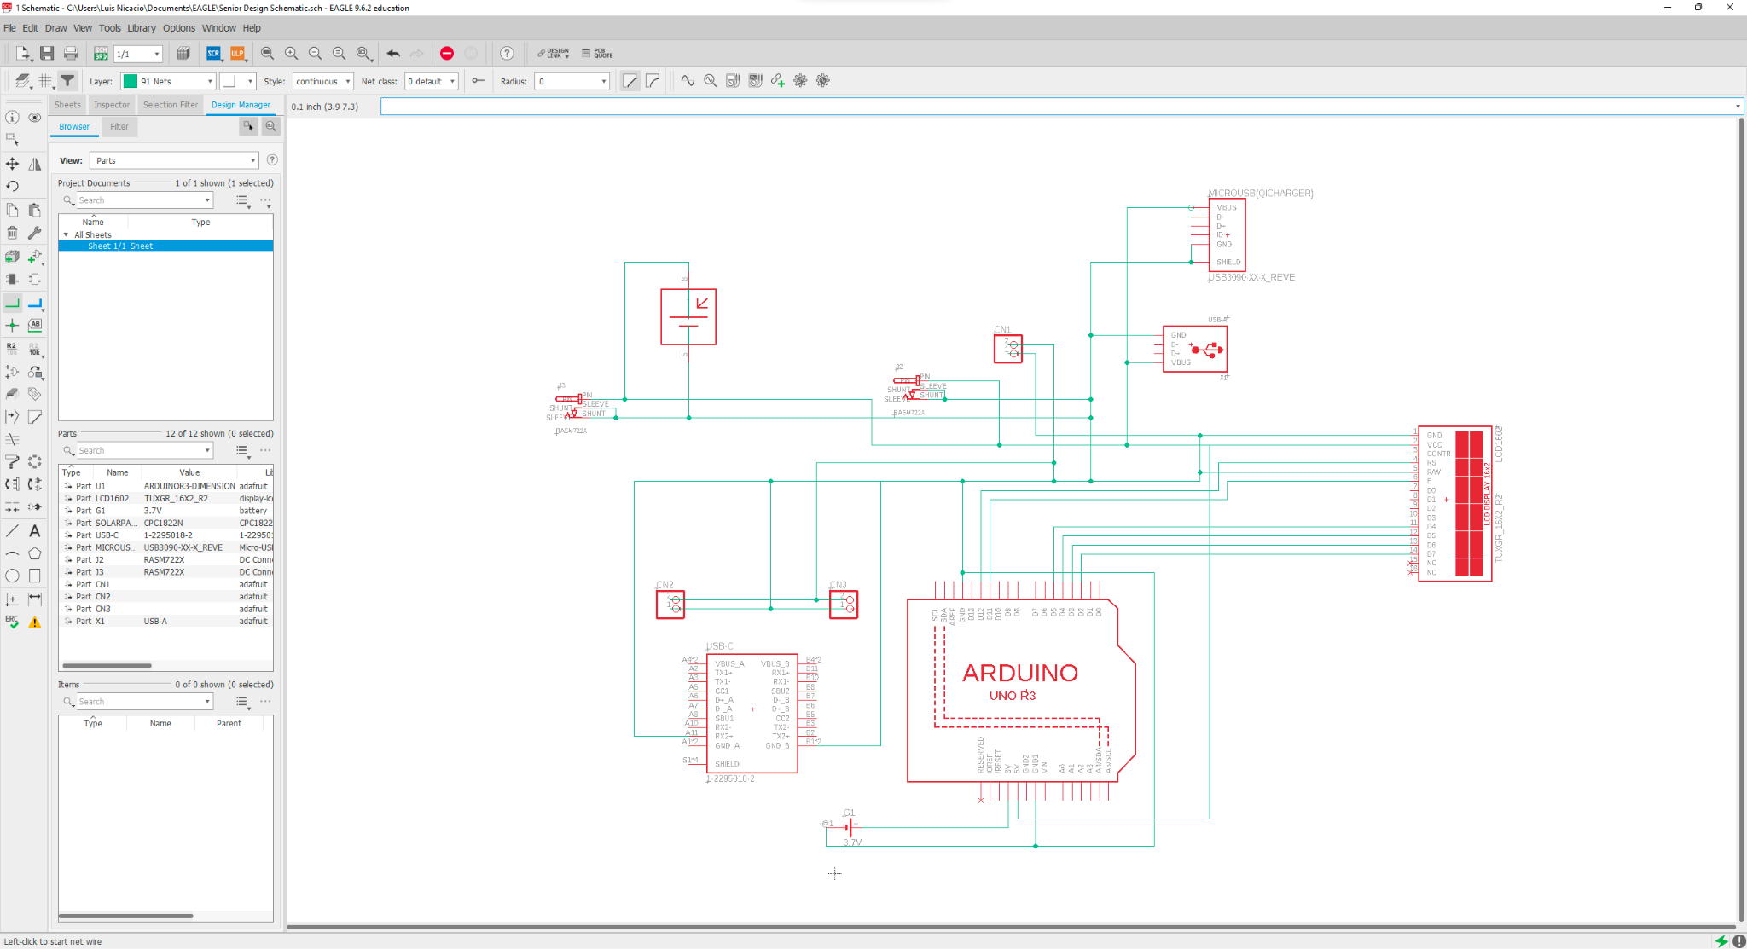
Figure 58. Schematic

5.4 Software

The software is a big part of our project. There is software that can be used to implement hardware components for the Solar charger. The project's software was chosen for a variety of reasons, including ease of use, thorough documentation, and the fact that it is widely used, making it more portable.

The project's software includes CAD applications like Eagle, as well as numerous software and programming languages that support the microcontroller. We will be using the arduino to code and be able to know the voltage input and output so that we and the user have a better understanding on how much power is produced from the solar panel and how much is being used. This will also help with knowing the battery life of our solar charger.

5.4.1 Methodologies

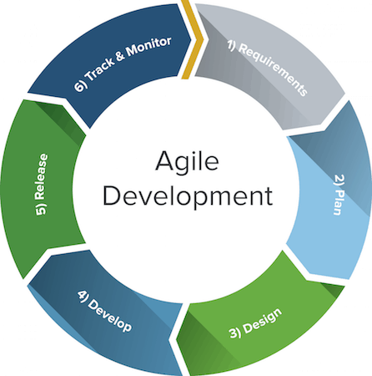
Agile is a project management methodology that is commonly utilized in software development nowadays. A lot of important companies use this method and it seems to deliver great results. It is most commonly known as a waterfall model, which means we used a process to construct a better ordered application. The first stage in the waterfall approach is to collect all of the requirements we'll need to build the program we desire. Then, during implementation, we will have some coding that will be run. Then there will be verification and, finally, maintenance. In other terms, as shown in figure 39, Agile is a chain of quick development and implementation, which means that the first portion of the program is always the planning section, followed by the design and development of the application. After that, we debug and test, release, and finally review everything before putting it all into production.
Figure 59. Agile methodology

Furthermore, another feature of Agile is that instead of working on a broad section of the program, we work in iterations, meaning we take small sections and have defined tasks that must be accomplished and we order them by priority levels so that we know what needs to be worked on first and results we are expecting. By doing this we also ensure that our final project meets and satisfies all requirements provided by each team member at the start of the project.

The following are the most important and main benefits of Agile: increased software delivery persistence, increased stakeholder satisfaction, inspect and adapt, the ability to welcome changes at any stage of the software application process, design is important, and daily interactions with team members are also important. Agile provided the framework for us to make better decisions, resulting in more efficient software. We discovered better techniques of building software by doing it ourselves and assisting our other team members if they ran into any challenges or concerns. This method will work great especially because we will have to work with different softwares to develop the 3D model, the code and the schematics and connections.

5.4.2 Development with Arduino

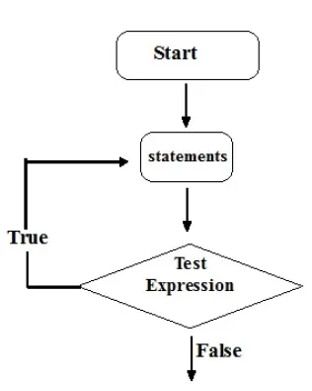
One of the simplest tools for controlling electronic things is Arduino. It is easy to gather inputs and work with them, like in our case getting the input voltage and calculating the exact number or percentage to display it to the user. As a result, Arduino was utilized to read and control inputs and outputs. The actual component of Arduino is the board named Uno, which has a microcontroller on it, as well as the software IDE that we downloaded and used to program our Arduino board. The Arduino code is the third component, also known as the source code.

Before any code is developed we have to make sure we have an overall understanding of what we want to accomplish in our project and what we want the microcontroller to do. For this, we will need to come up with a flowchart where we show that statements or functions, the testing which is where a function makes a decision whether to continue down the code, exit or repeat. We will follow the flowchart example shown in the next figure.

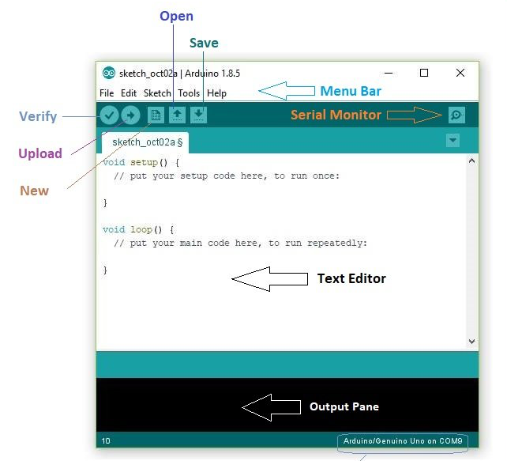
The code that we typed inside the Arduino IDE is loaded onto the Arduino board's microcontroller. A sketch is the name for the Arduino code that we write. We will mostly utilize C programming language and some of their libraries to write the lines of code. The microcontroller's ease of use is what drew us to Arduino. The user handbook for the majority of microcontrollers is close to 300 pages long. However, Arduino makes it quite simple; we can connect and test it on a breadboard and then connect it straight to the LCD and voltage booster afterwards. We plan to make an easy statement to check whether the battery is being read or not and then display the power output. Since we are planning to use a LCD, it will be easier to debug and show anything in the display instead of through the computer.
Figure 60 Overall flowchart

The Arduino IDE is also created for simplicity. An example is shown in figure 50, it is a very simple editor where you can save your code and upload it directly to the microcontroller. The arduino website also includes different tutorials on how to use some of their libraries in different languages that will be helpful during our programming phase. While there are several integrated development environments available, the Arduino IDE is constructed with ease of use in mind. We would only have to click a button to submit the code we write, and it executes so automatically. Finally, the Arduino code includes operations such as reading and controlling inputs and outputs. We would have to continually return to the user manual for very precise information we require for a certain sensor or for controlling anything special if we were to program a microcontroller without utilizing Arduino.
Figure 61. IDE

By offering easy programming functions for us to utilize, the Arduino language has considerably decreased that complexity. In addition, we installed and used a number of Arduino code libraries. These libraries made it easier to use a variety of components, from communicating with sensors to controlling various outputs. Arduino is also open source hardware, which means that other firms create Arduino boards that are compatible with the Arduino IDE and can be programmed with it.

We picked the Arduino software because there is so much infrastructure out there that nearly whatever we needed to do was simple to do because there were so many resources and infrastructures accessible for the usage of Arduino. The program installation takes only a few minutes. The Arduino system is made up of IDEs (Integrated Development Environments), which aid in programming, as well as a physical board.

What makes Arduino so simple to use is that they developed software that runs on Windows, Mac, and Linux, making uploading our code as simple as plugging in a USB cable or plugging in a DC power connector and pressing a button. We can work using any kind of computer and know that the code and program will still be compatible. Arduino has developed a programming language that allows us to configure all of the Arduino hardware devices in a consistent manner.

The majority of our development with Arduino will be in the software. Every Arduino program, once installed, contains two primary sections: the "void setup" and the "void loop." We set our pins in the void setup, then in the void loop, we set the jobs we need to repeat again and over. In addition, the Arduino is very budget friendly, under $30 which was very convenient with our budget plan. Also, not only is it totally open source to program the Arduino, but the hardware itself, the actual circuit board on which the Arduino is built, is also open source, and we can obtain the design files if we need to.

5.4.3 Microcontroller Software

This section explains how the system's software operates to take into account the operability of all of the physical components. The software is used to make system choices and deliver user-requested functionality. The software that runs in the microcontroller will help our system to display the power output of the battery. The most significant part of the design is the microcontroller. It must correctly understand the inputs, process the inputs, show the results on the LCD, and transfer the processed data without any mistakes.
It is critical that all data be processed and sent in soft real time. Soft real time indicates that we require the data to be provided in real time, but missing the deadline once in a while is acceptable, even if it degrades the device's quality.

The software is in charge of enabling the communication between some of our hardware components such as the battery, microcontroller and display. In order to have a full code for our microcontroller, we will have to start with a pseudocode to make sure we understand the steps we need to take to gather the voltage input from the solar charger, distribute it to the qi charger and be able to display the power output to the LCD. Once we have a set pseudocode, we can move on to coding using a compatible IDE for the Arduino and then upload the software to our microcontroller. The pseudocode, which is written in a very high-level C/C++ type language, would provide for a simple to read and clear description of what the code does, and could be used to keep everyone on the same page throughout code design and layout. Our software should also enable the display to refresh any time the values change.

5.5 Flowchart

The flow of code in our concept is depicted in the diagram below. Software development necessitates the use of a flowchart. Our microcontroller will be at the center of this system, taking all inputs and generating outputs dependent on how we program it. The microcontroller will read the request and respond with the desired data, which will then be shown on the LCD for the user.

5.5.1 Software Flowchart

The flowchart presented below is an overview of how the software will work to display the power output from the solar panel. We included representation of actions that the microcontroller and code need to accomplish, each action will take inputs and make decisions on what to output.

The arduino will have to be initialized first, reading the code that had previously been uploaded and it checks whether it is receiving enough voltage or not. The user interface will send signals to the Arduino. The Arduino code will interpret the user interface values and report the right data.

The arduino will power the LCD and determine if the battery output is within a safe limit, if so it displays it using the LCD. Before even displaying, the microcontroller will have to calculate what is the battery percentage in the battery at that moment, convert it and send the information to the display. Our plan for the display is to be able to show the user the voltage and battery percentage, so we have to make sure that data is being sent to the microcontroller and that it can read it using our code. The flowchart is good to have for an overall understanding when it comes to coding. It might change later on when we do more testing and can have all the connections needed.
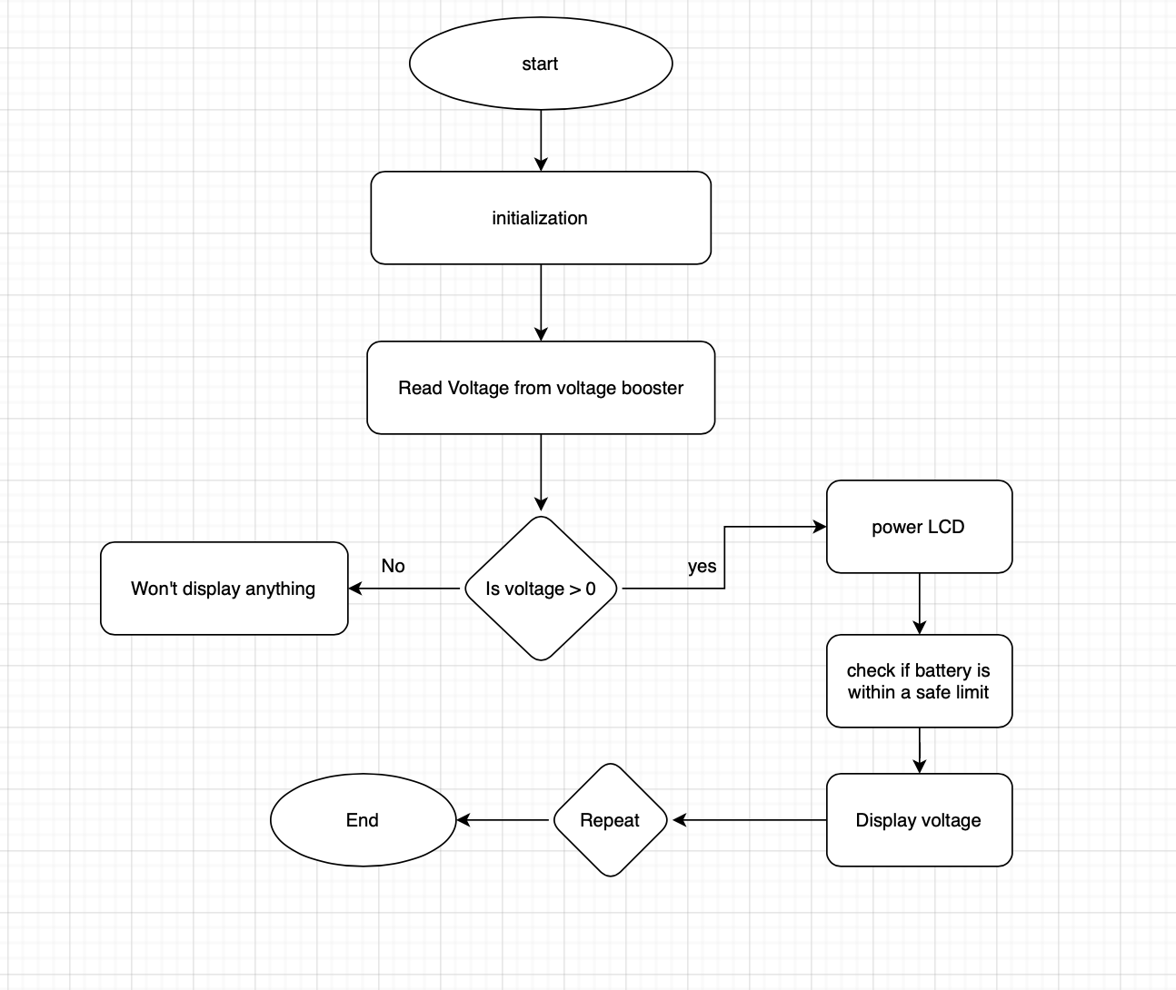
Figure 62. Software flowchart

5.6 Interface

The section provides further explanations on the overall interface of the project, including the components within the project. Below provides the different designs of the overall interface and the interface of the body (stadium) of the project.

5.6.1 Overall Interface

Although our device is extremely capable, its interface is actually quite simple. The top side of our charger will be the wireless charger in the center and the LCD to one side (depending on which way you are looking at the device). Our device will also contain a USB-A port for charging additional devices and a USB-C port for charging the battery directly from a wall outlet instead of waiting for the solar panel to charge the device.

5.6.2 Stadium Design/Interface

Our overall interface is mentioned above, but this section relates that to our stadium design. The wireless charger, for phones only, will be placed in the center of the stadium right underneath our field (which will be some sort of artificial turf or green cardboard). The LCD for displaying the voltage output to the wireless charger will act as our stadium screen, and will be placed above one side of the bleachers. The USB-A port will be underneath the stadium, acting as a doorway, bathroom, etc in our little stadium; once again, this USB-A port is for using the battery to charge other devices. The USB-C port is really too small to look like anything other than a doorway, but this port will be used to charge the battery and power the wireless charger when there is no sunlight available.

Unfortunately, we were unable to go ahead with our original plan to craft a stadium in AutoCAD. We did not have the requisite experience necessary to construct something as detailed as a stadium in AutoCAD, and our whole group was learning how to use AutoCAD for the first time. We decided to go with the design of a box that we hollowed out and made offsets to. Unfortunately our 3D printing software/printer wasn’t able to handle printing the whole thing at once, so we had to splice the figure in AutoCAD and split it into four parts. We used the 3D printer to print each of these parts separately, then used electrical tape to piece them together.

5.6.3 AutoCAD Modeling

AutoCAD is a commercial computer aided design/drafting software that is used in the architectural industry by project managers, graphic designers, city planners, etc. It has two and three dimensional modeling capabilities, and allows the creation and modification of geometric models with an almost infinite capacity to develop all types of structures and objects. Because of these proficiencies, AutoCAD has transcended the traditional architecture/engineering world to enter the graphic and interior design space.
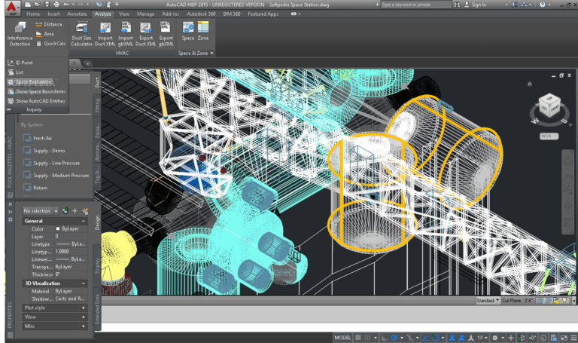
The software works with its own native file type called .dwg, and .dxf has been developed because of its wide degree of popularity. Some reasons for AutoCAD’s popularity is that it increases the quality of the design because of its exceptional interface, and can be used to create a database for manufacturing. Furthermore, because of the documentation aspect of the software, this can improve communication between developers, and this will increase the overall productivity of the users. Wiring diagrams and surface model diagrams can be created using the software, which has led to its dramatic increase in popularity among the engineering community. Even the fashion industry has dabbled in the use of AutoCAD, since it has the tools necessary for planning designs for the manufacture of jewelry, toys and other delicate objects.
Figure 63: AutoCAD Window

We may be using AutoCAD to design the foundation of our solar charging station, which will be modeled after the University of Central Florida’s 3MG Stadium. We would use AutoCAD’s tools to create a rough design of the stadium, and if the file is compatible with the 3D printer’s software, we will print the model based on the .dwg file that we create. However, since the difficulty level of using AutoCAD would be much higher, we will most likely be using the same software that came with the 3D printer, which is called XYZware. We’ll be printing each section of the stadium separately, then using hot glue to connect the different parts of the foundation together.

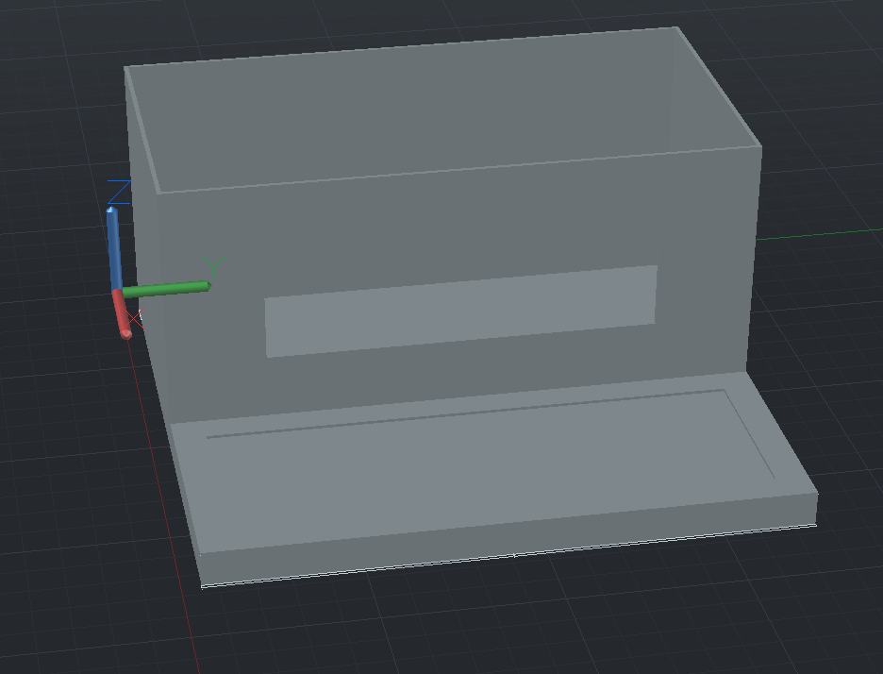
Above is the AutoCAD design that we used to house all of our gadgets, wires, and devices. The top box will house all the components we’ll use and The roof of the top box will be occupied by our solar panel, and the window on the top box will be where the LCD display and the PCB’s LED lights will be suspended . The bottom platform will be where the wireless qi charger and wireless charging device will rest.

6. Integration, PCB Design, and System Testing

This section is all about building the project, developing the appropriate PCB, and following through with testing to ensure everything works as expected. The Integration section details exactly how we built our project and why. The PCB design was created from the schematic in previous sections. The Testing section will explain how we tested our project, what issues we found, and how we solved them. One of the most important parts of any project process is the testing phase.

6.1 Overall Integration

This section will focus on building our project. Mainly, it will discuss the order each part was put together and why. Additionally, it will discuss some common practices for handling parts and preparing them for a buildup.

6.1.1 Integration Preparation

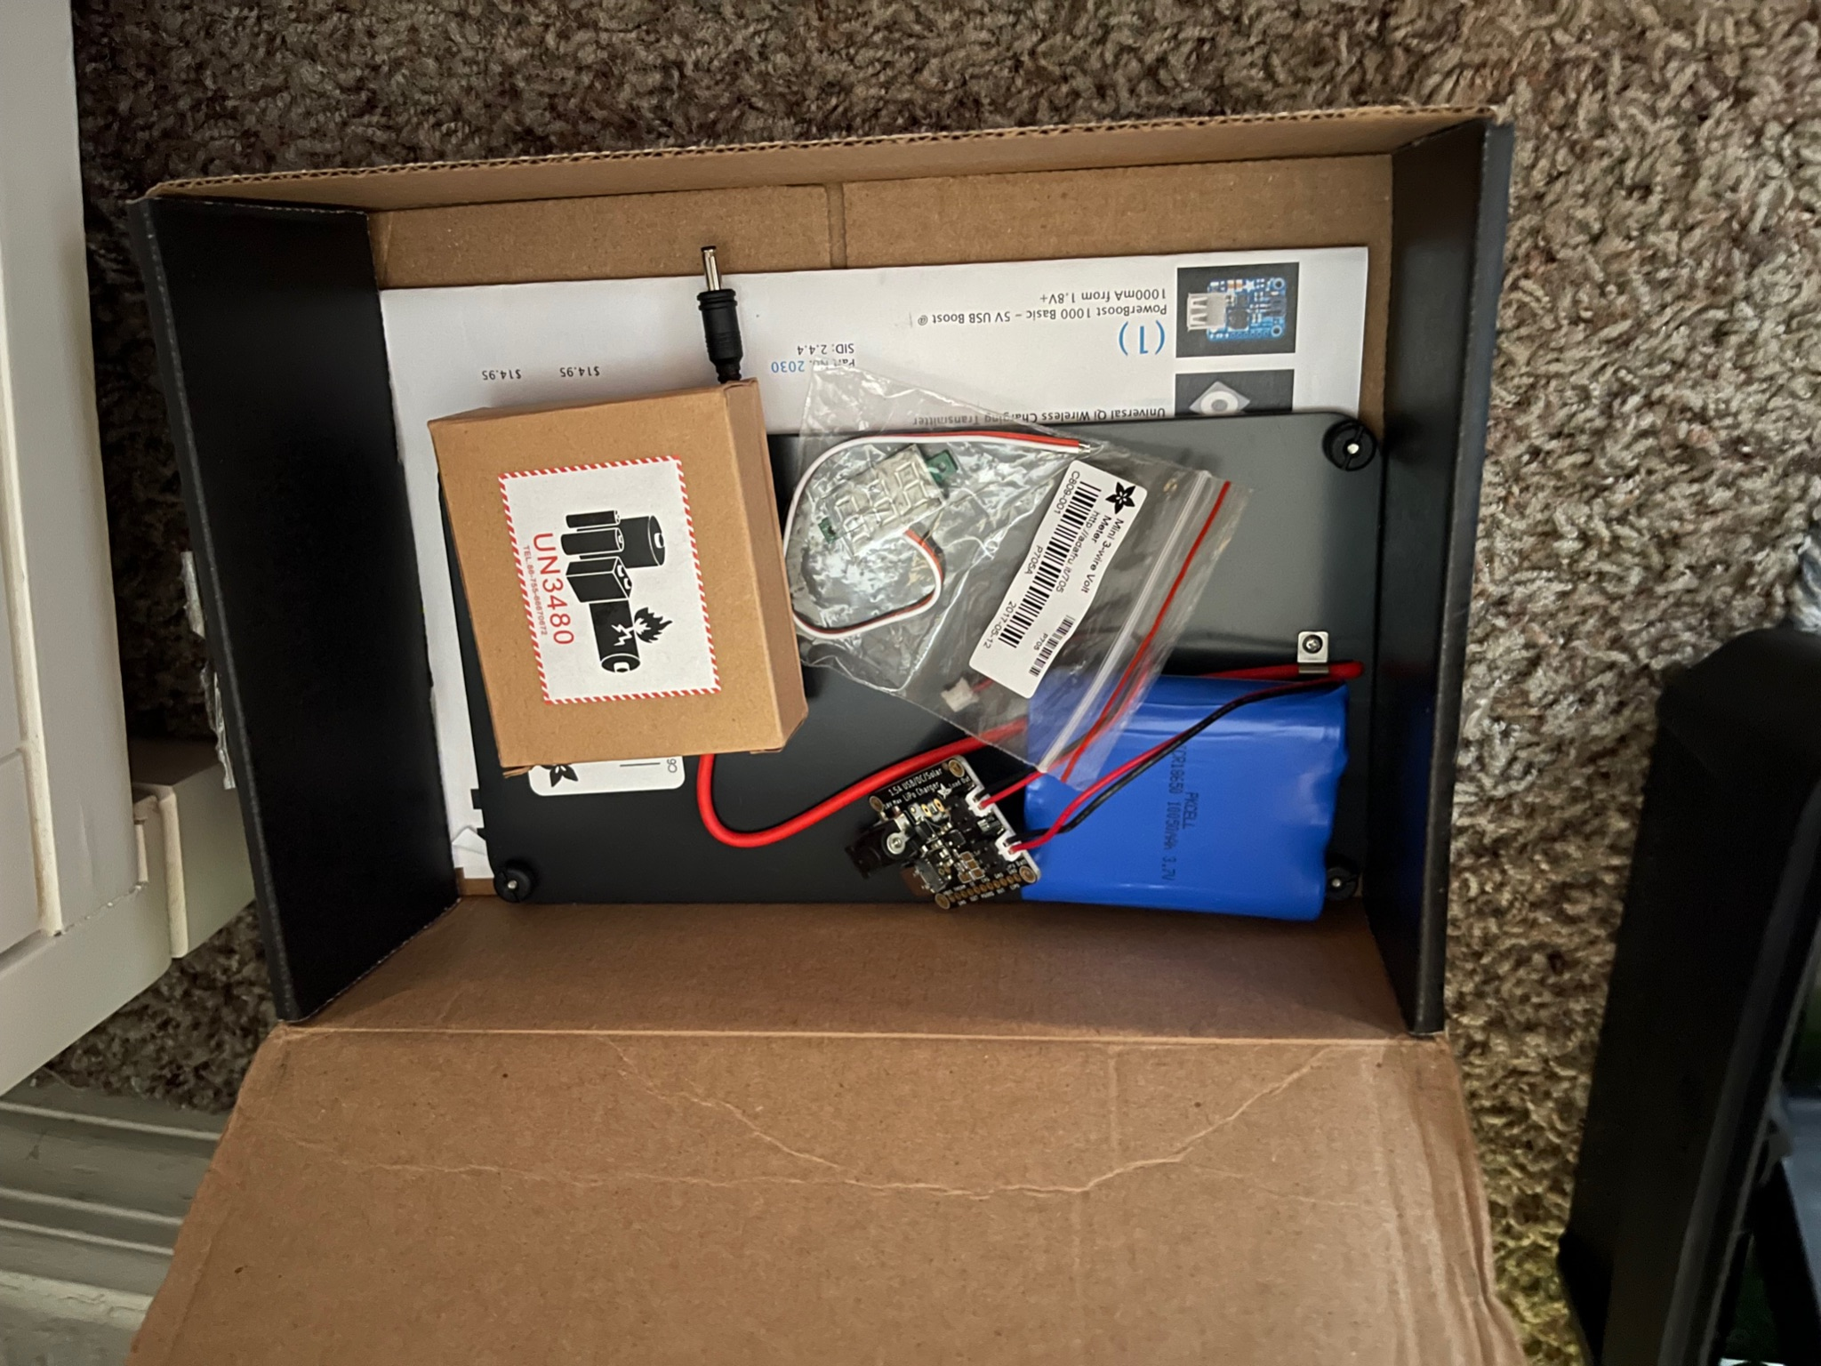
The first step to the buildup of any project is ensuring all of the required materials are at the ready. First, the group made sure our block diagram and earlier sections were completed; this is important because we need to know how we are going to build our design. If the group is not all on the same page, that could create a huge number of quality issues. While unboxing all of our parts, the group pulled up the parts list of everything we ordered (which was also included in the box) as well as our block diagram to ensure everything was accounted for. Next, we moved forward with carefully opening the box to prevent damaging any parts. The group removed all of the parts, placed them on my benchtop (my desk), and compared the parts to the parts ordered list. After confirming everything lined up, we all began to put all of the parts together.
Figure 64. Box of Parts

6.1.2 Charger Integration

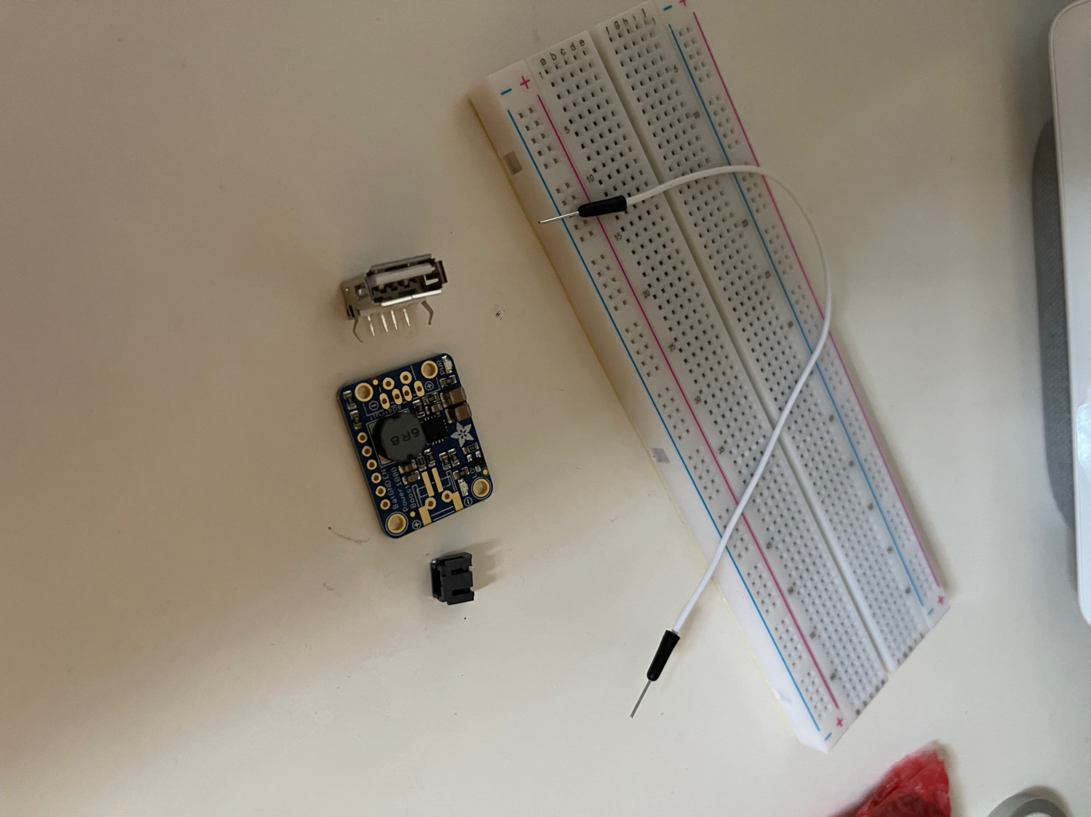
After ensuring all parts are accounted for and safely removed from their packaging, it is time to move forward with building the project. First, we picked up the solar panel and removed the tape holding the DC connector to the base of the panel; then we laid it flat on the table (solar cells facing up). Next, we used a pair of scissors to cut open the bag for the battery charger. Inside, there was the battery charger as well as a row of pins that could be soldered on for breadboard usage (although we should not need this functionality for the battery charger). This is where we actually ran into our first issue. The solar panel uses a 1.1 mm DC connector while the battery charger has a 3.5 mm DC connector port. Therefore, we will need to order an adapter in order to compensate for the difference. Once this arrives, we will be able to finish this part of the project. To keep up with our time schedule, we will move along to the next part. This will help us stay on schedule and find any other issues (just in case we need to order more parts).

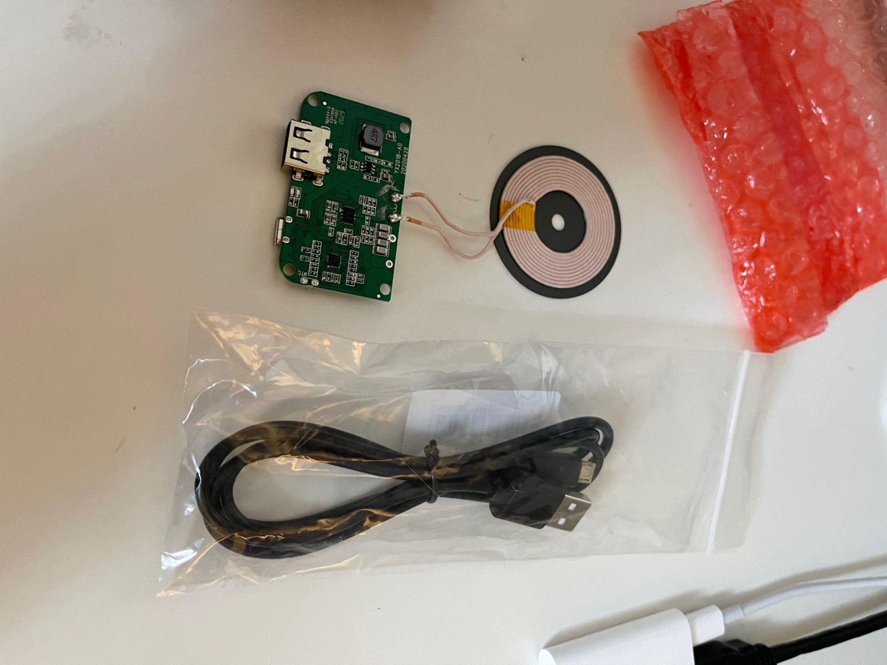
Next, we went ahead and removed the battery from its own box and bag - then we connected it to the battery charger using the builtin JST cable and the corresponding battery JST connector port. The next step is connecting the voltage booster. Before we do that, however, we will need to grab our soldering kit and solder on the JST connector port to the voltage booster (it does not come preinstalled). For the time being, we connected the JST cable to the JST load port on the battery charger. Now back to the voltage booster - the first thing we need to do is solder the JST port to the voltage booster module (we made sure to attach the JST port to the side with only two terminals). Once that has been completed, we need to solder jumper wires to the other side of the voltage booster. Originally, the USB port would have connected to this side, but instead, we are connecting these jumper wires to a breadboard for the purpose of our Arduino Integration (see section below). After we have soldered four jumper wires to the voltage booster module, we connect the other end of the jumper wires to a breadboard. For the time being, we will use a normal breadboard; in the future, however, we will consider using a breadboard that involves soldering to seal our connections (once we confirm everything works as intended). Then, we need to take the USB port that was included with the voltage booster and place it on the breadboard (we had to bend the pins on the USB port that were designed to hold it on the voltage booster module - these are not the pins that are used for functionality purposes).
Figure 65. Breadboard
Figure 66. Wireless charger chosen

Once the voltage booster and breadboard combination has been set up, it is time to move onto the wireless charger. The Arduino Integration, which will be attached to the breadboard, will be discussed in detail below. After removing our wireless charger and charging cable from their packages, we began to move forward. We connected our USB cable between the USB port on the breadboard and the USB port on the wireless charger module. The USB port on the breadboard is USB-A while the wireless charger input uses micro USB.

6.1.3 Arduino Integration

This subsection is all about how we plan to integrate our Arduino into the rest of the project. We broke our integration section into two subsections: Charger Integration and Arduino Integration. We did this because the two parts can be built individually (meaning we do not need the Arduino to build the rest of the project). Additionally, the code for the Arduino as well as the breadboard, wires, etc, can be prepared without the solar panel and charger (although it would help with testing).
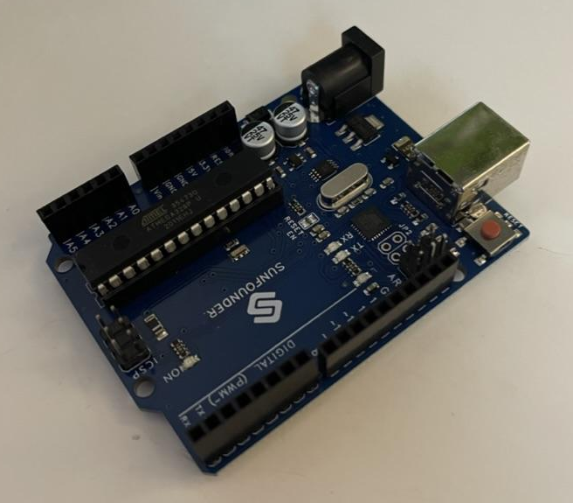
These two subsections, Charger Integration and Arduino Integration, are fundamentally different. The Charger Integration section, shown above, lists all of the hardware that does not directly need coding experience. That subsection is all about the solar panel, battery charger, battery, voltage booster, and the wireless charger. These are the fundamentals of what we need to make our charger work. The Arduino has one purpose, which is to read and display the output voltage at the wireless charger on a LCD display. We need our main functionality to work: wireless charging a phone from a battery and a solar panel. We ideally want the Arduino to work, but our project can function without it. The text below will discuss how we developed the Arduino hardware as well as the coding required for the Arduino to operate.
Figure 67. Arduino integration

Our coding strategy is to build up a number of functions and try to implement each one to get the prototype to work. Once we've verified that each section of the program is working and doing its purpose, we'll begin the process of putting the project together as a whole. The arduino will be reading the voltage from the voltage booster since this will give us an accurate power output. However, the solar panel is going to be powering different components other than the arduino, such as charging the battery and it will also go to the voltage booster to later power the qi charger. Therefore, we will need to make enough tests to make sure we are reading an accurate voltage output.

For our initial prototyping we plan to connect some of our components, including the arduino, using a breadboard. The advantage of arduino is that it has some analog pins in which you can connect your power source such as a battery, solar charger, or voltage booster and it is able to read the voltage power and convert it to digital format and display the output on an LCD or computer.

We can initially start by connecting the solar panel to the Arduino to make sure that we can successfully read power output from a source. We can connect the solar panel to one of the arduino’s analog pins and convert the voltage to display it to the LCD. The picture below shows an example of the connections of a solar panel to an arduino and how it can display to an LCD. In this example we have to add some resistors. This schematic is a good guidance for us to get our connections and test the power output. Once we have an overall idea of how to read the voltage, we can move to connect the arduino to the voltage booster and get our readings.

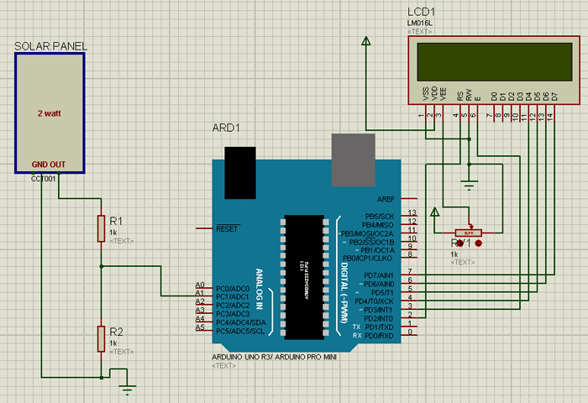
Figure 68. Arduino Connections

Our connections for our final prototype will be most likely the same or at least similar, however, what we will be changing and modifying is our code. We will be using different open source libraries that Arduino provides.

6.2 PCB Design

A printed circuit board (PCB) will be used for all the power circuitry connections as well as the connections for the microcontroller, we need this design in order to develop our portable charger system. A circuit board construction software, such as Eagle PCB Design, will be used to design the PCB.

6.2.1 PCB Expectations

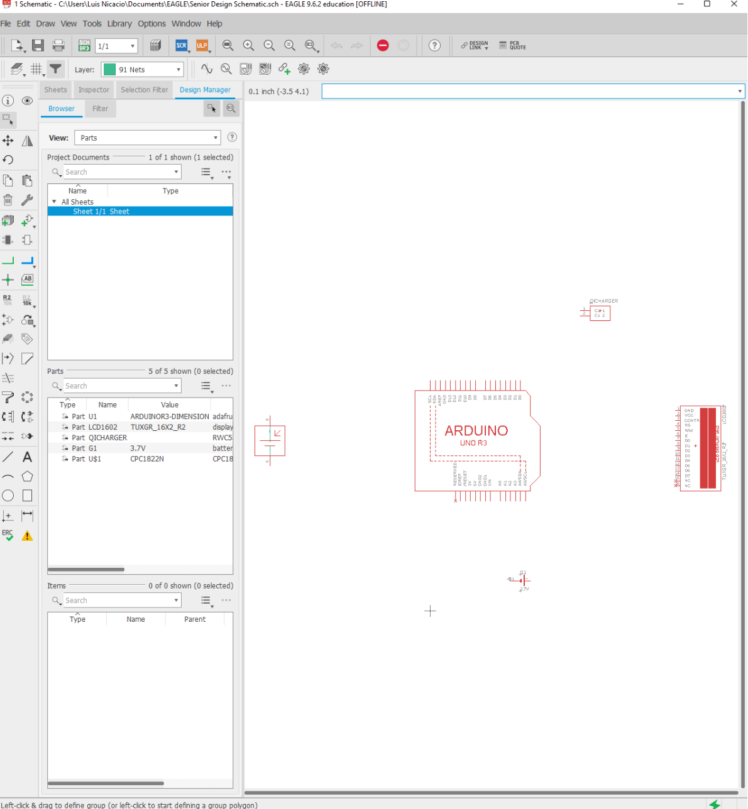
The PCB Design is basically a real life board shown virtually. We are using a program called Eagle to develop our in-depth schematic. Then, using this schematic, we will create our PCB Design. The Eagle software is extremely intelligent; it will automatically add all of our connections,
components, and modules onto the PCB board. However, it is up to us, the board designers, to designate where each component will be placed on the board. This is to ensure that the board will be built correctly. Once our PCB Design has been completed, we will send our board to one of many manufacturing companies. They will develop this board using our PCB design and then mail it to us. Additionally, we may attempt to develop the board ourselves depending on the level of complexity. We would like to build our own board, but if the design is too complex, we may not have the skills or tools required to complete the job correctly.
Figure 69: Eagle Window

6.2.2 PCB Timeline

At this point in our project, we have currently completed our block diagram, but we are still working to complete our schematic. Our main schematic will contain multiple modules as well as our Arduino microcontroller unit. All of our parts are mainly modules, and these modules will be displayed in our schematic. However, we cannot display the entire modules using Eagle, so we will display the ports only. By having just the ports, we are still able to connect all of our components together using the virtual wiring tools.
Additionally, we will use a virtual Arduino module in Eagle. With this component, we will connect all of our wires to the other part modules displayed. Then, we will ensure we add our LCD since it is another part available in Eagle. Once all of our parts and modules have been added, we will connect them using the multiple tools available in Eagle. Then, once everything has been connected, our overall schematic will be completed.
At this point in time, all we have completed is our overall schematic. For the time being, we will have to hold off on producing any more in-depth schematics and/or PCB Designs due to time constraints. For our first unit, the demo unit, we will be using an Arduino to read the voltage from the voltage booster (which will then enter the wireless charger and to our phones). However, depending on time and resource constraints, we plan on developing our own board to replace the Arduino for our final project. We already know how we will implement our Arduino into our project, and it will read the voltage as expected. However, for efficiency purposes, we would like to create our own board that will perform the same function as the Arduino. Our board will be similar, but it will not include all of the extras that the Arduino has; the board we will create needs to perform one purpose and one purpose only - read the voltage from the voltage booster. We want to do this because it will cut costs, be more energy efficient, and will allow us to learn a great deal about the design and manufacturing process.

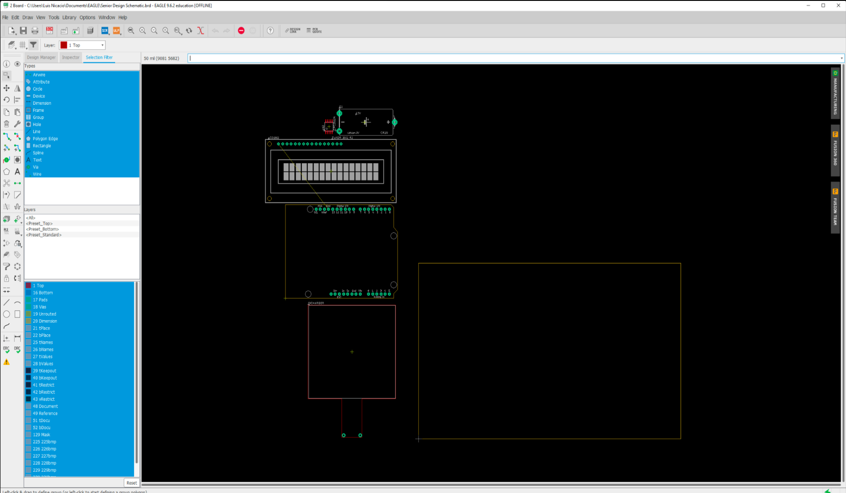
Figure 70: PCB Screen

6.2.3 PCB Summary

In summary, our goal is to produce our very own board along with the use of an Arduino microcontroller. We will have to learn a lot about how to work with software other than Arduino software. Afterwards, we will use Eagle to produce a new indepth schematic. Using our schematic in Eagle, we will create a PCB Design. This PCB Design will then be added to this report. The PCB design will then be sent to a manufacturer to be built, and then returned to us. All of this will take place early Spring (February/March).

PCB Timeline
Step | Idea | Research | Design | Manufacture | Implement
Date | December | January | February | March | April
Table 23: Initial PCB Timeline

6.2.4 PCB Research Step Preparation

In order to prepare for the next step, the research step, we will first need to establish what it is we are researching. We already know our idea, all of that was discussed in the subsections preceding this one. For our research, we will begin looking for footprints and schematics from multiple manufacturers. We will produce our design in Eagle, and we will use these schematics for inspiration. They will guide us and allow our team to produce a product that functions as expected. After we have found multiple schematics, we will then begin to look for who can manufacture our design. An important part of any project is determining how we can build our design as cheap as possible without compromising quality or functionality. After the research process is complete, we will begin designing our board according to the PCB Timeline.

6.2.5 Redesigned PCB Schematic

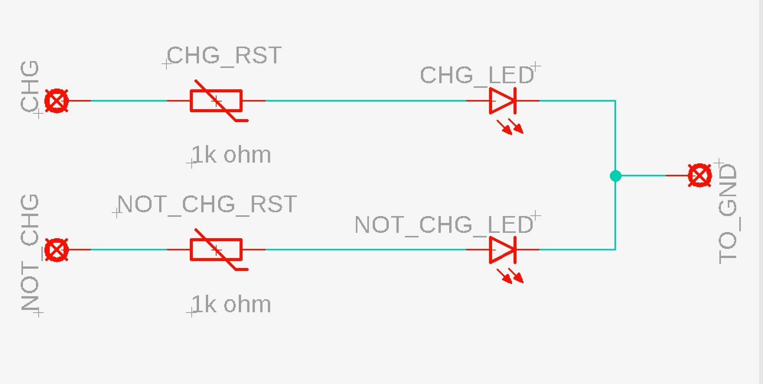
A new PCB has to be designed, due to complications regarding assembly. This new PCB provides a different function for the wireless charger. Autodesk EAGLE software was used in creating the schematic and board files for the PCB, while also using the skills learned through the junior design course taken in a prior semester. The purpose of the PCB is to provide the consumer with two LED lights, a green light and a red light, letting the consumer know when their device is charging properly, but also when there are no issues occurring, in regards to any voltage or wiring. An image is provided of the PCB in Autodesk EAGLE.
Figure 71: New PCB design in Autodesk EAGLE

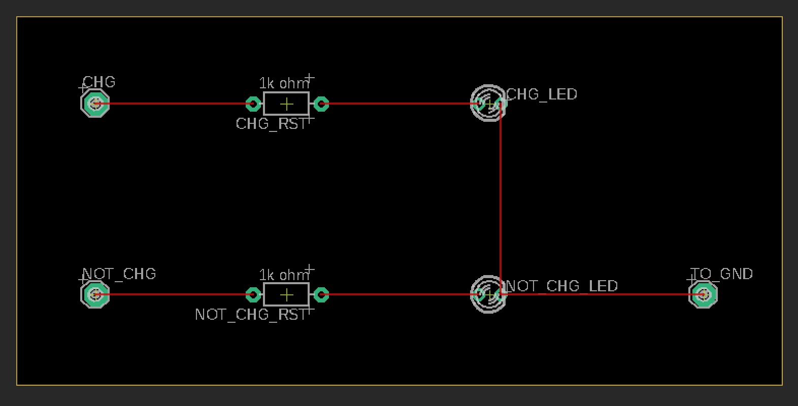
When developing and designing the new PCB, our vision was to develop something that could be used and look simple. The PCB is connected to pins A4 and A5 of the microcontroller, communicating with the other components in the wireless charger, such as the voltage booster and qi charger, where the device is placed to be charged. Along with using the schematic file to edit and create the PCB, the board file (.brd) is used to make sure no wires are touching or interfering with each other, to prevent issues. Below is the board file for the PCB. Overall, the development of this PCB provided a much better outcome and its use will be very beneficial to the charger and overall charger.
Figure 72: board file of PCB design

6.3 System Testing

This section will focus on the testing aspect of our project, so that we can be sure that everything is working prior to our presentation. It will include how we will be testing the voltage production from the solar panel, and how the microcontroller will be tested to ensure compatibility.

6.3.1 Solar Panel Testing
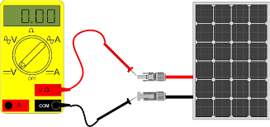
We plan to use a voltmeter to evaluate the voltage output of the solar panels. We can also use its probes to connect to the wire coming out of the cells and measure the voltage created by exposing it to sunlight. The sunlight will activate the photoelectric effect, causing electrons to move down the metal contacts, and through the voltmeter. Using this method, we will be able to evaluate how much voltage is being produced in proportion to the amount of sunlight in real time. A solar cell's lifespan is defined as the period of time it can work until it reaches 80 percent of its initial efficiency.
Figure 73: Solar Panel Testing

Furthermore, another way we can test our solar panel is hooking it up to the arduino and viewing the voltage production on the LCD display. The LCD should be displaying the voltage production reading in real time, therefore if we cover up the solar panel with a black cloth it should be producing zero volts, and if we illuminate the panel with a flashlight then it should be producing its maximum voltage.

6.3.2 Microcontroller

The MCU will be checked in a number of different ways to confirm that it is functioning correctly. The atmega328P is a controller that is compatible with Arduino boards. We will be testing different functions in the arduino to make sure it is working properly before we can even upload our actual software into the microcontroller. Because we will be utilizing the microcontroller development board to build and test our code base as well as show the power output, it will undergo the most testing.

Combinations of these components will be put together to produce a prototype version of the solar charger when early tests are finished. It may take a few tries to get both the charger and the display to work.

6.3.2 Battery Health

The most frequent approach to determine the battery’s health is to measure the voltage. The battery’s health will deteriorate as time passes and the battery cycles several times. The discharge rate and capacity of the battery will be assessed, as well as its behavior under modest voltage and current overloads. In order to avoid unsafe circumstances, it's crucial to understand how the battery will behave to unpredictable activity.This computation may be done in a variety of ways, taking into account various factors such as charge acceptance, voltage, and internal resistance.

Capacity is a typical metric for determining battery health, as degraded batteries have less capacity to retain a charge over time. One advantage we have is that we will display the battery voltage so we can keep track of how much power we have and how the battery is performing. This will mainly work for when we use the prototype indoors, since the battery will kick in when the solar panels are no longer providing enough energy.

As a result, the battery health will be assessed by a capacity over time calculation within the microcontroller. As the battery's total capacity diminishes, the user will notice that the battery's health is deteriorating and that the battery will need to be changed soon.

6.3.3 Presentation Measurables

In our end of semester presentation, there are three measurables that we must demonstrate to the people who will be judging our project. We must be able to demonstrate these things in the time span of our presentation which is about 10-15 minutes. We will be demonstrating three aspects of our choosing during this time.

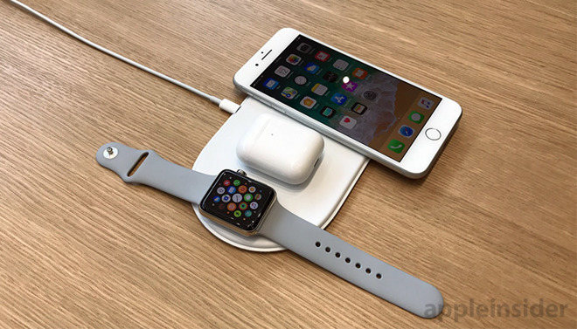
The first thing we will demonstrate is that our solar charging station charges wearable devices along with phones. Since we will be using a wireless Qi charger for our module, we will show that the wireless charger can charge an Airpods Pro case, a Galaxy Buds case, and an Apple Watch Series 6. The charger will be able to charge all three devices as long as the solar panel is absorbing light energy. The way we will confirm that the Airpods and Galaxy Buds cases are charging is that the light on the side of the case lights up when the case is gaining charge. For the watch, the display will light up with a message saying that it’s charging and displaying the battery percentage with a lightning bolt attached to it. For the phone charging demonstration, we’ll use a Galaxy S20 and an iPhone 11 Pro. Both of these phones will light up with a charging message when placed on the wireless charger. We desire to use two different brands of device (Samsung, Android and Apple iPhone) because we want to ensure that we demonstrate that all devices with wireless charging capability will be able to be charged by our solar charging module.
Figure 74: Devices We Will Test

The second thing we will demonstrate is the voltage production being displayed in real time by the solar panel. We will shine a flashlight on the solar panel from a distance, which should cause the LED display’s voltage reading to dramatically increase. We will then use a cloth to cover up the panel, and this should cause the arduino’s LCD voltage reading to decrease to about zero. Since there will be little to no light being absorbed by the solar panel, the photoelectric effect won’t have any photons to activate the electron movement, therefore the LCD will display zero volts. After this, we will use regular room lighting, and we’ll see how much the LCD’s voltage reading displays. Having this feature working during the presentation will show that our solar charging station has the capacity to display an accurate voltage production reading in real time, which is one of the pillars of our project goals.

The third thing we will demonstrate is the battery percentage being displayed on the arduino’s LCD. Since we have a way to charge the batteries from the voltage booster element, if we’re able to display the battery percentage on the LCD, we should see the battery percentage increasing. This is what we will be demonstrating during the presentation. We will plug in the USB-C cable to the voltage booster, charging the battery
pack, and over the span of our 10-15 minute presentation, we want to prove that the batteries are actually charging. Once the battery percentage has increased, as viewed on the LCD display, we will have proven that our battery charging feature works.

In conclusion, our three project measurables should be able to be met in our 10-15 minute presentation period. The first two measurables shouldn't take very long to show because they’re simply displaying that both aspects of the project work whether it’s wirelessly charging phones, earbuds cases, or a smartwatch. The second measurable is simply testing whether the voltage production reader on the arduino LCD display is functioning properly, and illuminating the panel with a flashlight (to test maximum voltage production reading) and covering up the panel with a cloth (to test if the reading goes to zero) will be feasible. We’ll also be using normal room lighting to hopefully display the regular indoors voltage production. Furthermore, the battery percentage display increase will be tested by plugging in a USB-C charging cord to the voltage booster in order for the battery pack to charge. This should display an increase in the battery percentage, and this is what we’re hoping to show in our presentation. We must prove that not only can the solar charging station charge the battery, but also that an alternative method to charge the battery pack exists.

Measureable | Goal
Phone and Wearable Device Charging Capability | To prove that the wireless charger on our solar charging station charges airpods, galaxy buds, an apple watch, an android phone device, and an iPhone device successfully
Real Time Voltage Production Reading on Arduino LCD Display | To prove that the LCD display can successfully display the solar panel’s voltage production reading when the panel is covered or illuminated by a flashlight
Real Time Battery Percentage on Arduino LCD Display | The prove that the LCD display can successfully display the battery pack’s percentage and any increase in it when it’s plugged in to a USB-C charging cable
Figure 24: Measurables

7. Administration

This section details the specifics of how we completed this project as a team. That includes how we established a budget, what technology we used to communicate, and what software we used to develop this document. In many of the sections above, we discussed our estimated budget and financing - this section will talk about what we actually spent on our prototype device and how we divided the roles in order to meet our goals.

7.1 Budget and Financing

This subsection will discuss the budget and how it was established. In addition to this information, we also outlined what the project actually cost, after doing some research and strategically picking our parts, in comparison to our initial estimate.

7.1.1 Budget

The budget was one of the first items we discussed as a team other than what the project would be. As students, we are very limited by our cash flow, especially since we did not have any sponsor for our project. Although large corporations have a heavy amount to invest, the budget is still one of the first things discussed for a new product or project. Developing a budget is a difficult and awkward situation, but it is extremely necessary to build a project successfully. Additionally, it is a vital conversation to have if you want to ensure a team works together effectively.

In order to determine an accurate budget, we first started by analyzing other examples. We started by referring to friends that have also been in senior design before us. After receiving recommendations from them, we reviewed sample reports to get an idea of other team’s spending habits. Once this information has been collected, we went around the room and stated a number that would be too high for each member. Finally, we settled on a budget. Our final budget was $150 per person, and since there are four members in this team, our total budget was $600. Although we did not need this much money in the end, it was nice to know that we had access to more if absolutely necessary (just in case a module or other part broke, and needed to be replaced).

7.1.2 Expenses

The budget was developed to find the maximum amount of money we were actually willing to spend on this project. Ultimately, we decided that a maximum of $150 per person ($600 total) was more than sufficient for our project. In the end, we only spent a fraction of our total budget because we already had access to much of what we needed. For example, our 3D printer was already provided by one of our team members; this saved us the most money because 3D printers are extremely expensive. Most 3D printers are upwards of $600 or $700 which is our entire budget. Additionally, we already have access to a large amount of 3D filament from previous projects. This saves us money and shipping time to get the filament here. All of the Arduino components (LCD, breadboard, wires, etc) and the Arduino itself were all provided in a kit that one of our team members already had from a previous class. Therefore, the only parts we had to order were for the battery charging system (not for the voltage measurement side). These parts included the solar panel, battery, battery charger, and more. The budget for the product is split down into quantity and price in the next table, and all of these parts have already been ordered.

Item | Quantity | Price
Lithium Polymer Battery | 1 | $29.95
Universal Qi charger | 1 | $26.95
PowerBoost 1000 | 1 | $14.95
Solar Panel 6V | 1 | $45
Adafruit Universal USB / DC / Solar Lithium Ion/Polymer charge | 1 | $9.95
DC Jack adapter | 1 | $30
PCB | 2 | $30
ATmega328 chip | 1 | $5
Pins |  | $5
Table 25. Parts and quantity

7.2 Milestone Discussion

Throughout the timeline of the project, there were certain milestones/checkpoints that were required to be met. Below is a more detailed explanation of the group’s timeline, including the deadlines given by the professors, as well as our personal schedules on meetings for working on the report and project.

7.2.1 Milestones

This section breaks down the project's milestones completion. We had previously set up milestones at the beginning of the semester, but some might have changed and others came up. In the table below, we also show the dates set for each milestone and timeline in which we accomplished them.

For our weekly meetings, we decided to meet twice a week in order to catch up with any necessary work and be able to accomplish our weekly goals. We initially set our meetings to be on Mondays and Thursdays, but after some consideration and since we didn’t need to meet for class, we decided to change the days to Tuesdays and Thursdays to be able to use those class hours and set up additional time on Thursday’s afternoons.
We also had set multiple deadlines for page count. We initially needed to accomplish 10-20 pages to be able to showcase our project idea to the professors. We were a little behind on pages for our first and second Divide and Conquer, so we had to redo our document, changed some weekly milestones and goals and started to work towards our goal. We had initially set a block diagram where we had defined our roler, but it wasn’t too specific, so we went back and added more specifications, and color coded it. Also, a lot more research had to be done and we decided on the parts that were going to be needed in order to assemble our prototype, and compared different manufacturers and sizes for the pieces.

The major purpose of the first paper due, Divide and Conquer, was to generate technical information that included the following: our project's goal, specification, technical objectives, and requirements. We conducted research to see whether there are any projects that are comparable to the one we want to establish, as well as the influence on practical design restrictions such as economic, environmental, social, political, ethical, and health and safety. This semester's first paper was to divide our project into sections that would include not only a design overview and technology, but also sections that we would use and the influence it would have on people's lives, in this case it would make it easier to charge somebody’s phone.

Our major aim at the start of September was to brainstorm and come up with new ideas. We began by giving each other a few days to brainstorm ideas that would make a positive difference in someone's life. We all came up with the solar charger based on the time window that was provided to us and the money that we established for the overall project. We realized it would not only make someone's life simpler and save them money, but it would also allow us time to investigate what parts and components are required within a certain time limit.

We also incorporated most electrical component research, acquired all electrical components required for breadboard testing, and designed and tested circuits utilizing software and breadboard testing in the report. The numerous types of batteries and how to choose the right one based on capacity, gravimetric capacity, and End of Discharge Voltage (EODV), as well as constant-voltage and constant-current chargers, were all covered.

The meetings with Dr. Wei have been very important during the process of developing the document and our project. It is a good way to keep track of our progress and see what is missing or if we are right on track. There have been two meetings along this semester, but a couple submission dates to be able to meet the page count and requirements.

We had to write a total of 120 pages for the final assignment. We were instructed to make a few changes to the last paper we presented by incorporating schematics, bills of materials, and project experience summary.

Overall, our milestones for this semester are set to guide us in the process of making our final prototype and what our project will be. We mainly focus on completing our document so that during Senior Design 2, we can come back and look at specifications and diagrams if necessary and only worry about assembling and testing.

 | Assignments | Date
Senior Design 1 | Project idea discussion | 08/29/21
 | Role assignment | 09/07/21
Initial Project Report
 | Weekly group meetings | Meet twice a week
 | Divide and conquer document | 09/17/21
 | Set a budget | 09/19/21
 | Document Review w/Dr.Wei | 09/20/21
 | Re-do first draft. Complete 30 pages | 09/24/21
Research, Document and Design.
 | Updated Divide and conquer | 10/01/21
 | Research related work | 09/27/21 - 10/05/21
 | Solar panel research | 09/27/21 - 10/05/21
 | Microcontroller | 09/27/21 - 10/05/21
 | Qi charger | 09/27/21 - 10/05/21
 | Battery comparison | 09/27/21 - 10/05/21
 | Look into arduino’s open source code | 11/02/21
 | Document Review w/Dr. Wei | 11/05/21
 | Schematic Design | 11/02/21 - 11/05/21
 | Select parts that will be used | 11/05/21
 | Re-discuss the group budget | 11/05/21
Order Parts
 | Gather parts and check for final elements | 11/18/21
 | Test parts functionality | 11/18/21 - 12/06/21
 | Complete 100 pages | 11/19/21
 | Test arduino’s code | 11/30/21
 | Test 3D printer | 11/30/21
 | Complete 120 pages | 12/01/21 - 12/07/21
 | Final Document due | 12/07/21
 | Start designing the 3D housing
Senior Design 2
 | Start 3D printing necessary parts | TBD
 | Assemble prototype | 03/01
 | Test and redesign | 03/15
 | Modify/add to document if necessary | 04/15
 | Finalize Prototype | 04/15
 | Finalize documentation | 04/15
 | Final presentation | 04/20
Table 26. Updated Milestones

7.3 Role Assignment

During our research and planning, we assigned roles that certain people needed to focus on. Our team consists of three electrical engineers and one computer engineer. Therefore, most of the circuit boards and connections were researched by the electrical engineering students, while the microcontroller and programming was done by the computer engineer.
Two of our teammates will focus on the 3D design of the housing and the 3D printing.

All of these project role breakdowns are flexible and feature a lot of overlap to ensure that everyone on our team understands how the system works. All the team was part of the components research and part selection so that we would all agree on the budgeting and the quantity of parts that would be required. We agreed to assign a set of responsibilities to each team member and set a deadline for the first set of tasks after we all came up with the same project idea. The roles are split as shown in the table below.

We all started by setting a list of parts and requirements that our project needed to have, this was necessary so that we could later on start researching what brands to use/buy from and look into what specifications we needed in order to accomplish our goal. We also started setting up a schematic, Luis was initially in charge to set this up and later on John jumped in to help and together they finalized the design. Our teammate John got in charge of selecting the brand for the components and ordering all of the parts.

Tasks | Person Assigned
Set a list of parts | All
Parts research | All
Part Selection | Conner (John)
Components Testing | All
Competitors Research | Tyler
3D Printing / Design | Tyler, Conner (John)
Schematics | Conner (John), Luis
PCB | Conner (John), Luis
Arduino - Code | Leslie
Overall Block Diagram | Leslie
Flow Chart | Leslie
Battery Block Diagram | Conner (John)
Prototype Integration | All
Table 27. Roles

7.3.1 Project Experience - Conner (John)

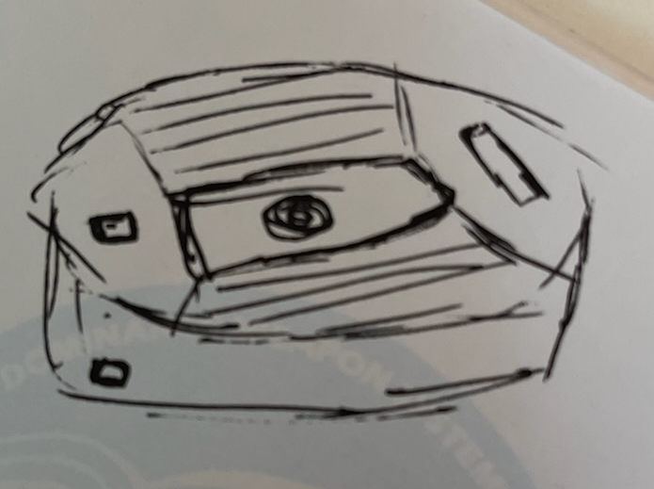
Overall, this project has been a great experience! I have had so much fun working with my team and developing our project. Throughout this experience, I have learned a lot about how the development cycle works for a product as well as some new technical know-how. In the following paragraphs, I will elaborate and summarize some of the information I have learned along the way.

One of the most challenging, yet most important, skills I have learned through this project is how to research. We all spent time researching how batteries and solar panels work, but one of my main focuses was on parts research. I first began by drawing a rough sketch of what we wanted to do - at this point, we had already decided on what our project would be. Once I had a rough block diagram, I began searching with my team online for parts. I found a company called Adafruit, more on which is discussed above. This company was exactly what we needed! They offered all kinds of parts, modules, and other components that were exactly what we needed to complete our project. After spending several hours, we had finally found the perfect company to provide us with parts. Then, I began searching through their parts to see if it would match my rough sketch. I then redrew our rough block diagram, and began to reexamine with my team which parts would work. After much consideration, we determined which parts we needed, and ordered them.
Figure 73: Mockup Drawing

My objective throughout this entire process was to ensure we were all on the same page. Yes, we always work as a team, but that can be confusing when each person is working on something different. Therefore, the first thing I put my time into was organization. I started by laying out the document with all of the titles, sections, and subsections we would need in order to meet the Senior Design 1 Report requirements. This would allow my teammates and I to fill in the sections as we need and give us an idea of what is still missing. Additionally, I continued to create and redraw the block diagram to keep up with the ever changing needs of our project. Initially, these drawings were hand-drawn, and I uploaded pictures for the rest of my team to see. Eventually, I switched over to using PowerPoint to develop a clear and easy-to-understand block diagram that can be found above. This block diagram was used to develop multiple other sections of our report, and it is one of the many pieces that kept us all on track.
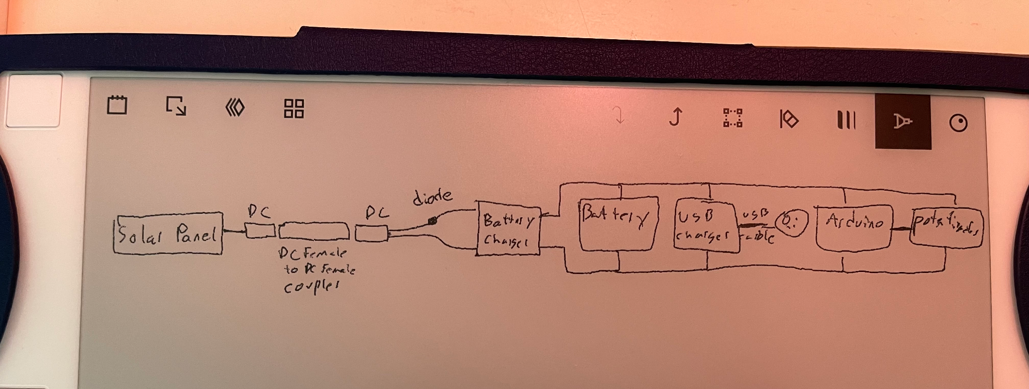
Figure 74: Original Schematic
Another important piece of any project is the budget. I strived to keep our costs as low as possible by only ordering parts we need while also reusing parts we already have. For example, all of the many parts we needed from Adafruit, we had to order of course. However, the other part of our project requires an Arduino, breadboard, jumper wires, and an LCD display. All of these components, including the Arduino, I already had acquired from a previous class when I ordered an entire Arduino kit. Therefore, we did not need to add this to our expenses. Additionally, we have decided to 3D print the casing and structure for our project. I already had a 3D printer that I purchased for a project from another class. Therefore, I saved our team hundreds of dollars by not having to purchase our own 3D printer. More importantly, all of us worked together to establish our budget. We selected a number that was fiscally responsible for each of our respective situations, while ensuring it would be enough to complete our project.

7.3.2 Project Experience - Tyler

After completing this project, I’ve had such an extraordinary experience working with my group mates to develop our solar charging station. It’s been very enjoyable, learning about engineering specifications, design constraints, and all the research we’ve had to do. I’ve learned a great deal of practical knowledge, and how the development process works for our project.

Initially, we only had a block diagram with a rough sketch of the flow of our project. As we spent more time researching and thinking about the design of our project, we were able to add some engineering specifications, motivations, goals, and related work. As we got deeper in, we were able to look up components, obtain dimensions, and battery considerations. After we agreed upon the design of the foundation, we were able to add information about how we will use a 3D printer to construct the base of the module, and shape it into the form of the Bounce House, also known as 3MG Stadium. Furthermore, we figured that we could connect an arduino to our solar panel to display the voltage that the photovoltaic panel is producing in real time, and to display the battery backup’s percentage.

This gave us enough of an understanding of our project to estimate our budgets and financing, as we came up with a total budget of $600, and $150 per team member.

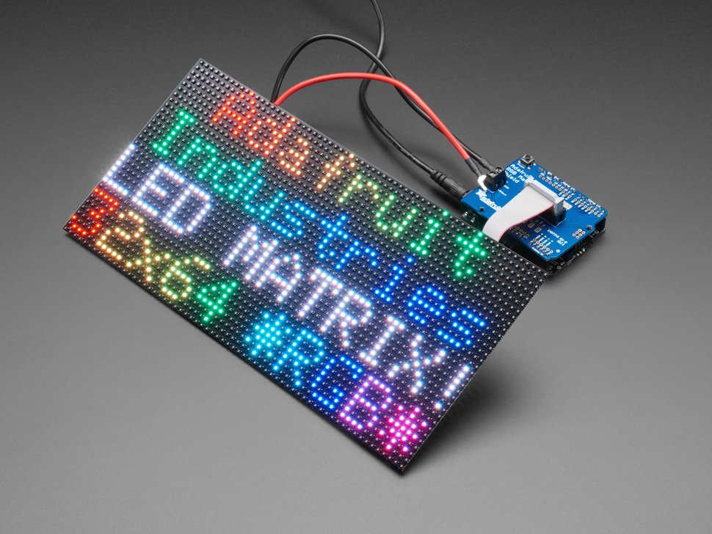
Furthermore, we spent the majority of our time doing research on every aspect of our product. We researched how solar panels work, solar panel manufacturing methods, solar panel testing and certification standards, lithium ion batteries, LCD displays, microcontrollers, and wireless chargers. One of the sections that I personally contributed the most to was the market product comparisons. Researching products already on the market gave us an excellent understanding of how advanced the existing products are, and how expensive a quality solar charger would cost. I researched 4 different devices, each of them were of varying prices, quality, and water resistance ratings.

After we selected our parts, we came up with some design constraints and standards that we must adhere to in order for our product to work flawlessly. There are design, time, manufacturing, sustainability, software, and testing constraints to name a few, and for the standards there’s battery, programming language, solar panel, wireless charging, and PCB standards. Furthermore, we moved on to project design, where we dove into the modeling application for the 3D printer that we’re using for the foundation of the solar charger. After this, we explained how we’ll connect the solar panel to the battery, the battery to the arduino so that the percentage can be displayed,
Figure 75: LED Screen

7.3.3 Project Experience - Luis

Looking at the overall experience of this project, I would definitely do it again with the same idea and group members. Throughout the time working on the report and prototype for this project, there is so much that I have learned and still yet to learn. I really liked the chemistry every group member had, during the time we worked on the project, as well as the time when we were bonding and making the chemistry stronger. Every single group member put their input and provided 100% every single time we met up and worked on the project. Throughout the time we worked on the project, there were many differences faced with one another, but we all got through them and came back stronger and continued working as a team. Meeting twice a week for six hours was very tough and time consuming for everyone in the group, but we all managed to pull through and definitely reach the milestones needed to move forward.

One of the most difficult tasks that was confronted is the overall schematic of the project. Conner and myself continued to look for specific schematic symbols for specific components, which we could not find or had to find a different schematic symbol representing what is needed to represent. Even emailing the support desk to the website where the components were purchased, the support desk had responded saying that they did not have that information available, leaving us no choice but to search for different schematic symbols on multiple websites such as SnapEDA. We did manage to find some sort of schematic symbol for the specified component and for the overall schematic.

When looking at how much work was put in, I can gladly say that we continued to push through and work hard until the very end, even while we all had other courses to worry about with midterm exams, homework and even final exams. As some of us also do volunteer work and attend club meetings, this project also helped apply skills of collaboration, teamwork, determination and self-discipline. This project has definitely opened my eyes on how much of these skills, information and projects will be applied in my engineering career, then later on see how far I have come, all beginning from this moment when I truly felt like an electrical engineer.

7.3.4 Project Experience - Leslie

This project has been a challenging, but fun experience. Not only does it give some hands on real experience that we can definitely apply in our workforce, but it also teaches us time management and to learn to work in a group. One of the most difficult parts of our project was choosing an idea to work on, but after we decided on doing a solar charger, everything started to come into place.

Also, it was difficult to start assigning roles when we hadn’t known each other for that long and we didn’t really know how each worked. However, we started setting milestones and goals and decided to assign roles based on majors and previous experiences. We had initially set a block diagram where it showed the project’s idea and flow but without assigning any roles. Later on, I modified it and color coded so that we would have more specifications and understanding on what we needed to do and wanted to accomplish. I started assigning the roles in the block diagram and it was a good start for all of us. We all worked well on writing the document and keeping up to date with our milestones, and making sure we wouldn’t overlap into each other's work. Before every meeting we would discuss what we needed to accomplish for the day/week.

I started researching on some standards and constraints that could affect our overall project idea and started documenting them so that when it comes to the assembling phase, we can have some knowledge on what to look for and what to be careful with. Also, researching on the standards was important to knowing things that will challenge us and hold us back - this helps us prepare in advance to avoid issues because we already know what the issues will be. Setting standards is like setting a goal; it gives us an end design to meet, we just need to pave the road to get there.

In addition, I started looking at different house of quality designs that we could use for our project. After looking at different options and reorganizing it, I came up with the one we included in our document. I started filling any customer requirements as well as engineering requirements, and some numbers to quantify the requirements and expectations.

During the research section of our project, I focused on the microcontroller and found that Arduino was the most affordable and easy to work with. I learned more about the open source code that was available online and looked at some videos that could help us code and assemble our project. I will be using Arduino IDE to code and be able to display the power output to the user. This will also help us know the battery life. The arduino is a very important part of our project so I will need to make sure that proper testing is done and that the code is running without any bugs or mistakes. I will also work on designing a flowchart to have a better understanding of what goes into the code and how it will work.

8. Conclusion

This project incorporates a variety of strategies to ensure that the greatest amount of electricity is transmitted from point a to point b, from getting energy from solar panels to energy storage in batteries. This project encompasses a wide range of solar energy efficient technologies in order to give the user with the greatest possible experience in their hands and on their budget. During the research and development stages of this project, the group members faced several hurdles and impediments, many of which were related to engineering. From figuring out what our project topic would be, the research and getting a schematic for our parts.

Members have to design a method for accomplishing duties, as with most engineering projects, and then manage that process to guarantee ideal working circumstances. This project's group members were able to work together with little to no disagreement. To sustain this level of teamwork and cooperation, organization and communication are essential.

For each and every component that went into this product, the criteria and needs specified at the outset of the report were continually taken into mind. These criteria and requirements, as well as the restrictions listed in the middle of the report, were met.
The team is now working on building a final prototype of a solar charger that will be safe to users and convenient for indoors and outdoors.

Appendix

A1. References 122

A1. References

[1] Ada, L. (n.d.). USB, DC & Solar Lipoly Charger. Adafruit Learning System. Retrieved September 30, 2021, from https://learn.adafruit.com/usb-dc-and-solar-lipoly-charger.
[2] Collins, Courtney. Solar Powered Charging Station. https://www.asee.org/documents/zones/zone1/2014/Student/PDFs/125.pdf.
[3] Picture on 5.2.2: “Understanding Arduino Uno Hardware Design - Technical Articles.” All About Circuits, https://www.allaboutcircuits.com/technical-articles/understanding-arduino-uno-hardware-design/.
[4]Picture on 5.4.2: https://www.theengineeringprojects.com/2018/10/introduction-to-arduino-ide.html
[5]Picture on 5.4.1 https://www.larksuite.com/blog/agile-methodology
[6] “Aladdin Solar, LLC.” How Do Solar Panels Generate DC Electricity from Sunlight, 2008, www.aladdinsolar.com/pvhowitworks.html.
[7] SouravB22, and Instructables. “Voltage Booster.” Instructables, Instructables, 20 Sept. 2017, www.instructables.com/Voltage-Booster/.
[8] Picture on Arduino Uno. https://create.arduino.cc/editor/leslierecendiz/1abb4b91-930d-4209-b5f3-6736931e02da
[9] Picture of industrial 3D-Printer https://www.fabbaloo.com/2018/05/new-industrial-3d-printers-from-stratasys
[10] Picture of devices charging https://appleinsider.com/articles/19/02/19/airpods-wireless-charging-case-may-not-need-precise-location-on-a-charging-pad
[11] Picture from solar panel testing https://www.windynation.com/cm/Testing%20a%20Solar%20System_R1.pdf
[12] Picture of DC Jack Adapter Cable https://www.adafruit.com/product/2788
[13] Picture containing adafruit panel, voltage booster, and battery https://www.adafruit.com/product/4755
[14] Picture containing https://www.adafruit.com/product/2162
[15] Picture containing adafruit battery pack https://www.adafruit.com/product/5035

